State of Engineering
2018
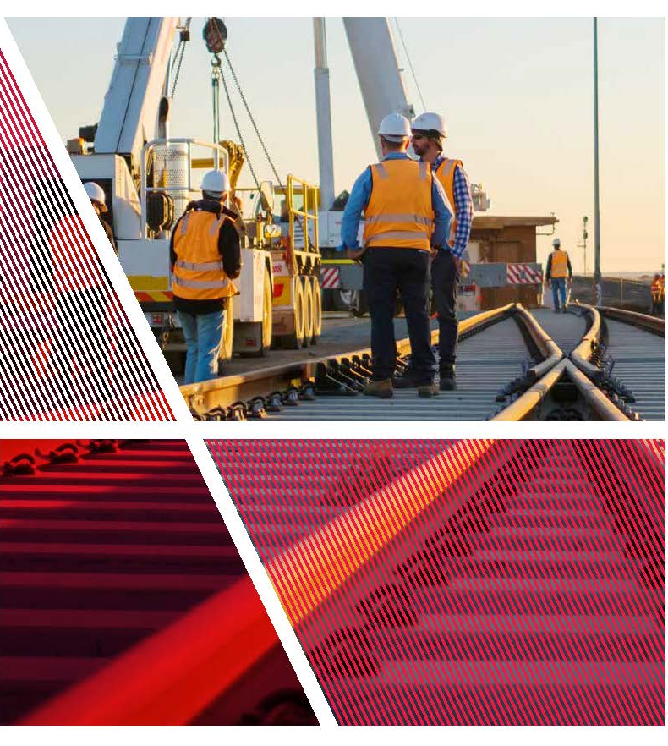

The Secretary
Department of Treasury and Finance
1 Treasury Place
Melbourne, Victoria 3002
Australia
Telephone: +61 3 9651 5111
Website: dtf.vic.gov.au

Authorised by the Victorian Government 1 Treasury Place, Melbourne, 3002
Printed by Doculink, Port Melbourne
Printed on recycled paper
© State of Victoria 2018

Accessibility
This document is available in PDF and Word format on the internet at www.opv.vic.gov.au
Email enquiries: enquiries@opv.vic.gov.au Telephone: 03 9651 1690

Victorian State of Engineering report is licensed under a Creative Commons Attribution 4.0 Australia licence, provided you credit the State of Victoria (Department of Treasury and Finance) as author, indicate if changes were made and comply with the other licence terms.
The licence does not apply to any branding, including Government logos.

Copyright queries may be directed to IPpolicy@dtf.vic.gov.au

Published October 2018

ISBN 978-1-925551-15-0 (pdf/online)
ISBN 978-1-925551-14-3 (print)

Treasurer’s foreword
The Victorian State of Engineering report makes clear the critical role of engineers to Victoria’s social, environmental and economic wellbeing, now and in the future.
The appointment of Victoria’s inaugural Chief Engineer within the Office of Projects Victoria acknowledges the importance of this vital profession and strengthens the Victorian Government’s commitment to supporting it. This is further confirmed by the proposed Victorian Engineers Registration Scheme, recognising the value of Victorian engineers.
Engineers are problem solvers, innovators and builders that help drive Victoria’s economic engine. Engineering projects generate employment and construct essential infrastructure that improves the quality of life for all Victorians.
As Victoria’s economy evolves and we prepare for the future, our engineers face complex challenges, such as creating efficient public infrastructure, reducing pollution, delivering faster broadband, designing our hospitals and schools, and building more energy-efficient homes.
Engineers are driving a range of improvements in the way Victorians live, play, work, commute and socialise, through the delivery of record levels of new infrastructure in Victoria. Alongside the many professionals required to ensure the success of the State’s infrastructure, engineers play a critical role in the planning, delivery, operation and maintenance of our major projects.
By shining a spotlight on the essential contribution of engineers, this report also highlights the importance of enhancing engineering education pathways and career structures. This will support a trained and experienced engineering workforce able to meet the challenges before us.
The Victorian Government recognises that engineers shape the landscape of our community, and encourage more to join this critical profession.
We will continue to engage with the profession to develop policies and projects that bring benefits to all Victorians.
Tim Pallas MP
Treasurer of Victoria

Introduction by Victorian Chief Engineer
Engineers have a significant impact on Victorian industries and our everyday life. Engineering-enabled industries generate more than 600 000 jobs and contribute to nearly 25 per cent of gross state product in Victoria.
Engineers enable critical infrastructure to be developed and constructed. Without the technical skills and knowledge of engineers, many industries would fail to operate, and our community would struggle to adapt to the challenging future we face. Engineers work alongside architects, scientists, financiers, economists and policy makers to ensure Victoria continues to be known as the state for successful and innovative industries and infrastructure development.
Victoria has always needed skilled engineers and this need will increase as the population grows and technological change accelerates. It is vital engineers work together and with other professions to provide continued social, environmental and economic benefits for Victoria.
Increasing the involvement of engineers in decision-making and planning processes helps to address technical challenges in the complex areas of sustainability, infrastructure, climate change and renewable energy.
Continued support from the Government and industry is imperative to attract and shape the next generation of engineers. To meet the significant engineering demands of the future, we need to encourage more engineers to enter and thrive in the profession. This includes promoting cultural and gender diversity to bring broader perspectives, and to make Victoria more liveable, cleaner, efficient and productive.
To foster professional pride and cohesion and increase public awareness of the importance of engineers, this report showcases the wide range and outstanding quality of engineering in Victoria. It also explores coming challenges and initiatives to consider that will prepare us for the future.
Dr Collette Burke
Victorian Chief Engineer

Contents
Treasurer’s foreword i
Introduction by Victorian Chief Engineer ii
Report purpose 1
Engineers’ influence 2
Engineering Victoria’s economy 3
Engineering for the environment 6
Waste and water management 7
Engineering and climate change 9
Improving biodiversity and land health 10
An engineer’s reach 11
The public infrastructure boom 11
The built environment 13
Information and communication technologies 14
Space 16
Medical technology and pharmaceuticals 17
Defence, aerospace and security technologies 18
Energy 19
Manufacturing 20
The wider impact of engineers 21
Engineering in the public sector 22
The future of engineering 24
A networked society needs interdisciplinary engineering 25
Transforming cities for a smarter future 26
Victoria’s strategic horizon 27
Changing skill needs 28
Non-technical skills 28
Technical skills 29
The life cycle of an engineer 30
Before school 30
Primary school 30
Secondary school 31
TAFE 32
University 33
Workplace 34
Engineering equality 36
Female representation 36
Aboriginal engineers 39
International and culturally diverse engineers 40
Engineering a better future 41
Conclusion 43
Acknowledgements 44

Report purpose
The Victorian State of Engineering report has been written to highlight the value of the engineering profession to environmental, social and economic benefits for Victoria, both now and into the future.
The report’s purpose is to identify areas where Victorian engineers interface with our lives, where engineers add value to the State, and to celebrate engineering success stories.
The report also details future challenges and current key initiatives that will enable the engineering profession to continue delivering creative solutions for Victoria.
With the support of the Office of Projects Victoria, the profession, wider government and other influential stakeholders, the Victorian Chief Engineer will continue to develop initiatives and programs to address the needs of infrastructure and engineering development in Victoria.

Engineers’ influence
Using their technical skills and an understanding of our needs and wants, engineers develop and implement solutions to benefit all Victorians. This can enable cleaner water, more affordable electricity, a quicker commute to work, faster internet access, better health and more affordable housing.
Victorian engineers take the lead in developing and implementing innovative and sustainable solutions to pressing issues such as climate change, sustainable resource management, an increasing population, a growing demand for health care, and our transition to renewable energy sources.
To address these issues, Victoria’s engineers must go beyond their technical specialisations and collaborate across engineering disciplines, along with other professional fields. As the fourth industrial revolution (termed ‘Industry 4.0’) approaches rapidly, engineers must adapt to the digitisation of virtually everything, and harness synergies between humans and machines, managing autonomous robots, big data and the transition toward connected life, termed the ‘Internet of Things’ (IoT).
As industry and society transform, Victorian engineers will continue to maintain independence and strive for honesty and diligence, as well as continuously advancing their knowledge and skills to meet the challenges of a changing world with integrity.
Engineers’ contribution progresses our society towards a more cohesive, automated, innovative and sustainable state. The benefits generated by the profession requires increased awareness to best attract younger generations to become engineers of the future.
The Budj Bim cultural landscape of the Gunditjmara community in south-west Victoria is one of the world’s first engineering projects delivering water needs, preceding the pyramids of Egypt and Stonehenge more than 6 000 years ago.
Victorian engineering innovations include the black box, plastic banknotes and the bionic ear.

Engineering Victoria’s economy
The value of engineering reaches far beyond the profession. Engineers make an enormous contribution to Victoria’s economy across a wide range of industries and regions. Engineers are often the minds behind the competitive products and services that drive a large portion of Victorian exports.
According to the Australian Bureau of Statistics (ABS), engineering-enabled industries contributed $93 billion to the Victorian economy in 2016-17, representing 25 per cent of gross state product (Figure 1).
An engineer’s technical expertise is required in developing almost all the consumer, commercial and industrial products we need. These products generate a large number of jobs in the areas of procurement, marketing, manufacturing, financial services and retail.
Arguably, no other profession has a greater impact on Victorian job creation than engineering. Engineering-enabled industries generate more than 600 000 Victorian jobs and 40 000 Victorian businesses across construction, information technology, power, telecommunications, manufacturing, and infrastructure.
Engineering-enabled job creation is not confined to urban areas – one in five jobs is in a regional area.
These businesses design, manufacture and deliver important products and services to other businesses and consumers across Victoria, Australia and globally. The contribution of skilled Victorian engineers is vital to these industries and businesses.
The value addition of Victorian engineering to the economy is larger when considering downstream industries. Scientific and engineering advances provide a $330 billion boost for the Victorian economy through productivity gains and flow-on effects (Figure 2).
Victoria leads many engineering and technology- based industries. In these industries, one of the engineer’s roles is to maintain and improve our competitive edge and growth capabilities so Victoria continues to flourish.
Figure 1: Engineering-enabled industry sectors 2016-17
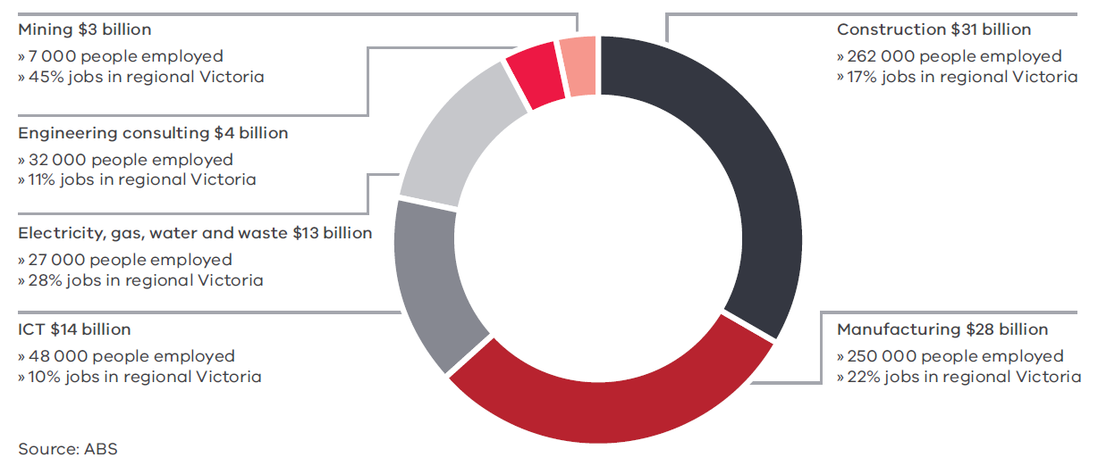

Victorian engineers:
- design and fabricate a large proportion of retail products;
- build the roads that take us to and from work every day;
- develop and manage the public transport and infrastructure that gets us to our destinations;
- plan and construct the homes and buildings in which we work and live;
- enable the delivery of the food on our table and clean water in our taps;
- develop the grids that reliably distribute electricity to us; and
- create the mobile towers that allow us to call our friends and family at any time of day.

Figure 2: Engineering-enabled industries flow chart
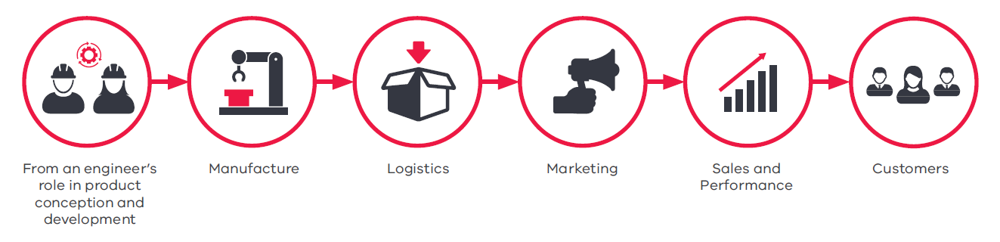
Businesses in engineering-enabled industries employ more than 600 000 people in Victoria. This equates to around 22 per cent of the workforce, or 10 per cent of the total Victorian population (Figure 3).
Figure 3: Proportion of Victorian workforce employed in an engineering-enabled industry 2016-17
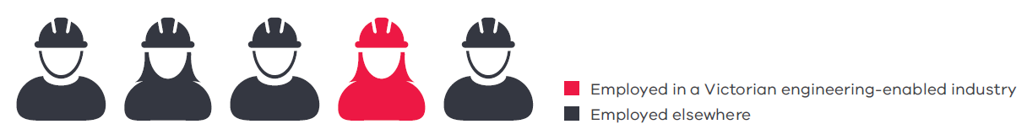
Source: ABS

Engineering for the environment
The next generation of Victorians should have the same or a better quality of life than we have now. Victorian engineers play a large role in creating this future.
This future requires decision-making to focus on the triple-bottom line: economic, social and environmental sustainability, including climate change.
The Interim Victorian State of the Environment Report 2018 provides a considered glimpse into the content, challenges and structure of Victoria’s environment. The final Victorian State of the Environment Report to be released in 2019 by the Commissioner for Environmental Sustainability will highlight the opportunities and challenges ahead for a cleaner future.
Engineers need to be informed about the current state of the environment to be effective in collaborating for the development of next-generation products, infrastructure and energy sources. They will need to consider the environmental impacts of a project or product in order to move away from merely minimising harmful impacts, towards net-zero impact and regenerative outcomes.
Innovation and technology will play a large part in creating a positive future for the next generation of Victorians. Engineers will need to collaborate with political and economic stakeholders to support them in the quest for a more sustainable Victoria by giving insight on how new technologies, innovative systems and products can help to achieve this quest. Following are some of the ways Victorian engineers are striving to be more sustainable.

Waste and water management
Clean drinking water and a hygienic environment are integral to a civilised society. Victorians enjoy some of the purest drinking water in one of the cleanest environments in the world, and the ingenuity of our engineers has been pivotal in creating this.
When you turn on your tap, it is engineers who have designed, manufactured, constructed, operated and maintained the extensive systems behind it: the dams, reservoirs, pumps, water treatment facilities, and large network of pipework. When you throw your rubbish in the bin, it is engineers who have developed the tools to collect, dispose of, or recycle our waste in an efficient manner.
Victoria’s population growth is challenging the capacity of our water supply systems. We need to move to a more distributed demand and supply management framework with environmental sustainability as a core objective. The growing population will greatly increase pressures on assets, infrastructure and wastewater services and will affect water resource availability and management. Victorian engineers will be key in making more effective use of existing assets and designing and building the infrastructure to address these issues.
The Victorian Government has already been proactive in this space with mitigation infrastructure such as our large reservoirs, the Victorian Desalination Plant and the North-South Pipeline.
At the beginning of this year, China introduced new trade measures that limit the import of low-quality mixed recyclables, including paper and plastic. This change has had an impact globally, as many countries have relied on China for recycled materials.
In the short term, the Victorian Government included funding to increase capability to process materials to a higher quality to meet China’s new specifications or for the Australian market. For the medium to long term, the Government has committed to a Recycling Industry Strategic Plan in July 2018 with $23 million that aims to stabilise the recycling sector, increase the quality of recycled materials, improve the productivity of the recycling sector, and develop markets for recycled materials. With continued support, Victorian engineers can create a sustainable system that embraces the circular economy.
While the Victorian Government and our local councils are responsible for regulating and managing our waste and water services, the Victorian community also has a role to play. Very little of our drinking water is consumed. Waste should not be disposed of without thought for the arduous and expensive task of sorting the different types of materials in our garbage.
Water and waste management will become easier and more efficient with a combined effort from all Victorians. If individuals take responsibility for managing their water and waste, and fully utilise the tools and infrastructure developed by engineers, Victoria will be able to cope with population growth.
There are many opportunities for individuals and large organisations to develop procurement frameworks that favour the circular economy, including avoiding single-use products such as plastics, and promoting infrastructure projects that use sustainable materials and construction techniques. This includes the use of recycled materials such as high-density polyethylene, reclaimed asphalt pavement, crumb rubber, glass fines/cullet and crushed concrete.
Currently more than 300 000 tonnes of fine glass is stockpiled in Victoria and most of it goes to landfill. RMIT University researchers are developing methods to recycle glass for construction material, such as cladding systems, providing a sustainable alternative to other materials on the market.
Victorian engineers have taken advantage of the digital revolution to optimise Victoria’s water supply, installing smart meters around the State to monitor our water use. Melbourne’s Federation Square has improved its water efficiency and emergency maintenance procedures, with systems that can detect abnormal usage within 15 minutes.
Researchers at Victoria University are developing a method for purifying water by harnessing UV light to make waste water treatment more affordable, healthier and energy efficient. The sophisticated membrane technology does not require specialised skills or resources and is ideal for use in disaster-affected areas and remote communities in Victoria, Australia and the rest of the world.
Engineering students from Monash University have developed a backyard mini-recycling unit. The unit can recycle old milk bottles, plastic bags and containers to make anything from phone cases to bowls and even structural beams.

Engineering and climate change
Australia has committed to reducing its emissions by a minimum 26 per cent over the next two decades to mitigate the impacts of climate change.
The Victorian Government has committed to renewable energy generation targets of 25 per cent by 2020 and 40 per cent by 2025, and has introduced incentives to encourage us to meet and exceed the minimum targets, as well as funding renewable energy projects around the State. This includes rebates for solar photovoltaics (PV) and hot water systems, helping households reduce their emissions and energy bills. It also includes decentralised grid trials, and funding for solar farms, wind farms and large energy storage systems. Victoria is on track to meet these renewable energy generation targets.
These are only a handful of the countless solutions already available that, if adopted, enable progress to achieving or exceeding our emissions targets.
Victorian engineers have the skills, technology and some of the most advanced facilities in the world to champion initiatives that reduce our emissions and mitigate climate change.
Climate change management also involves infrastructure and technology in the transport industry. As our population grows, so does the need for an expanded, efficient transport network. However, greenhouse gas emissions and noise pollution are adverse effects of this transport boom. The Government has accounted for this by advancing our public transport network. Engineers must develop and implement the upgrades for our trains, railway lines, tram and bus networks.
The Melbourne Renewable Energy Project is the first time in Australia local government, cultural institutions, universities and corporations have purchased renewable energy from a wind farm in Crowlands, north-west of Melbourne.
Engineers recently upgraded EastLink’s tunnel ventilation system to create a world-leading apparatus, which adjusts fan speed using real-time data from air flow sensors. As a result, power usage has reduced by 68 per cent, reducing annual greenhouse gas emissions by 9 000 tonnes with no compromise to air quality.
The Gannawarra Energy Storage System, developed by Edify Energy, is one of the world’s largest integrated battery and solar projects, and is supported by $25 million in funding from the Victorian Government and the Australian Renewable Energy Agency. Situated near the township of Kerang, this innovative project uses Victorian-designed and built electrical equipment, including Wilson’s manufactured kiosk transformers. Together with a Tesla battery storage system, it provides a world-class storage facility coupled with Victoria’s largest operational solar farm.

Improving biodiversity and land health
Protecting our environment benefits tourism and our economy. Solar Victoria, Sustainability Victoria and Land Use Victoria represents a significant commitment by the Victorian Government to protect our ecosystems and improve overall biodiversity.
Engineers share an interest in protecting our natural ecosystems. Conserving and improving Victoria’s biodiversity begins with an understanding of the potential impact of Victoria’s engineering projects. Engineering projects should aim to cost-effectively mitigate the negative impact on the natural environment, and appropriately offset any impacts that cannot be avoided, including harmful by- products and waste. This is particularly true when delivering projects.
A key challenge for engineers is helping protect and enhance our state’s biodiversity, together with maintaining the viability of the agricultural sector, which is essential to all Victorians. The State has seen a decline in the condition of land, water and biodiversity, which Victorian engineers need to mitigate and potentially contribute to improvements to the condition of our natural environment. To assist with this challenge, the Victorian Government has provided a 20-year strategy – Protecting Victoria’s Environment: Biodiversity 2037. The plan brings together the latest conservation and social science to ensure that Victoria’s biodiversity is healthy, valued and actively cared for. A focus on protecting and improving our natural environment is also a paramount consideration to ensure our agricultural industry thrives as the population grows.

An engineer’s reach
By collaborating in multidisciplinary teams and dynamic environments, Victorian engineers add value at all stages of our lives.

The public infrastructure boom
Victoria’s population is expected to increase by around 50 per cent (more than 3 million) in the next 28 years. As our population increases, we must continue to build the infrastructure to meet our community’s needs.
Figure 4: Population growth and public sector spending on engineering construction
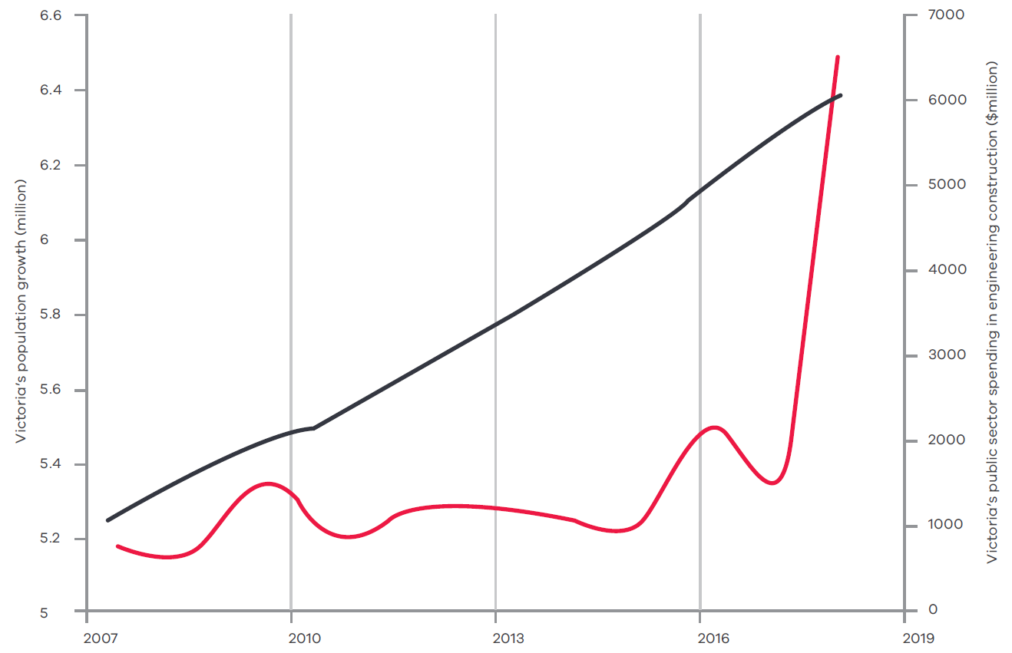
Source: ABS
In recent years, the Victorian Government has taken major steps to improve the delivery and planning of infrastructure, as seen in Figure 4.
In 2016, the Asset Management Accountability Framework was released to improve the way Victoria’s public assets are planned, used and maintained. The Asset Management Accountability Framework applies a consistent approach to asset management, which is aligned with international best practice.
Beginning in 2017, the Department of Treasury and Finance and Office of Projects Victoria instigated improvements in the project assurance framework for the State’s high-value, high-risk projects. The improvements provide increased central oversight of major infrastructure projects to increase the confidence that these projects are well planned and can be successfully delivered.
In 2018, the Department of Treasury and Finance refreshed, standardised and streamlined the State’s construction contracts to align with Australian standards, contemporary practice, and with other jurisdictions.
Infrastructure Victoria was created in 2015 to provide independent guidance and advice on Victoria’s future infrastructure needs. Infrastructure Victoria’s Victorian Infrastructure Plan outlines $80 billion of strategic investments over the next 30 years. Many of these strategic investments will be developed over the long term, but we also need to continue to focus on the short to medium-term development roadmap.
This roadmap should be underpinned by the ‘fundamentals’ that drive infrastructure need: engineering, future technologies and societal drivers (such as birth and migration rates), with the aim to achieve statewide prosperity and advancement.
Nevertheless, the large-scale infrastructure projects underway will continue to connect Victoria and service the community. These projects will provide exciting opportunities for our engineers. The West Gate Tunnel Project is only one example, and brings to Victoria some of the best tunnel engineers in the world. Combined with the skills and knowledge of local engineers, Victoria’s capabilities in this area continue to develop.
A large portion of Victorian Government investment has been on transport infrastructure. Over the coming years, $36 billion will go towards road and rail upgrades, and more than $4 billion of that has already been invested to improve the connection between regional Victorian towns, to get people and freight to their destinations faster and more efficiently. Further investments are planned for health, education, energy, water and waste, justice, culture and sport and digital connectivity.
Victoria’s infrastructure investment will present a multitude of job opportunities for a wide range of engineering businesses and roles over the next 10 years. This investment pipeline creates an excellent catalyst to grow the engineering capability and capacity in the State, which will cement Victoria as Australia’s engineering capital for decades to come. The Office of Projects Victoria, the Victorian Chief Engineer and the Office of the Coordinator General are working together to ensure Victoria has the engineering skills available to realise this investment.
Future engineers will be required to design and construct physical and virtual infrastructure, as well as take part in decision-making, project planning and management, cost estimation and risk management. The delivery of projects will see engineers continue to collaborate with architects, scientists, planners, financiers, constructors, economists and policy makers to ensure land use and transport infrastructure decisions maximise the development of our cities and towns and the benefits for Victorians.
Victoria’s Major Project Skills Guarantee seeks to engage more Victorian apprentices, trainees or engineering cadets on all projects above $20 million.

The built environment
Victoria’s rapid increase in population has created an unprecedented demand for housing and social infrastructure, leading to housing affordability problems and a chronic shortage of social housing.
The Victorian Government released a housing strategy in 2017 to address this, which involved increasing funding to support home buyers and homeless Victorians.
To complement the current Government initiatives, Victorian engineers have developed a number of solutions to address the problem of building high-quality housing and infrastructure efficiently and sustainably. Some of these solutions are already underway.
Modular housing is one answer. Modular housing is fast and affordable, and Victoria is fortunate to host many companies that have contributed greatly to the development of off-site prefabricated construction modules.
Critical focus areas for the built environment that Victoria can adopt include: new materials and systems, digital design and engineering, including building information modelling, advanced manufacturing and automation, as well as Industry 4.0.
Industry 4.0 will likely transform Victoria’s built environment. Sensors and automation technologies will integrate with lean manufacturing to make our built environment smarter. Smarter building includes mass-customisation, new structural and architectural forms, predictive maintenance, proactive building control and improved material selection.
Adopting these new approaches and technologies may require a shift in economic assessments, business models and risk-sharing contract methodologies to accommodate step-outs in innovative technologies.
By doing so, Victorians will likely achieve more affordable social housing, timely delivery of public buildings, better living conditions, and more sustainable designs.
The Victorian Government is procuring 100 prefabricated school classrooms. Building the classrooms off-site ensures minimal disruption to students, a safer school environment and reduced waste from construction by up to 40 per cent.
As more families move closer to the city, the restriction in space has led to Victoria’s first vertical state schools developed by teams, including engineers, providing the latest and safest facilities for primary and high school children.
In 2018, Swinburne University engineers won a Research Impact Award from the Australian Road Research Board for their work on strengthening bridges with carbon-fibre polymers. This reinforcement technique uses less material for greater strength and has been employed on the West Gate Bridge and M80 Western Ring Road.

Information and communication technologies
The engineer-rich Victorian information and communication technologies (ICT) industry is thriving. Melbourne is the second largest ICT city in the Asia-Pacific, home to more than half of Australia’s top-20 technology companies and the largest number of multinational ICT companies in Australia, including IBM, Microsoft and Intel.
ICT is a big part of Victoria’s economy, contributing $14 billion towards the gross state product.
Victorian engineers play fundamental roles in the ICT industry, including designing and manufacturing ICT equipment, providing ICT infrastructure services and maintaining computer hardware. Almost half of Victorians in our ICT industry provide computer software and digital content development, publishing, consulting and system analysis services.
Victoria is globally competitive in software development, market platforms, cloud technology, spatial technology, sensor networks and data analytics, which are all engineering-enabled aspects of ICT.
Industry 4.0 will have a dramatic effect on ICT, with many areas of engineering converging toward the cyber-physical realm, which involves integration between computation, networking and physical processes. These digital technologies will rapidly change the way Victorians work, play and live.

The development of new digital technology will drive innovation in, and increase the capabilities of, many other industries. For example, in fishing and agriculture, the CSIRO is leading the digital revolution with:
- phenomics sensing, which tracks how plants respond to changes in environment or genetics;
- software engineering, to create decision support tools for real-time decision-making;
- precision agriculture, which observes, measures and responds to crop variability using data analytics;
- food innovation, which allows for more efficient processing of food while preserving flavour and essential nutrients; and
- farm systems management.
The Victorian Government is proactive in this area of engineering. On-farm IoT technology is being rolled out across Victoria to promote agricultural ICT, such as sensors for soil moisture, which will improve crop yield and livestock tracking.
IoT is also being applied in the management of Victoria’s infrastructure, water, waste, parks, sporting facilities and roads, involving technologies such as virtual and augmented reality, cross-reality digital twins, which allow visualisations of existing objects that can be viewed from any angle, complex-systems simulations and intelligent transport systems. The future performance of Victorian digital assets will be determined by Victorian ICT engineers.
This transition brings challenges such as systems interconnectivity, cyber-security, digital identity and data ownership and protection. As technology continues to evolve, engineers must take a lead role in the implementation, management, and adoption of these new technologies across both the private and public sector.
The CSIRO is applying sensor systems that cheaply and accurately monitor agriculture for farmers to maximise production sustainably and cost-effectively. The Victorian Government has committed $27 million for Victorian farmers to install IoT and other digital technologies, including robotics, biotechnology adoption and virtual fencing.
La Trobe University has developed a low-cost and lightweight Fitbit-like device for farm animals, which will help farmers understand individual animal behaviour in large-scale farming.

Space
Victoria is home to 250 businesses and organisations in the space and space-enabled industry, employing around 2 300 workers and generating around $400 million a year.
With the Commonwealth Government allocating $41 million over four years towards the establishment of an Australian Space Agency, this sector is ready to grow. Victoria is well-positioned to support an Australian Space Agency to achieve its goal to triple the size of Australia’s space industry by 2030, with Melbourne being the technology hub of the country and home to the largest number of multinational information technology companies in Australia.
Victoria is a leader in using and applying space data. It has five top-500 globally ranked universities with space-related research disciplines and well-established space-related engineering, research and development capabilities, and national and international networks. Three of Australia’s largest aerospace and defence companies, Lockheed Martin, BAE Systems and Thales, operate in Victoria with extensive capabilities and engineering talent.
The space industry sector is far greater than just launching rockets. It will be the driving force behind improvements in real-time communications and on-demand access to information. Space and space-enabled technologies will become an increasing part of our everyday life, through areas such as reliable and real-time communication, accurate weather information and GPS satellites.
Engineers will be the ones to design the systems and devices that will launch us into space physically or virtually, manage and analyse the vast amounts of space and geospatially generated data, and transform our understanding of the universe.
Engineers and scientists support the innovative research of Victorian universities and industries, which have the capability to meet the challenges presented by a growing space industry.
‘With the global space industry forecast to be worth more than $1 trillion by 2040, there is a huge opportunity for Victoria to play a major role in the aerospace industry for decades to come.’
– Dr Amanda Caples, Victorian Chief Scientist
Engineers at La Trobe University have created advanced on-board control systems for an earth-sensing imaging spectrometer aboard the International Space Station, which monitors bushfires and other natural disasters around the world.

Medical technology and pharmaceuticals
Victoria’s medical technology and pharmaceutical industry is the largest in the nation, home to nearly half of Australia’s biomedical researchers and medical research funding. It delivers some of the world’s most advanced research and development and adds $2.2 billion to the Victorian economy each year.
The medical and pharmaceutical sector benefits from an interdisciplinary approach that integrates engineering, life sciences, physical sciences, computer science and mathematics with medicine and health sciences to prevent, diagnose, monitor and treat many conditions.
Victorian engineers are driving rapid growth in this sector by contributing to the design and development of emerging technologies such as bionics, bioelectronics, nanomedicine, customised implants, robotics and organ-on-a-chip. Our engineers have created life-changing technologies including cochlear implants, bionic eyes, 3D-printed spinal implants and epilepsy management implants.
Victorian engineers are developing precisely tailored medical devices based on patient-specific genomic, molecular and digital profiles. Using data mining and machine learning techniques, Victorian engineers assist the Australian Genomics Health Alliance to turn large volumes of complex medical and biological data into information on which clinicians can base treatments.
The Victorian Government has committed to digitising the Victorian health system, for example, with real-time prescription monitoring. Embracing Industry 4.0, Victorian engineers are already developing technology that connects medical devices, sensors and software applications to clinical systems to improve productivity, accuracy, service and reliability.
The bionic eye is being developed by Bionic Vision Technologies in Victoria to help restore vision to vision-impaired people. This is an excellent example of successful interdisciplinary collaboration by world-leading experts in ophthalmology, biomedical engineering, electrical engineering, materials science, ICT, neuroscience, psychophysics, and surgical and clinical practice.
Victoria is at the forefront of orthopaedic and maxillofacial personalised devices, with successful world-first surgeries replacing the heel bone and the jaw joint. The University of Melbourne has helped engineer Australia’s first 3D-printed titanium jaw for implantation in a patient. This development is key to the success of a local start-up company, OMX Solutions, which has since implanted more than 100 customised jaw prostheses in Australian patients.

Defence, aerospace and security technologies
Victoria’s defence, aerospace and security technologies sector is worth $8 billion annually. It comprises more than 400 businesses, employing around 20 000 people (including in industry and the Australian Defence Organisation).
With the Commonwealth Government injecting $200 million into defence capabilities, Victoria’s defence, aerospace and security sector is primed for growth. Victoria can lead the way through diversifying capabilities vertically in global supply chains and growing our defence, aerospace and security research, development and education capabilities. This can only be achieved by showcasing and utilising our engineering expertise. Growing Victoria’s technical capability in the defence, aerospace and security sector will require further development of domestic talent in all areas of engineering.
Thales’ plant in Bendigo manufactured the Bushmaster Protected Mobility Vehicle and will now manufacture the Hawkei vehicles, with 16 out of 19 tier-1 suppliers based in Victoria.
Victoria is home to:
- Australia’s largest concentration of military vehicle engineers;
- significant maritime engineering design and development capabilities;
- leading aerostructures designers and manufacturers;
- the Defence Materials Technology Centre; and
- elements of the Defence Science and Technology Group.
Victoria is also the home of many research and development facilities, advanced manufacturing and education precincts that focus on defence and aerospace, such as those located at Fishermans Bend. As we continue to grow our skills in all engineering disciplines, Victoria is in a prime position to lead many future defence and aerospace projects that underpin Australia’s security.
The Northrop Grumman sensor system for the Joint Strike Fighter F-35 was manufactured and machined by AW Bell in Victoria.

Energy
Victoria’s electricity supply has been primarily sourced from lignite (brown) coal, one of the worst-polluting fossil fuels with an imminent expiry date. By transitioning to renewable energy sources, Victoria can mitigate significant future environmental issues and associated costs. As part of this transition, engineers must continually ensure the reliability and affordability of electricity. In the short term, this requires improvements to our current electricity network. This can be achieved as we build a low-intensity energy power grid, begin diversifying our electricity sources and move towards a decentralised energy system.
In the medium to long term, engineers can lead the transition to renewables, applying extensive expertise in batteries, solar cells, energy-systems modelling and large-scale infrastructure projects. These lower-cost and clean-energy options will help Victoria achieve its target of generating 40 per cent of the State’s energy from renewable sources by 2025.
Examples of recent renewable energy initiatives include the Victorian Government’s purchase of two new wind farms and a solar farm, as well as investments in solar battery storage.
Victorian engineers are well positioned to decarbonise Australia and the world. They are working on innovative energy projects, including next-generation battery prototyping, next- generation solar-cell fabrication and carbon capture and storage. They are also integrating carbon reduction technology in large-scale infrastructure projects.
Victoria is transitioning toward a greener future with the recent announcement of six large-scale wind and solar farms across regional Victoria, a microgrid grant program for the Latrobe Valley and further solar energy rebates. This momentum towards a cleaner, greener, brighter future for our children must continue and be built on.
Developing and innovating in this industry presents an opportunity for Victoria to gain a competitive advantage. With increased funding for renewable energy research and development, Victorian engineers could create innovative, entrepreneurial solutions that will be in high demand nationally and globally. For this to occur, Victorian engineers need support to enhance their technical skills around power systems, ICT, big data, new energy technology, and large-scale project management and planning.
Monash University’s Net Zero Emissions Initiative focuses on making its campuses carbon-free by 2030, partly by installing renewable power and micro grids – the largest campus demonstration of this in the world.
The world’s first coal-to-hydrogen plant was launched in Victoria, with immense potential for reduced carbon emissions. Hydrogen can create clean energy for power generation, transport, fuel cells and batteries.

Manufacturing
Manufacturing in Victoria is adapting to global changes and is thriving. Manufacturing is the third-largest employer in the State and contributes more than $18 billion (70 per cent) to Victoria’s exports.
Victoria leads the nation in manufacturing research and development investment. Many global companies such as Ford, Siemens and Boeing choose to base their engineering research, development and design operations here. They do this to take advantage of Victoria’s engineering capabilities.
Victoria’s manufacturing capabilities are strong in construction, defence, food, medical technology, pharmaceuticals, new energy and transport. Engineers provide critical skills across the many disciplines needed by manufacturers at all levels of business, including electrical, mechanical, automotive, aerospace, biomedical, civil, ICT and systems.
To continue to compete in the global economy, Victoria must manufacture advanced, high-value products, requiring skilled engineers to manage the complex product life cycle through development, manufacturing, logistics, and disposal. The Victorian Government’s Advanced Victorian Manufacturing report highlights the key high-value products that are already being developed in our state, as well as potential future growth areas.
Victorian engineers will play a key role in the rapid transition of manufacturing toward Industry 4.0, by taking a lead role in scoping, design and implementation of digital manufacturing and supply chain technologies.
The transition to Industry 4.0 will increase demand for systems engineering, a complex discipline of engineering that focuses on interdisciplinary integration of systems, projects, equipment and processes. Systems engineers have extensive training on complex processes, and develop effective digital solutions for manufacturers.
The Victorian Government is upskilling our manufacturing workforce to create opportunities, with commitments to retraining automotive supply chain workers and to the Latrobe Valley Worker Transition Service, for example. FormFlow is a Victorian company that has successfully transitioned workers and technology from automotive manufacturing to producing prefabricated modular structures.
Wilson Transformer Company (WTC) is a great testament to engineering longevity in Victoria, celebrating 85 years in 2018. WTC is Australian owned and the largest local supplier of distribution and power transformers in Australia. Around 600 employees contribute to the firm’s engineering and manufacturing operations in Glen Waverley and Wodonga, and hundreds of thousands of transformers are currently operating in Australia and various parts of the world.

The wider impact of engineers
Beyond the contribution to areas mentioned, the impact of engineering on our lives is deep and widespread with extensive benefits for all Victorians, including:
- mining and petroleum engineers in regional Victoria deliver the coal for our electricity, petrol for our cars, precious metals for our electronics and jewellery, and materials for our houses and other constructions;
- pipeline engineers deliver the gas we use to cook our meals, heat our homes and take hot showers;
- aerospace engineers design and manufacture aircraft components to increase efficiency and push down the price of our next holiday;
- automotive engineers working for global vehicle companies are developing next- generation cars we will soon be driving;
- mechanical engineers in Victoria’s regional areas have for generations designed and continue to design the equipment farmers use to put food on our tables; and
- nano-engineers are helping find cures to diseases by revolutionising diagnosis and treatment techniques and increasing insight into how our bodies process medicine.
RMIT engineers are collaborating with international aerospace company RUAG and the Innovative Manufacturing Cooperative Research Centre to develop 3D-printed aircraft parts with similar, if not superior, mechanical properties, which can potentially save operators huge overhaul costs.
Engineers at Deakin University have found a way to recycle denim jeans to create artificial cartilage for joint reconstruction, water filtration and advanced battery technology.
Victoria is the biggest exporter of mining equipment, technology and services (METS) in Australia, with more than 1 800 METS businesses. Australia’s biggest mining companies, including BHP Billiton, Rio Tinto, Newcrest and Orica choose to locate their headquarters in Melbourne.
The Port of Melbourne is Australia’s busiest container port, handling more than a third of Australia’s container trade. Engineers Australia Engineering Excellence Award Winners AECOM Australia showcased the engineering input into the world’s most automated container terminal at the Port of Melbourne.

Engineering in the public sector
The number of engineers employed at all levels of government has declined from 100 000 to around 20 000 over the past few decades.
The main reasons for this decline are due to changes in agency delivery models surrounding government infrastructure, rail and shipping businesses, electricity and gas, roads and waterways, and construction and maintenance functions.
As a result, industry is now the major custodian of the engineering expertise government needs for the future. Internal government technical capabilities are required to deliver successful and feasible project outcomes. A good example of this need for technical expertise in government is in procurement.
The traditional driver for procurement has always been value for money. Judging value requires impartial assessment of life cycle costs and public value, which engineers are well positioned to contribute to. For the benefit of Victorian taxpayers, government needs engineers to provide advice on foreseeable asset costs and life cycle management.
The Victorian Government has taken important steps to address this need. The Office of Projects Victoria and the role of the Victorian Chief Engineer were established to provide high- quality, independent advice on developing major infrastructure assets. The Victorian Government has also created Infrastructure Victoria, Rail Projects Victoria, the Major Roads Projects Authority, the North East Link Authority, the Western Distributor Authority, and various building authorities, as well as the Advanced Manufacturing Advisory Council. All these entities are tasked with delivering better outcomes for the State throughout the life cycle of our assets.
As our projects grow larger and more complex, government agencies will require greater engineering expertise. It is important we retain existing government engineers and continue to develop them to build public engineering capability.

One of the Victorian Chief Engineer’s initiatives is to champion the Victorian Digital Asset Strategy through the Office of Projects Victoria, to extract the benefits data and digital assets can deliver to major infrastructure projects and asset management.
The Office of Projects Victoria is committed to increasing government capability in major project delivery by:
– establishing the Victorian Major Projects Leadership Academy for current and emerging Victorian Government project leaders;
– estimating the employment impacts of major infrastructure projects to guide industry workforce planning; and
– providing independent support and advice to government infrastructure delivery agencies.

The future of engineering
Interacting with policy makers and other professional fields, the engineer of the future must be able to plan, design and build solutions, which address challenges such as affordable housing, clean and low-cost energy, reduced congestion and enhanced social connectivity.
Engineers must also address these large challenges while navigating Industry 4.0, which brings its own challenges and benefits. Figure 5 identifies how Industry 4.0 will change society and the future role of engineers.
Just as oil was the main commodity powering the last industrial revolution, data is driving the fourth industrial revolution. The engineers of the future will need to plan, design and build the data infrastructure equivalents of refineries, grids and pipelines to allow Victoria to realise the benefits of data.
Key changes that will revolutionise the future of engineering are the networked society and smart city living and governance. As Victoria becomes automated and connected, the ways we communicate, make decisions and go about everyday life will change. Therefore, we must carefully consider how society will also influence and accept developments in technology, digitisation, mobility and the way we live.
The University of Melbourne, Monash University and La Trobe University have developed and implemented testing of autonomous vehicles on campus. This technology is closer than you think and is likely to be a disruptor – leading to large changes in the vehicle industry, regulation, insurance, and urban planning.
Figure 5: Changes in activity enabled by Industry 4.0
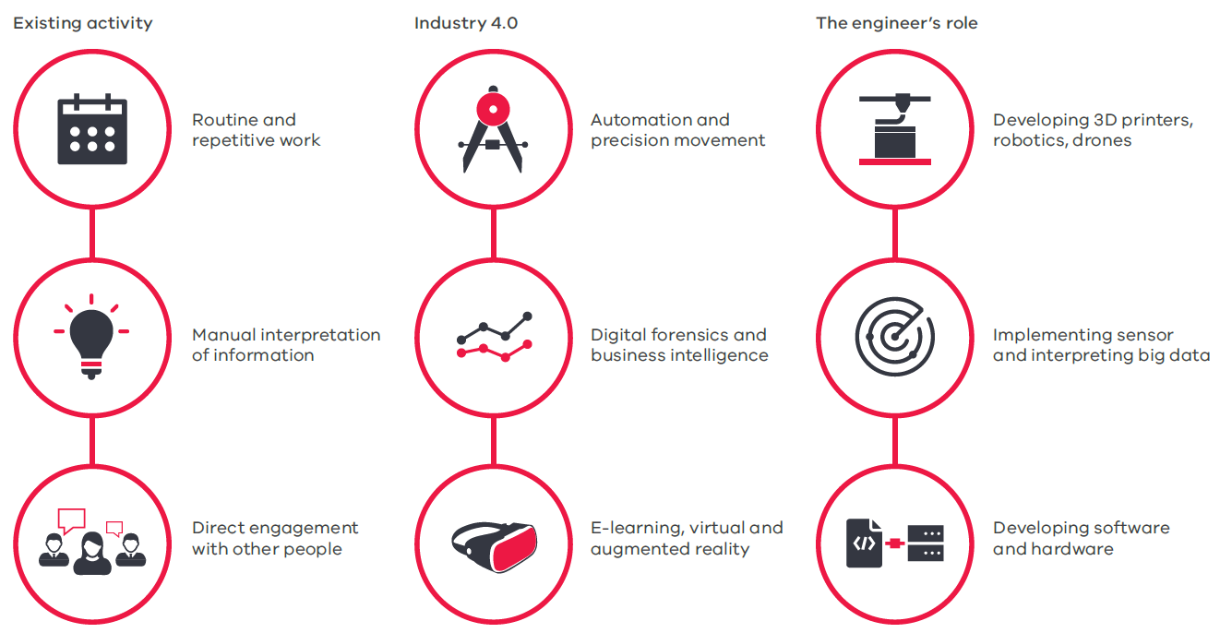

A networked society needs interdisciplinary engineering
As the industrial revolution transformed global society in the 18th century, digital, networked and automated technologies are driving massive social changes in the 21st century.
Our social, professional and political lives are increasingly influenced by digital connectivity between people, places, and things. Our experiences are becoming more virtual.
Engineers can apply rapidly increasing computing power to autonomous learning and adaptation – in cars, smart phones and traffic systems, for example. Automated, networked digital systems that allow rapid transmission and processing of data are disrupting how we live, work, shop, interact, travel, manufacture, conduct business and govern Victoria.
The increased digitalisation of our lives is generating large amounts of data about us. Engineers are needed to deal with this, as well as the associated cyber-security concerns.
Roads Australia is a not-for-profit industry association that collaborates with international transport networks to explore the potential of advanced technology and digital systems to develop transport to world-class standard.

Many sectors are embracing this transformation and realising the benefits:
- process improvements in logistics and information management;
- productivity gains in mining, agriculture and health care; and
- new commercial opportunities in shared infrastructure, services and skills.
Automation and digitalisation will transform the economy. Some jobs will vanish, and new jobs and new approaches to work will emerge.
To manage this transition, there is a need to further develop the skills in Victorian engineering, including professional engineers, engineering associates and engineering technicians. Technicians and associates are often overlooked, but they are critical to deliver future projects because they boost our capability and capacity in engineering with specialised skills, fulfilling the technical needs of Victoria’s development.
The digital revolution brings with it strong social and environmental benefits, which will be maximised if industry sectors and engineering disciplines adapt in synchrony. Engineers should be active in the decision-making process, providing unbiased technical guidance on how to best implement new technology.

Transforming cities for a smarter future
Large cities like Melbourne face the paradoxical challenge of managing growing populations, while reducing emissions and waste. Part of the solution is becoming a ‘smart city’ that uses data and digital technology to increase efficiency, sustainability, prosperity and quality of life for city workers and residents. For example, our smart cities will have:
- reduced traffic congestion and increased work flexibility through remote access via virtual and augmented reality;
- cleaner and better energy, water and waste management using demand data and real- time information on the condition of infrastructure and resources; and
- safer, faster and well-integrated transport as private vehicles, public transport and roads share information, moving towards mobility as a service.
The success of smart cities relies on engineers developing and implementing these new technologies. Smart cities can only be created by complex systems engineering and making informed decisions on the best development and use of technology.
The Australian Road Research Board has built new laboratory testing facilities in Port Melbourne and developed an intelligent pavement assessment vehicle, which can collect road condition data in one pass at 80 km/h. Monitoring the state of our roads leads to fewer accidents and savings on maintenance.
Figure 6: Sectors requiring engineering advancements for a transformed future city
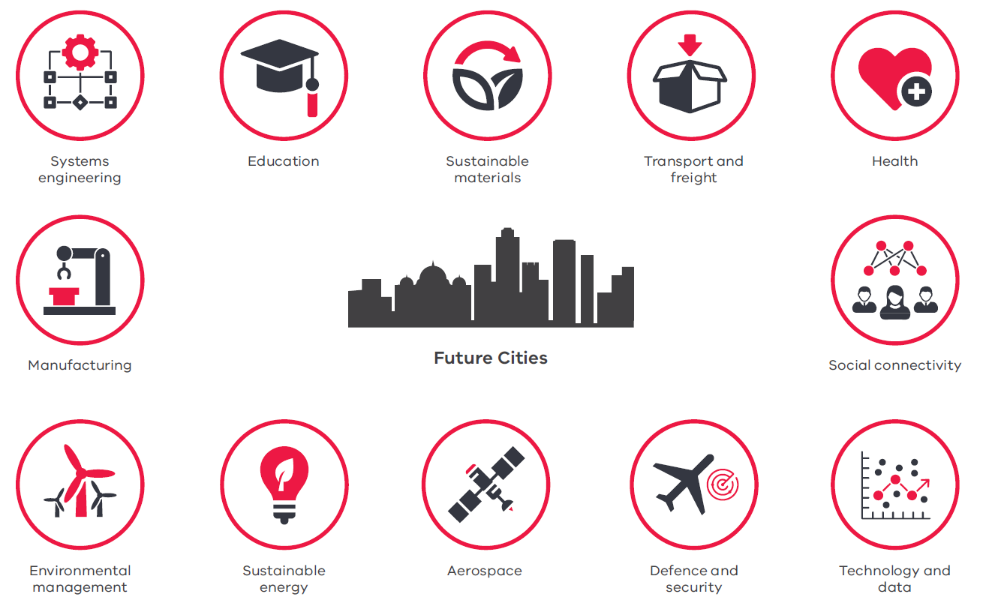

Victoria’s strategic horizon
Victoria’s future infrastructure development will be further enhanced by short and medium-term strategic planning. Consideration will be given to the factors affecting the future of our cities, including population growth, immigration rates, social and economic requirements and technological advancement. A detailed picture over the next decade will inform the development in key areas such as education, transport, health, security and communications (Figure 6).
Investment in planning for Victoria’s strategic horizons will greatly assist all stakeholders across a wide range of industries. The Government’s commitment to detailed planning is underpinned by the creation of Infrastructure Victoria. Infrastructure Victoria has contributed greatly to the Government’s planning for infrastructure in the medium and long term.
Effective infrastructure planning requires a long-term, evidence-based strategy developed with input and support from government, industry, stakeholders and the community.

Changing skill needs
As our social, technological and environmental context evolves, so too must the skills of engineers. Arguably the demand for engineering skills over the next decade will be unprecedented, due to the shift to new technologies of Industry 4.0.
The fourth industrial revolution will require new cross-disciplinary engineering skills such as mechatronics, design for digital and human- machine collaboration. In addition to their core technical skills, engineers will need excellent problem solving, project management and communication skills that develop with every stage of their careers.
Unless we foster the skill requirements now, Victoria may struggle to continue as a globally competitive state.
Engineering is social first and technical second

Non-technical skills
Engineers rarely work in solitude and their functions are not limited to designing, manufacturing or constructing. Increasingly, engineers must collaborate in multidisciplinary teams and with government, industry and community stakeholders to successfully deliver projects. To deliver value in multidisciplinary teams, engineers need better non-technical skills: interpersonal and communication skills, and flexibility in approach.
Being adaptable and resilient is another valuable non-technical skill for engineers. As technology changes rapidly and the engineering tools we use today become redundant over time, engineers must be able to embrace change.
Engineers also need to develop more business, commercialisation and entrepreneurial skills. These include abilities in procurement, project management, contract management, logistics, supply chain management and marketing.
Along with industry-specific capabilities, human and business skills are the most common abilities industry looks for in engineering graduates.
These skills are difficult to teach, and many of these lessons are only captured in work placements or internships. Students who undertake these programs are better equipped with such skills, and are more desirable when entering the workforce as a graduate.

Technical skills
We will continue to need engineers from diverse disciplines, who have a fundamental understanding of science and mathematics as our economy continues to transform.
An engineer’s education focuses on applying this understanding to design, build or maintain products, services or structures. These foundation skills will continue to be of the utmost value to society, but new skills specific to certain
streams of engineering will be created or become more important as we transition toward Industry 4.0, as shown below.
Skills we need now | Skills we will need in the future
Software engineering, especially cyber-security; | Biomedical engineering encompassing biomechanics, bionics and implants, medical robots, computational engineering, etc.;
Electrical engineering to apply digital technology in everyday devices; | Data engineering – demand is expected to surge with increasing use of big data;
Data engineering to manage the increasing volume of digital information; and | All engineers will need skills in data analytics in spatial information, digital literacy and the IoT;
Sustainable engineering to respond to demand for new energy sources and increase the efficiency of our current energy technologies. | Systems and network engineering for cities and states;
 | Materials engineering to develop and apply sustainable materials of the future; and
 | Robotics and mechatronics engineers for automation of all kinds.

The life cycle of an engineer
Engineers are needed now and will continue to be needed in the future across a wide range of industries.

Before school
Fostering an engineering career begins before a child’s first day of school. Parents and other role models have a major influence on a child’s creativity and problem-solving skills and form the child’s concept of society and gender roles, even before they enter school.
The Australian Chief Scientist’s STARportal collates and centralises exciting and engaging science, technology, engineering and maths activities around Australia and provides an excellent resource for parents and role models.

Primary school
Nurturing a love for science and mathematics from the beginning of a child’s education is crucial. Parents and primary school teachers should support children’s natural interest in understanding how the world works.
We must help children to explore and experiment with their surroundings, encouraging them to ask ‘how?’ and ‘why?’. How we respond to those questions has a major influence on our society in the future.
Many tools are available to make STEM more exciting and engaging for children. For example, the Australian Academy of Technology and Engineering provides teaching resources and programs.
Unfortunately, studies show that our ability to engage children in the ‘how?’ and ‘why?’ of the world is in decline. Student performance in numeracy and science literacy has decreased over the past decade. Clearly, more must be done to engage Victorian primary school children in science, technology, engineering and mathematics (STEM) education. Children need ongoing exposure to STEM with learning activities that can be applied to the real world.
In Year 3, NAPLAN results show 39 per cent of students are in the top two bands (out of six) in numeracy, but this drops to 22 per cent by Year 9.
The Victorian Government’s ‘Learning for Life’ Education State school targets aim to improve achievements in maths by 25 per cent for Year 5 students.

Secondary school
Once in secondary school, students start making choices about their career paths via subject selection, typically guided by parents, peers, role models or career counsellors. Students need to be fully informed about the outcomes their subject choices lead to.
Worryingly, Year 12 enrolments in VCE maths methods, specialist maths and physics – fundamental building blocks for almost all tertiary engineering studies – have decreased over the past decade (Figure 7). These subjects are often considered ‘too hard’ and students are not inspired to choose engineering as a career.
A number of university and non-for-profit programs exist that are attempting to reverse this trend. There are two main program types:
- one-off experiences for students to see exciting examples of engineering in action, either at school or during a visit to an organisation’s facility; and
- training teachers to increase their confidence in teaching STEM subjects. The latter type has longer-term benefits.
Enrolments in VET engineering subjects are more promising. Certificate II in Engineering Studies had more than 400 students enrolled in 2017, compared with 11 students in 2007.
There are many pathways into engineering, and studying VCE physics, mathematics or VET engineering subjects in Year 12 is not compulsory to enter tertiary engineering. Associate Degrees and Advanced Diplomas in Engineering are offered in many Victorian institutions without prerequisites.
Careers advisors and parents must heighten students’ awareness of these opportunities as well as the promising future that engineering offers. We must promote engineering to attract students in this crucial decision-making stage of their lives. To meet society’s needs tomorrow, we need to educate students about engineering today.
Enrolments in the VET Certificate II in Engineering Studies, Certificate III in Information, Digital Media and Technology, Certificate II in Integrated Technologies and Certificate III in Laboratory Skills have grown substantially since they were introduced.
This does not translate to pushing students to choose physics or specialist maths, but instead, providing ample information and experiences to help students appreciate the range of jobs engineers do, and their associated value to society. To deliver accurate advice, teachers, careers advisors and parents need to be informed about engineering pathways.
Figure 7: Year 12 enrolments in engineering-related VCE subjects
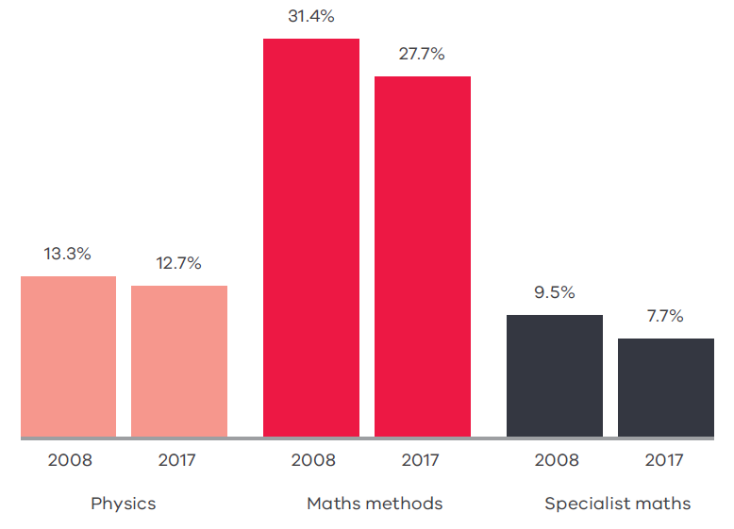
31.4%
Source: Victorian Curriculum and Assessment Authority

TAFE
Associate Degrees and Advanced Diplomas in Engineering are two-year qualifications offered by many universities and TAFE colleges. This pathway can lead directly to many employment opportunities as engineering associates and technicians – highly-skilled workers with specialised knowledge ranging from drafting buildings using computer-aided programs, to solid modelling and 3D printing, to upgrading electrical facilities.
Despite high demand for these skilled, hands-on workers, enrolment for Associate Degrees and Advanced Diplomas has fluctuated significantly over the past decade. One of the drivers of this fluctuation could be that diplomas are perceived to be less important and prestigious than university degrees, and hence less desirable. As a result, many Victorian industries are struggling to find the engineering associates and technicians they need to meet the current infrastructure boom.
About half of all Advanced Diploma in Engineering students and nearly all Associate Degree in Engineering students transition to a Bachelor of Engineering degree.
Efforts must be made to not only increase diploma and associate degree enrolments, but to encourage students to pursue careers that these qualifications lead to. This could be through improved marketing of educational institutions, improved industry connections, or through greater incentives. The Victorian Government’s recent introduction of Free TAFE for Priority Courses, such as Certificate IV in Engineering, strengthens efforts to increase engineering enrolments. These efforts will take time to be realised.
Students undertaking a VET qualification in engineering account for about 3 per cent of all engineering students. Around 67 per cent of engineering students are studying for a Bachelor’s Degree or a higher degree (e.g. Master’s or Doctorate).
The Victorian Government has pledged to support the development of a new TAFE course in Building Information Modelling as part of the Office of Project Victoria’s Victorian Digital Asset Strategy.

University
The number of domestic and international students studying engineering in Australia has been increasing, but compared with the overall growth in higher education student numbers it is slowly declining in popularity. A central problem remains – we are not producing as many engineers as society needs, particularly with the sustained high levels of infrastructure development and operations.
While the popularity of engineering is slowly declining, Victoria leads the nation in producing engineers. One in every three engineering graduates in Australia is from Victoria. Victorian universities attract more international students than any other state, strengthening our reputation as the Education State. But many international students return to their countries of origin to apply their engineering skills.
Retention of women engineering students is slightly higher than for men; however, the number of women in engineering careers remains considerably lower. Retention of engineering graduates depends on successful transition from studies to practice.
In the past decade, the proportion of engineering graduates able to find full-time work has dropped. Stakeholders maintain this decline is due to students’ lack of experience, as many engineering undergraduates struggle to secure relevant work experience prior to graduation. This highlights a critical gap, which provides a major opportunity for educational institutions, industry and government to collaborate and ensure future engineers are prepared with real-world experience.
Work-integrated learning through internships, cadetships and traineeships are great ways to make graduates ready for employment. These opportunities are common in many other fields of study such as medicine, nursing and law. With support from industry and government, engineering educators can also embrace this approach to produce employment-ready graduates.

Workplace
‘Four in 10 qualified engineers work in the field of engineering. Many qualified engineers are extremely valuable to employers in industries such as finance, risk, research and teaching.’
– Chris Walton, Chief Executive Officer, Professionals Australia
Employment prospects vary between engineering disciplines. Civil engineering graduates are currently in high demand, while aerospace engineers and chemical engineers are in less demand. However, engineers from all disciplines have the versatile ability to solve problems, which is useful to employers across all industries.
Compared with other professional graduate roles, engineers generally attract a lower salary. This trend has not improved over time and may explain why fewer students pursue engineering.
Since 2011, Victoria’s engineering workforce has changed from being majority Australian-born to majority overseas-born due to migration driven by skills shortages. Employment of engineers from overseas has been necessary to deliver many Victorian projects. Anecdotal evidence suggests multinational engineering firms operating in Victoria will recruit overseas engineers if the local engineering labour market lacks the capabilities they require.
Victoria has a large share of Australia’s engineers with its workforce of 92 000, mostly employed in metropolitan Melbourne.
While overall, engineers’ wages have not increased in line with other professions, Victoria’s wage growth for professional engineers was the highest across the nation at 2.7 per cent, as reported by Professionals Australia. Despite this, the proportion of Victorian engineers practising engineering is declining. Data for engineering technicians and associates is not currently available.
More needs to be done to ensure we are training enough engineers with the relevant skills and experience to manage the infrastructure boom, emerging technologies, as well as climate change.
To promote engineering as a career choice requires the collaboration of educators, industry and government, to showcase the impact of engineering on day-to-day life and explain the career opportunities in this field to children and their teachers and parents (Figure 8).

Figure 8: Promoting engineering at every stage in an engineer’s life cycle
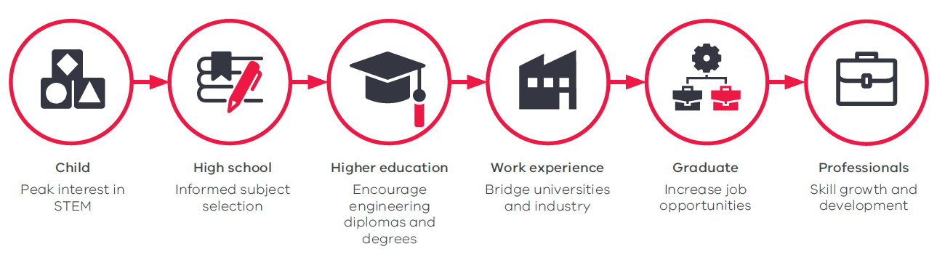

Engineering equality
Diversity in the workforce has been proven to result in more creative solutions and to foster a collaborative workplace. Studies have shown that a diverse workforce will lead to increased financial performance, reduction in staff turnover, better employer and customer satisfaction as well as increased productivity.
Unfortunately, diversity in engineering is very poor. More needs to be done to understand and boost gender and cultural diversity.

Female representation
Less than 14 per cent of career engineers are women. Effectively, half of the community is under-represented in engineering.
Capability is not an issue. NAPLAN results show that for Years 3 to 9, girls outperform boys in literacy domains and there is little to no difference in numeracy between boys and girls. Victoria’s NAPLAN performance in science literacy for Year 6 boys and girls is similar.
Despite the generally better performance of female students in primary school STEM subjects, female enrolments for mathematical methods, physics and specialist mathematics in Years 11 and 12 – the building blocks for engineering – are very low (Figure 9). This highlights the social and cultural stigmas that influence young women as they begin to define their career pathway through secondary school.
Only one in five young women will choose physics, and only two in five will choose mathematics methods and/or specialist mathematics.
This very low female representation in secondary school has a flow-on effect well into university, where women make up less than 15 per cent of engineering enrolments.
Women who study engineering tend to favour certain disciplines. In biomedical, environmental, and chemical engineering, women comprise 25–40 per cent of enrolments. In mechanical, electrical and civil engineering, women comprise fewer than 20 per cent of all enrolments.
The general problem is recruiting women into engineering and achieving gender balance across all engineering disciplines. This may be attributable to the significant lack of female role models in the engineering and other mathematics and science-based careers.
Once they are in the engineering education system, women are more likely to remain in education to progress their engineering studies further (Figure 10). Research careers often lead to a more flexible lifestyle in terms of work hours, which may be why women prefer to pursue higher qualifications in engineering. Despite this, only 7 per cent of engineering professors are women.
Figure 9: Proportion of female enrolments in engineering-related VCE subjects 2017
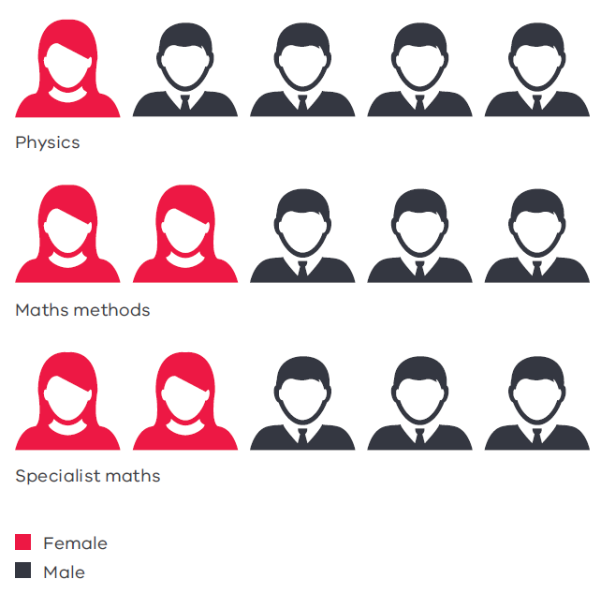
This can be directly attributed to the retention of female engineers in the academic workforce as well as in industry. There is significant attrition of women once they are qualified engineers.
One in six women between the ages of 20 and 39 leave the engineering workforce, in stark contrast to one in 100 men. Limited work flexibility, a large pay gap and difficulties in career progression are often the cause.
Once graduating from university, female engineers early in their career earn 2.5 per cent more than their male counterparts. However, due to low female representation in senior roles, the average female engineer earns 11 per cent less than men. This is also reflected in academia, where women with postgraduate degrees in engineering earn 20 per cent less than men with equivalent qualifications.
These well-known pay and representation discrepancies have triggered initiatives at various levels of the engineer’s pathway. Fostering girls’ interest in engineering must begin at primary school and continue throughout their education and careers if we want a gender- balanced engineering workforce.
Figure 10: Engineering enrolment gender proportion
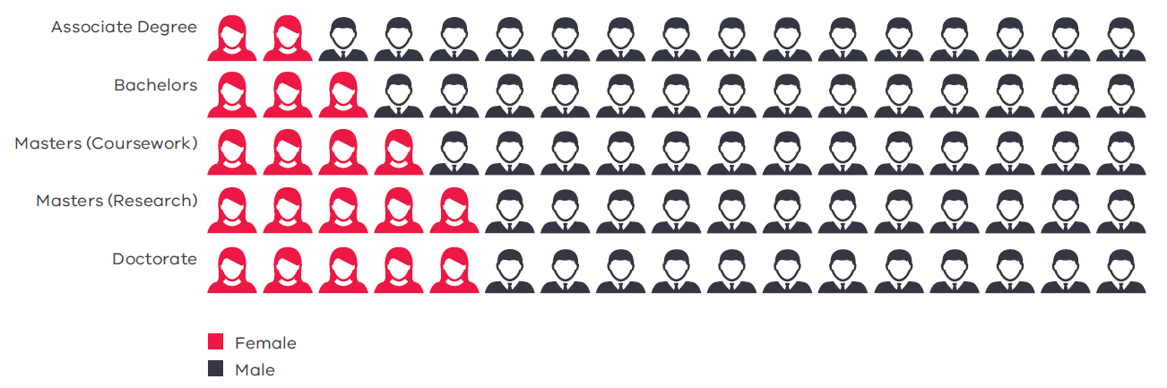
Source: Australian Council of Engineering Deans
At primary school, private industry programs such as In2Science, Robogirls and Little Scientists seek to address this need. Many universities also offer programs to engage female primary and secondary students in science by showing them state-of-the-art research, for example at Power of Engineering events. Universities are beginning to increase diversity in courses by offering scholarships for women in engineering.
Science in Australia Gender Equity is piloting the Athena Scientific Women’s Academic Network (SWAN) accreditation in various Victorian universities to address diversity issues in the STEM research sector. One impact of Athena SWAN is that universities in Victoria have created women-only academic roles in engineering to help attract and retain female students.
The Power of Engineering program is a Victorian initiative that involves
Year 9–10 girls in a day of activities and workshops to encourage an engineering mindset.
The private and public sectors are beginning to address the low retention rates of professional women engineers by improving the work environment and culture. Initiatives include job sharing, more part-time roles, longer paid maternity leave, and flexible work times and locations.
The causes of the lack of diversity in the engineering profession are complex. Fundamentally, we need to challenge cultural and social perceptions and stereotypes, and drive toward a long-term education strategy for parents, teachers and the community. We also need to keep investigating why, despite the many initiatives currently underway, we are not seeing the desired outcomes.
With Victoria’s current infrastructure building boom and digital technology transforming the economy, there are unique opportunities for governments, professional bodies, industry and educational institutions to position Victoria to reap the benefits of a strong, diverse engineering workforce.

Aboriginal engineers
Aboriginal people are under-represented in the engineering sector, including those studying engineering across Australia.
In 2016, only 11 Aboriginal students commenced an engineering program in Victoria, out of 134 Aboriginal students commencing an engineering program across Australia. Of those 134 students, less than 50 per cent completed their degrees.
Programs such as the Victorian Indigenous Engineering Winter School (VIEWS) encourage Year 11 and 12 students to participate in building the capacity of students who want to pursue a career in engineering, but these programs are faced with the challenge of increasing overall participation.
Many companies across the engineering sector have developed diversity targets and initiatives to increase the number of Aboriginal engineers. However, more work needs to be done in providing pathways to encourage Aboriginal young people to pursue a career within the engineering space.
’I have always wanted to make some small difference and leave the world in a better state than when I came into it. An engineering degree perfectly encompassed my interests in maths and science, which allows potential to have future societal impact.’
– Crystall Hall, from Pitjantjatjara country,
studying at Monash University

International and culturally diverse engineers
Students from across the globe come to Victoria for our highly regarded tertiary training in engineering. Most of these students return home to apply the valuable skills they have gained here.
Victoria attracts more international students than any other state. Two in five Victorian engineering students are international students. Our tertiary education system earns $500 million each year from international engineering student enrolments.
China is by far the largest market for enrolments, attracted by Australia’s proximity and engineering reputation. But in recent years, the number of international students from China has declined, with Chinese students preferring Canada over Australia. To retain the income international students contribute to the Victorian economy, and the benefits of cultural diversity, more must be done to attract them to our universities.
The majority of Victoria’s working engineers were born overseas, including those working here on visas and engineers who migrated to Australia as children. These engineers are critical to address Victoria’s skills shortage, and bring the benefits of cultural diversity.
John Holland has partnered with Jesuit Social Services to deliver the new Pathway Program to help qualified engineers from migrant and refugee backgrounds enter the Australian workforce. Twenty-three candidates have been placed across nine Victorian projects.

Engineering a better future
‘Sustainable progress requires engineering ingenuity and action.’
– Dr Collette Burke, Victorian Chief Engineer
To build a better future for our state, engineers must identify areas in which we can contribute positive change, not just for the benefit of the profession, but for all Victorians.
This future requires actions and initiatives across a range of areas:
- people – initiatives to enhance the Victorian engineering workforce and encourage Victoria’s best and brightest into engineering;
- projects – initiatives to prepare Victoria for the future; and
- profession – initiatives to increase the engineering community’s influence and capacity to solve issues that society will face in the future.
Implementation of the initiatives, as detailed in Table 1, has been divided into three horizons:
Short term: Already commenced or in planning prior to the end of 2018;
Medium term: Planned implementation in 2019; and
Long term: Implementation late in 2019.
In addition to initiatives currently underway, the Victorian Chief Engineer aims to investigate the following for the Chief Engineer’s forward work plan:
- building government’s engineering capability by engaging with industry;
- developing a strategic long-term framework for STEM education;
- investigating mechanisms that attract students into engineering;
- enhancing support for international engineers to boost our skills pool;
- investigating sustainable mechanisms for participation of women in engineering;
- increasing the number of senior women leaders in industry;
- investigating the application of best practice frameworks in risk and contingency for government and industry;
- investigating sustainable initiatives that support the infrastructure pipeline and sustainable construction;
- enhancing a medium-term infrastructure roadmap; and
- increasing research and industry collaboration in innovation by connecting industry with universities.
The Victorian Chief Engineer and the Office of Projects Victoria will work with the government sector, industry, professional associations and educational institutions to deliver these actions and initiatives.
These organisational bodies include, but are not limited to:
- all Victorian Government departments and agencies, including the Victorian public sector, the Commissioner for Environmental Sustainability, the Office of the Victorian Government Architect and the Office of the Victorian Chief Scientist;
- Victorian schools of engineering and technology and the wider tertiary sector;
- Engineers Australia and Professionals Australia;
- industry employers and associations;
- National Association of Women in Construction; and
- the engineering profession.
 | Initiative | Implementation | Timeline
People | Build government engineering capability | Work with Victorian public service graduate programs to improve the recruitment and development of technical and engineering staff. | Medium
 |  | Implement the Major Projects Leadership Academy to develop government project delivery capabilities in leadership and commercial acumen. | Short
 | Increase engineering work experience opportunities | Encourage government and industry to provide work experience placements for associate diploma and degree students in engineering and develop a work experience register. | Short
 | Define the engineering skills of the future | Review current course material to determine whether education and training addresses skills needed by future engineers. | Long
Projects | Improve sustainability of construction standards | Review construction standards in relation to sustainability, standardisation and rationalisation. | Long
 | Promote recycled and alternative construction materials | Develop a platform to showcase new and proven recycled Medium and alternative construction additives or materials, to reduce the drain on our natural resources. | Medium
 | Develop strategy for digital assets | Develop the Victorian Digital Asset Strategy for implementation on major infrastructure projects. | Medium
 | Develop standards for front-end engineering design | Develop a framework for the guidance and assessment of Long front-end engineering design. | Long
Profession | Elevate the engineering profession | Publish a State of engineering report every year. | Medium
 | Develop a community of practice | Develop forums and communities of practice for engineers in the public sector, academia and industry. | Long

Conclusion
Engineers affect every part of our daily lives and make a major contribution to our economy. They strive towards a more liveable, cleaner, advanced and efficient Victoria, creating a positive legacy for future generations.
Engineers’ interest in how things work and their love of problem solving must be nurtured in childhood, long before they start their career. The STEM education programs we have for primary and secondary schools are not translating to tertiary enrolments in engineering, jeopardising Victoria’s future. More needs to be done to attract young people, particularly girls and young women, to engineering.
Engineers are innovators, bringing competitive advantages to the Victorian businesses that employ them. Therefore, industry has an obligation to assist in training and developing the next generation of engineers, as well as increasing cultural and gender diversity in the workforce.
In two decades, Victoria will be a dramatically different place. Industry 4.0 will be well progressed, bringing challenges that we have yet to envisage. As problem solvers, engineers are best placed to guide us through these exciting, dynamic and challenging times by designing, manufacturing, operating and maintaining new and complex technologies – some of which do not exist yet.
Today’s engineers must advocate for their profession, articulate the role they play in the essential work that is being done, and, along with other professional fields, contribute to solving major issues that are otherwise clouded by misinformed debate or lack of appreciation for the magnitude of the problem. Engineers must participate in decision making and act on the big issues of sustainability, climate change and renewable energy, shape our future cities and deliver record-breaking infrastructure development.
This report highlights many challenges facing Victoria. The report also highlights many opportunities for the profession. The conclusions and initiatives presented in this report are supported by empirical evidence from well- informed stakeholders such as government, universities, industry and professional associations.
Through the Victorian Chief Engineer, current Government initiatives and support from a range of professionals, we can drive the transformation for a better Victoria.

Acknowledgements
Universities, industry groups, agencies and professional associations involved in the development of this report:
- Australian Constructors Association
- AW Bell
- Commissioner for the Environment
- Consult Australia
- CSIRO
- Deakin University
- Department of Economic Development, Jobs, Transport and Resources –
Digital Technology
- Department of Premier and Cabinet
- Engineers Australia
- Innovative Manufacturing Cooperative Research Centre
- La Trobe University
- Lawson Delaney
- Monash University
- PACCAR Australia
- Professionals Australia
- Roads Australia
- RMIT University
- Society of Petroleum Engineers
- Swinburne University
- The Power of Engineering
- The University of Melbourne
- Victoria University
- Victorian Curriculum and Assessment Authority
- Wilson Transformer Company

If you would like to receive this publication in an accessible format please telephone 03 9651 1600 or email information@dtf.vic.gov.au
This document is also available in Word and pdf format at opv.vic.gov.au

