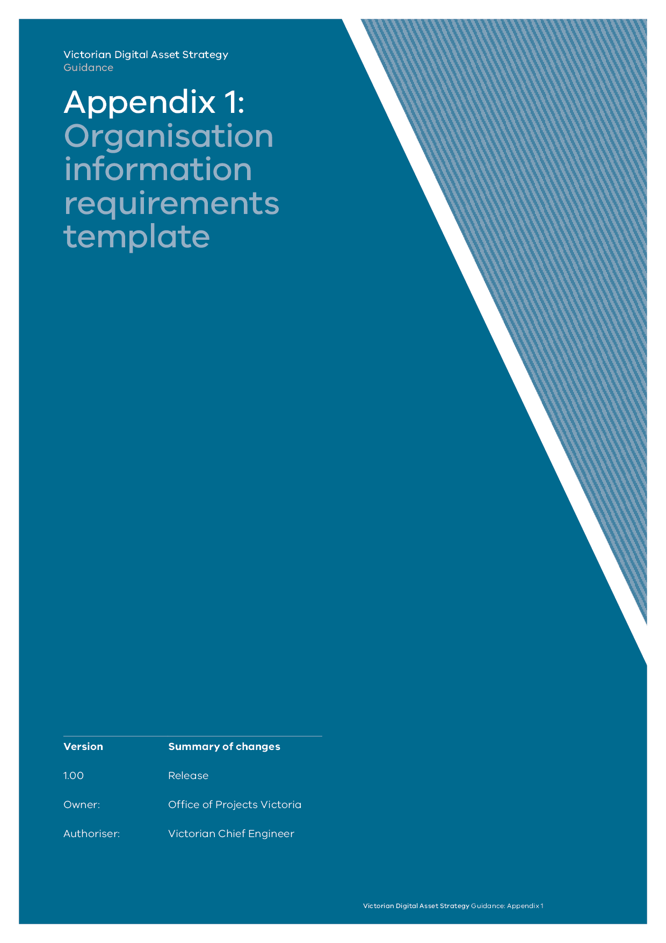

Introduction 1

Purpose 1

Background 1

Audience 4

Organisational information requirements 5

Section 1: Organisational information 5

Section 2: Organisational stakeholders 7

Section 3: Functional groups information map 10

Section 4: Functional groups integration map 12

Section 5: Integration map review 13



# Introduction

Organisations rely on information and data to make decisions. Without access to good information and data, decisions cannot be made in an effective and timely fashion. Ineffective and untimely organisational decisions erode the effectiveness of the organisation and their purpose. Better decision making starts at the top of any organisation.

ISO 19650 establishes a process for the organisation to understand how information flows in, through, and out of the organisation to improve decision making, quality of information, stakeholder engagement and user experience. This process starts with defining an organisation information requirements (OIR).

In turn, this makes the organisation more efficient and effective in converting data and information into an output – decision, report, contract award, etc.

This benefits asset users, stakeholders within the organisation and the wider public.

## Purpose

This document will help you establish a process to define and map your OIR.

An OIR allows departments and stakeholders to collaborate and understand where and how information is generated and who is it shared with. It also aids in decision making and reporting.

The OIR is a high-level tool that integrates information across the organisation.

The detailed information requirements for an asset form the asset information requirements (AIR).

The exchange information requirements (EIR) are detailed information requirements to exchange information between the Appointing Party and the delivery team.

This document is not intended to provide guidance on the digital engineering or the Victorian Digital Asset Strategy (VDAS) process. Further guidance can be found on the OPV website ([www.opv.vic.gov.au](http://www.opv.vic.gov.au))

## Background

The OIR is established within the ISO 19650 series. It is the first of three major documents (OIR, AIR, EIR) – all supported by the VDAS.

The OIR provides a synopsis of how information and data are generated, consumed and used within the organisation.

The OIR is a live document. It should be part of ongoing discussions about how the organisation can improve information and data generation, consumption and usage – termed information flow.

This set of requirements will feed into the asset information requirements (AIR) document. Appendix 1 contains an AIR template.

Information flow can be simplified into three linear components:

1. **Information and data inputs:** material, facts, news, intelligence, knowledge, raw data that forms the basis of processing and synthesis. These inputs can be sourced externally or internally to the organisation. They may also be new but could also be historical. These inputs form the basis for information processing and synthesis.
2. **Information processing and synthesis:** The processes and approach to federate, refine and present information and data in a meaningful way. This component will include consolidation, review, analysis, assessment and deliberation. It is likely to involve more than one stakeholder and is achieved through sharing, meetings and discussion. The output of processing and synthesis component is information outputs.
3. **Information outputs:** The outcomes and yield of the information processing and synthesis. These include reports, decisions, choices, conclusions and deliverables.

For a project team within an organisation, information flow may look like the following:



Organisations typically have more groups and stakeholders than just project delivery teams, and usually have more than one project.

Thus, this exercise can be repeated for each business unit, group, or section within an organisation to form a whole view of the organisation.

Examples include legal, procurement, executive leadership team, the board, the public, asset users, head contractors, project teams, maintenance, corporate risk, marketing and communications.

As part of the OIR template, organisations now have a best practice approach to establish these groups in a meaningful way and map information flow between the entities, as seen below.



Understanding how information originates, flows and then provides the basis for decisions within the organisation can give an indication of an organisation’s efficiency.

This OIR template will assist organisations in understanding these three components and moving towards digital asset information management best practice in line with the VDAS and ISO19650.

## Audience

The audience for this document is:

* executive management;
* asset owners: Victorian government departments, Victorian government agencies, or those representing their best interests;
* client-side asset management professionals, including those responsible for asset-level decisions;
* client-side project delivery professionals, such as engineers, constructors, commissioners; and
* client-side technology, finance and customer-focused departments.

### Conditions of using the template

Each project, asset, department or organisation is different, with every project acting as response to a unique organisational need.

As a result, no single template will be equally applicable in all these circumstances.

It remains the responsibility of the document author to interpret and validate what the project, asset, department and organisation is seeking to achieve, and to compose a document that responds to that organisational need accordingly. This template is a tool that can assist with that process.

The document should be read in conjunction with other VDAS documents addressing the digital engineering process.

**How to use this template:**

This template has instructional text directed at the Appointing Party. It is the obligation of the Appointing Party to fill this out and apply it in the context of the project, the AIR and the OIR.

# Organisational information requirements

## 

## Section 1: Organisational information

This section should be updated to reflect the characteristics of the organisation. Additional information can be added as needed.

|  |  |
| --- | --- |
| Organisation details | |
| Name |  |
| Location(s) (lat/long) | Head Office and Operations  <Lat> -37.8142  <Long> 144.9632  Maintenance facility  <Lat>  <Long> |

|  |  |
| --- | --- |
| Contact details | |
| VDAS Champion | <Name> <Phone> <Email> |
| Chief Information Officer | <Name> <Phone> <Email> |

|  |  |
| --- | --- |
| Date of assessment | DD/MM/YYY |
| Date of issue | DD/MM/YYY |
| Comments | <Additional comments> |

|  |  |
| --- | --- |
| Organisational  VDAS vision | Provide a brief summary of the organisation’s vision for VDAS and digital engineering. Note: an organisational vision is a clear and concise picture of the organisation at a point in the future. It is designed to create a collective sense of direction – something that individuals within and outside the organisation can align with and work toward.  This is to be defined and communicated by executive management.  For example:  The organisational vision for VDAS is underpinned by the development and continuous improvement of processes and technology solutions that enable us to guide and structure our most important decisions and activities. These are based on sound intelligence and having consistent, reliable and repeatable data to help us future proof our assets.  The use of digital engineering (CAD, BIM, GIS) goes beyond the construction planning and design stages by supporting lifecycle costing, project management and finally the management of our assets. Capturing usable data at each stage in this process is paramount for us to develop repeatable approaches, improving with each iteration. Having a standard and consistent approach to how we build, procure and manage our future assets, whether new construction projects or the maintenance of existing buildings, will save us time and money and provide clarity and transparency over performance and forward planning activities.  This is not a standalone effort. We will continue to work with industry, other government departments and the wider public sector to develop a common language for property data to enable our organisation and the Victoria Government to become a more intelligent client. |
| Organisational purpose | Provide a brief summary of the organisation’s purpose. The organisational purpose is the essence of why the organisation exists.  The purpose should articulate why this organisation stands out and differentiates itself from its competitors. Why does this organisation exist as compared to the function being served by another organisation. |
| Information management policy | Reference the organisation’s information management strategy. |

## Section 2: Organisational stakeholders

### Internal organisational groups

Amend the below table to articulate all the internal groups within the organisation. This list should be exhaustive. A good place to start is with the organisational chart. The owner of this document should work with each of the entities below and articulate what the organisation’s purpose is.

| Internal organisational group | Group purpose | FTE | Accountable to |
| --- | --- | --- | --- |
| Board | <Purpose > | < > | Shareholders or public |
| Office of the CEO/ Secretary | <Purpose > | < > | Board or minister |
| Legal – corporate | <Purpose > | < > | < > |
| Legal – projects | <Purpose > | < > | < > |
| Marketing and communications – internal | <Purpose > | < > | < > |
| Marketing and communications – external | <Purpose > | < > | < > |
| Engineering – civil, structural and mechanical | <Purpose > | < > | < > |
| Engineering – E&I | <Purpose > | < > | < > |
| Engineering – environmental | <Purpose > | < > | < > |
| Engineering – civils | <Purpose > | < > | < > |
| Procurement | <Purpose > | < > | < > |
| Project Zebra | <Purpose > | < > | < > |
| Project Tango | <Purpose > | < > | < > |
| Maintenance | <Purpose > | < > | < > |
| Operations – South East | <Purpose > | < > | < > |
| Operations –North West | <Purpose > | < > | < > |
| Etc. | <Purpose > | < > | < > |

### External groups

Amend the below table to articulate all the external groups within the organisation. This list should be exhaustive.

A good place to start collecting this information is:

* work with each of the entities below and gain a better understanding of where their information and decisions go, i.e. if the Finance department makes quarterly cashflow updates to Treasury, then include Treasury as an external organisation;
* include regulatory institutions; and
* don’t forget general public, asset users and stakeholder groups (employees, contractors) of each asset.

| External organisational group | Relationship to internal organisation | Size (S/M/L) |
| --- | --- | --- |
| Public | <Relationship > | < > |
| Worksafe | <Relationship > | < > |
| ASIC | <Relationship > | < > |
| ATO | <Relationship > | < > |
| Asset 1 stakeholders | <Relationship > | < > |
| Asset 2 stakeholders | <Relationship > | < > |
| Visitors | <Relationship > | < > |
| Emergency personnel | <Relationship > | < > |
| Head contractor – (Project A) | <Relationship > | < > |
| Head contractor – (Project B) | <Relationship > | < > |
| Head contractor – (Project C) | <Relationship > | < > |
| Facilities management – Location A – Asset A | <Relationship > | < > |
| Building security contractor | <Relationship > | < > |
| Hosting and IT contractor | <Relationship > | < > |
| Etc. | <Relationship > | < > |

## Section 3: Functional groups information map

This section is to articulate the information flow within each functional group internal to the organisation.

The owner of this document must work with the leader of each of the organisation’s internal functional groups (identified in Section 2) to work out the:

1. information and data inputs: material, facts, news, intelligence, knowledge, raw data that forms the basis of processing and synthesis. These inputs can be sourced externally or internally to the organisation. They may also be new but could also be historical. These inputs form the basis for information processing and synthesis;
2. information processing and synthesis: the processes and approach to federate, refine and present information and data in a meaningful way. This component will include consolidation, review, analysis, assessment and deliberation. It is likely to involve more than one stakeholder and be achieved through sharing, meetings and discussion. The output of processing and synthesis component is information outputs; and
3. information outputs: the outcomes and yield of the information processing and synthesis. These include reports, decisions, choices, conclusions, approvals and deliverables.  
   This section is to be broken down into as many subsections as required by the complexity of the organisation.

An example is provided below for the Executive Leadership Team or Office of the CEO. A new subheading for each internal group should be created.

### Executive Leadership Team (example)

This section is intended to be an example for the ELT of the organisation. This should be modified as needed. This exercise should be conducted through face to face interviews.

| Information outputs | Description | Process for output | Inputs | Intended audience | Frequency | Format/ delivery |
| --- | --- | --- | --- | --- | --- | --- |
| Board reports | <i.e. Board reports covering a range of matters, project updates, investment strategies, performance data, risk and regulatory reporting, HR and people matters, etc. > | <i.e. Collation of inputs from each area lead, triage of issues from each area, formatting> | <Unformatted and just-in-time risk, project updates, asset data, HR data> | <i.e. 10 members of the Advisory Board > | <i.e. quarterly> | <i.e. PDF via email> |
| Authority to proceed | <i.e. Project review and endorsement > | <i.e. Collection of project investment data, review of project information, RFI with project director, creation of AtP memo, collation of AtP in a spreadsheet for Invesco/Treasury. > | <Project Plans, memos, risk registers, project reports> | <i.e. Invesco or Treasury > | <Quarterly for Invesco> | <Letter of support to Invesco> |
| Briefs to Government | <i.e. Briefs and memos from the department on to the minister> | <i.e. Collection of daily briefs/memos, triage process, review, RFI and endorsement/ clarification | < Briefs and memos from various sections of the department> | <Minister> | <As needed> | <i.e. paper via email > |
| Letters to departments and agencies | <i.e. Letters of support, acknowledgement, referral and response back to other departments and agencies, users, employees, and the public> | <i.e. Collection of letter templates, review, and endorsement for distribution> | <Requests for information from various sections of the department> | <Others as needed, incl. departments and agencies, users, employees, and the public> | <As needed> | <i.e. paper via email and via post> |
| Advice to Government | <i.e. Daily meetings and correspondence with the minister on pertinent matters> | <i.e. Collection of issues, briefs, upcoming events, review, and endorsement for distribution> | < Briefs and memos from various sections of the department> | <Minister> | <As needed> | <i.e. meetings and via email> |
| Etc. | < > | < > | < > | < > | < > | < > |

## Section 4: Functional groups integration map

This section articulates how the previous sections will work together. For example, when a subgroup within the organisation hands information to another group within the organisation, this needs to be linked in the integration map.

Below are two examples (Board and the Office of the Chief Executive) linked together.

The OIR document owner needs to seek clarification from team members if linkage is not clear.

### Office of the Chief Executive and the Board (example)

This section is intended to be an example for the Office of the Chief Executive of the organisation in concert with the Board.

This is provided as an example, and should be repeated for all functional groups within the organisation as needed. This exercise should be conducted through face to face interviews.

The example below is not intended to be exhaustive.



## Section 5: Integration map review

This section is to articulate where the opportunities for the organisation are to improve information flow using the VDAS.

### Geotech conditions project escalation (example)

#### Current case



Owner

Head contractor

Subcontractor

2 weeks

2 weeks

1 week

1 week

#### Opportunity

**Time: Four weeks**

* The geotech lead determines site conditions are outside the current assumptions for the site.
* The geotech lead immediately notifies the head contractor project manager and owner project manager about the issue.
* The geotech lead proposes a high-level action plan and next steps.
* The head contractor project manager and owner project manager escalate as needed.

