Offsite Construction Guide

Delivering Victorian projects with modern methods of construction

The Secretary

Department of Treasury and Finance

1 Treasury Place

Melbourne Victoria 3002

Australia

Telephone: +61 3 9651 5111

Facsimile: +61 3 9651 2062

dtf.vic.gov.au

Authorised by the Victorian Government

1 Treasury Place, Melbourne, 3002

© State of Victoria 2022

[](http://creativecommons.org/licenses/by/3.0/au/)

You are free to re‑use this work under a [Creative Commons Attribution 4.0 licence](http://creativecommons.org/licenses/by/4.0/), provided you credit the State of Victoria (Department of Treasury and Finance) as author, indicate if changes were made and comply with the other licence terms. The licence does not apply to any branding, including Government logos.

Copyright queries may be directed to [IPpolicy@dtf.vic.gov.au](mailto:IPpolicy@dtf.vic.gov.au)

**Image credits:** ARKit, ATCO, CSBA, Harwyn, KLMS, Modscape, Samaritan House (Deakin University) and FormFlow, Sensum, LXRP, VHBA, Westkon Precast

Published June 2022

If you would like to receive this publication in an accessible format, please email [information@dtf.vic.gov.au](mailto:information@dtf.vic.gov.au)

This document is also available in Word and PDF format at [opv.vic.gov.au](http://www.opv.vic.gov.au)

Contents

Message from the Treasurer 1

Victorian Chief Engineer’s Foreword 1

Executive summary 2

Introduction 3

This section is an overview of this document, its purpose and the methodologies, key components and potential benefits of offsite construction. 3

Purpose of this document 4

How to use this guide 7

What is Offsite Construction 8

Project initiation 16

This section explores the drivers for Offsite Construction (OSC) on projects. 16

The content in this section introduces the OSC Evaluation Tool that provides a practical workflow of the considerations that influence the adoption of OSC on your project and a recommended application*.* 16

Critical success factors 17

Offsite Construction evaluation 19

Government construction procurement principles and procedures 28

Project management and delivery 29

This section explores the detailed OSC considerations for project management and the design, manufacturing, and construction (or assembly) stages of the delivery phase. 29

This section dives deeper to help explain important themes of function, quality, commercial, program, resources and sustainability to help navigate and mitigate the common pitfalls in offsite construction and get the best outcome for your project. 29

Project management 31

Design management 40

Manufacture management 50

Construction management 59

Acknowledgements 69

References 70

Glossary 72

Acronyms 74

# Message from the Treasurer

Offsite Construction will play a large part in delivering Victoria’s record infrastructure investment. The *Offsite Construction Guide* seeks to ensure Victorian Government staff continue as leaders in delivering projects using modern methods of construction.

Increasing the uptake of Offsite Construction on Victorian Government projects will drive investment in prefabrication and modularisation technologies, cementing the state’s reputation as a leader in manufacturing.

Victoria will see benefits by reducing disruption to students for school builds, providing quicker disaster response accommodation, building better social housing and improving productivity in our materials supply chain to ease pressure on the construction sector.

**Tim Pallas MP** Treasurer



# 

# Victorian Chief Engineer’s Foreword

How we plan, design and construct our built environment and infrastructure today has a profound impact on the Victoria of tomorrow.

The evidence is clear: rationalisation, standardisation, modularisation and offsite construction can drive better results with quicker, safer, higher quality and more cost‑efficient projects.

The *Offsite Construction Guide* has been developed to facilitate the uptake of more efficient and modern methods of construction in Victorian major infrastructure projects.

Adoption of these methods means better quality assets and services for Victorians. It will also support a growing industry for Victoria that can benefit Victorians through local investment and export opportunities.

I’m excited about what this will mean for our state’s future.

**Luke Belfield** Victorian Chief Engineer



# 

# Executive summary

Victoria has a rich history of using Offsite Construction (OSC) to deliver construction outcomes, from entire cottage houses being shipped in crates from England and the United States to solve chronic housing shortages in the gold rush of the 1850s to the rapid deployment of social housing necessary during the COVID-19 pandemic.

This guide captures many of the lessons from Victorian government projects to distil them into a practical resource for government project teams. It provides advice on how to plan, procure and design a wide variety of infrastructure assets on behalf of the people of Victoria.

Encouraging the uptake of OSC on Victorian projects and ensuring its continued successful delivery will unlock benefits such as higher construction productivity, lower lifecycle costs, reduced environmental impacts and improved build quality.

This guide doesn’t seek to advocate for wholesale adoption of OSC as a panacea for construction challenges but encourages the philosophy that OSC is one project management tool that may be used alongside many others.

This guide aims to help users make appropriate decisions regarding the use of OSC practices and deploy solutions that add value and avoid those that put their project at risk.

For those new to delivering projects using OSC, this guide steers Project Managers through each stage of the DTF Investment Lifecycle, setting a consistent approach to project delivery.

It includes a practical tool to assist decision making at the project initiation and contains case studies that highlight how OSC has delivered benefits for projects.

Government and industry experts have contributed their input to ensure the guide provides advice consistent with current best practice. Departments and agencies are encouraged to use the guide to steer and set requirements that reflect their portfolios and project types.

OPV’s Digital Build Program will continue to provide centralised department and agency support for the implementation of this guide. This includes providing training and guidance material on Digital Build approaches and technical advice support where requested.

Refer to **www.opv.vic.gov.au** for further information.

# Introduction

**This section is an overview of this document, its purpose and the methodologies, key components and potential benefits of offsite construction.**

Victoria invests extensively in the world‑class infrastructure and services needed to drive economic growth and secure the state's future prosperity. The Victorian Government seeks to increase productivity and improve sustainability outcomes in infrastructure projects through advanced manufacturing and modern construction methods. Offsite Construction (OSC) makes delivering infrastructure projects more practical, timely and cost‑efficient, ensuring higher long‑term asset performance.

The OSC industry is growing significantly nationally and internationally, driven by economic, environmental, social, safety and technological factors. Victoria is the OSC leader in Australia, housing more than 50 per cent of Australia’s OSC companies.

The Victorian Government seeks to help the construction sector innovate, grow, and capitalise on its capabilities by leveraging the state's high‑quality offerings in research, education, supply chain and project delivery.

Victorian construction companies, manufacturers and supply chain businesses are Australian leaders in creating, making and adopting OSC buildings and infrastructure.

|  |  |  |  |
| --- | --- | --- | --- |
|  | 5%  of homes were prefabricated in Victoria in 2016  (Australian Research Council Centre for Advanced Manufacturing of Prefabrication, 2018) |  | >50%  of prefabrication companies are based in Victoria  (prefabAUS, 2015) |
|  | >40%  decrease in waste compared to in situ building  (Australian Research Council Centre for Advanced Manufacturing of Prefabrication) |  | $6.5 billion  contribution of the manufactured modular housing sector to the Australian construction industry  (Built Offsite prefabAUS, 2015) |

Offsite Construction in Victoria and Australia

Purpose of this document

This guide seeks to help **project teams** extract value for their projects from OSC to:

* assess a suitable level of application of OSC
* develop scope and defined design parameters up‑front
* deploy a management approach that tackles the specific requirements of integrating offsite with traditional construction methods.

### Objectives

As part of Digital Build Program, the Office of Projects Victoria (OPV) has developed this guide to accomplish the following objectives:

|  |  |
| --- | --- |
| Objective | Description |
| **Improve understanding** | Increase the understanding of the concepts and requirements of offsite construction. |
| **Enhance project delivery** | Drive efficiency and predictability in project outcomes. |
| **Highlight value and benefits** | Detail the benefits available from offsite construction practices and how to realise their value within a project. |
| **Provide practical guidance** | Provide guidance on risks and challenges of offsite and the practical instruction to mitigate and manage for a successful outcome. |

### Intended audience

This guide should be used by **departments and agencies** seeking to plan, design and procure Victorian Government building, road, rail and other infrastructure assets.

Users of this guide

|  |  |  |
| --- | --- | --- |
| User/function | Your responsibility | Use this guide to |
| **Delivery agency**  (Project Directors/ Managers) | * directing a project through its development and delivery. * leading project governance activities. * delivering within the approved budget, time, and scope constraints. | * identify better practices for project delivery via offsite construction. * identify fit‑for‑purpose offsite construction methods to be applied to the project, including using the tool provided. * manage stakeholder expectations regarding application of offsite construction. |
| **Project Team** | * delivering project activities throughout its development and delivery. * delivering within the approved budget, time, and scope constraints. * developing and implementing processes for management of OSC. | * identify better practices for OSC. * proposing the applicability and potential options for the use of OSC, including using the tool provided. |
| **Business case writer or advisor** | * developing a business case for investments. | * ensure that investment proposals include a sound assessment of OSC opportunities. * identify opportunities for project benefit early. |
| **Asset owner or end user** | * ongoing accountability for the asset and responsibility for monitoring or managing projects. | * improved asset management, including consideration of more sustainable outcomes. |

### Other reference documents

This guide should be read alongside existing government standards, policies, frameworks and strategies.

Departments and agencies should use this guide to support OSC-specific guidelines and requirements that reflect the needs of their portfolios and project types.

When considering the inclusion of OSC on a project, it would help to revisit the following:

* DTF’s [Investment Lifecycle Guidelines](https://www.dtf.vic.gov.au/infrastructure-investment/investment-lifecycle-and-high-value-and-high-risk-guidelines) (ILG), to help shape proposals, inform investment decisions, monitor project delivery and track the benefits across three phases of the project: investment lifecycle, business case, and procurement and delivery.
* The [High Value High Risk](https://www.dtf.vic.gov.au/infrastructure-investment/investment-lifecycle-and-high-value-and-high-risk-guidelines) (HVHR) guidelines, which provide additional scrutiny, assurance checks and processes for HVHR projects.
* The [Public Construction Procurement framework](https://www.dtf.vic.gov.au/infrastructure-investment/public-construction-policy-and-resources), which provides mandatory requirements for key procurement stages.
* [The Risk, Time, Cost and Contingency](https://www.dtf.vic.gov.au/sites/default/files/document/Risk%2C%20Time%2C%20Cost%20and%20Contingency%20Guidelines.docx) (RTCC) technical guide for the identification, quantification and management of RTCC, with a particular focus on improving practice across HVHR projects.
* The [Sustainable Investment Guidelines](https://www.dtf.vic.gov.au/sites/default/files/document/Sustainable%20Investment%20Guidelines.docx) (SIG), which aim to incorporate sustainability into investment considerations. Of particular relevance to OSC projects is the explicit consideration given to the environmental and social impact metrics of projects.
* The [Project Development and Due Diligence (PDDD)](https://www.dtf.vic.gov.au/sites/default/files/document/Project%20Development%20and%20Due%20Diligence%20Guidelines.DOCX) guidelines, to guide early project activities to elicit information that can be used to make crucial or influential decisions before committing to a project's scope, cost and program.
* The [Digital Asset Policy](http://www.opv.vic.gov.au/Digital-Build/Digital-Asset-Policy) provides digital asset information management requirements to support Victorian Government projects and asset planning, design, construction, and operation.
* The Victorian Government [Circular Economy Plan](https://www.vic.gov.au/victorias-plan-circular-economy) for a cleaner, greener Victoria with less waste and pollution, more jobs and a sustainable and thriving circular economy.

How to use this guide

The OSC Guide is aligned with the DTF Investment Lifecycle stages and is structured into two sections:

Offsite Construction Guide overview

|  |  |  |
| --- | --- | --- |
| OSC Guide section | DTF Investment Lifecycle stage | Overview |
| **Project initiation** | **Business case** | Provides guidance on how OSC can be implemented across the DTF Investment Lifecycle.  This section also provides details on the evaluation tool to help project teams assess the suitability of OSC for their project. |
| **Project management and delivery** | **Delivery** | Provides guidance to the project team helping to take an integrated view of project management, design, OSC component manufacturing and construction both on and offsite. |

While this guide’s intended audience is Victorian Government project teams, it is equally applicable to stakeholders in the architecture, engineering, construction, and operations (AECO) industry. This guide is not exhaustive, and therefore should be used with consideration of the unique requirements of each project team.

What is Offsite Construction

## 

## About this section

Provides an overview of this document, its purpose and the methodologies, key components and potential benefits of offsite construction

## Who this section is for

This section provides context and insights for those planning and delivering government assets.

Overview

**OSC is the planning, design, manufacture, fabrication and assembly of building elements in environments that are not located on the final construction site.**

OSC is used to improve efficiency or address a specific project need, such as a requirement to be rapid, remote or repeatable. Traditional construction refers to the onsite construction of buildings, with single‑type materials, and delivered in­­ a linear, step‑by‑step process of trade‑based activities.

The OSC industry combines both conventional construction and manufacturing systems and techniques to produce either part or fully assembled buildings or assets offsite.

It comprises those companies, organisations, government agencies, research institutions, suppliers, consultants and individuals that have skills in systems and techniques in this method of project delivery as a complimentary technique to conventional in situ construction systems.

OSC is not the convergence of two of Victoria’s great industries of construction and manufacturing, but rather keeps their wonderful capabilities, efficiencies and delivery power separate and distinct.

This guide gives project teams the knowledge to decide when to use each industry in support of delivering Victoria’s infrastructure.

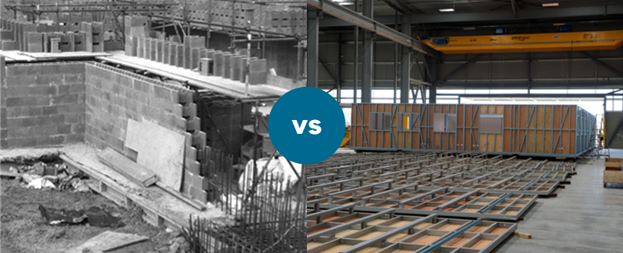

Traditional construction vs offsite manufacture [Photo thanks to *ATCO*]

There are four general application types of OSC, presented in order of increasing complexity and offsite use:

1. **Components and subassemblies**, such as electrical fittings, window frames and doors, are manufactured offsite and designed to be incorporated onsite. These range from simple structural components through to fully serviced and finished subassemblies.
2. **Non‑volumetric,** includes open and closed planar or panelised systems, precast concrete sections (posts, beams, slabs and columns) and structural steelwork trusses. It is described as non‑volumetric as it creates no usable space by itself. Standardised non‑volumetric preassemblies can be used as a kit of parts (*refer to Section 4*).
3. **Volumetric** creates usable space and is installed within or onto an independent structural frame e.g. bathroom pods or utilities cupboards. As with non‑volumetric types, standardised volumetric preassemblies can be used as a kit of parts.
4. **Modular** are volumetric components preassembled offsite to form the structure, fabric or enclosed useable space. Modular units typically require multiple trades such as plumbers and electricians to pre‑fit, for example, ducting and electrical cable trays. Modular units such as houses, offices or classrooms can be constructed and fully finished offsite.

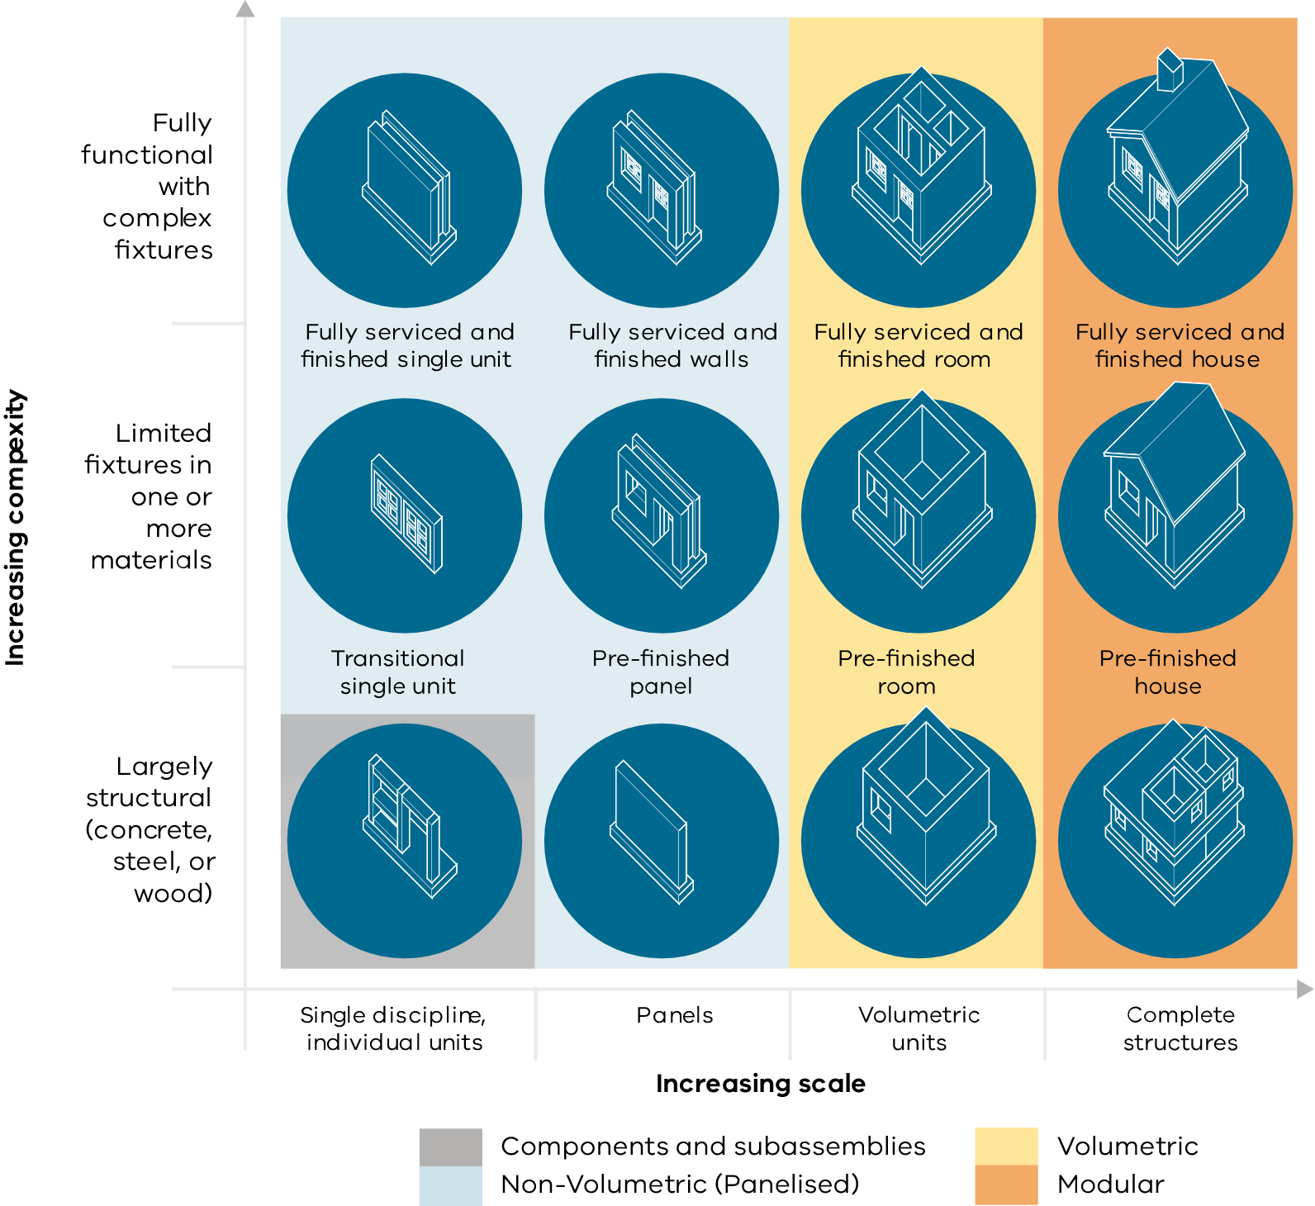

Complexity and scale of modular construction [modified from McKinsey, 2019]

A project team may use none, one or any combination of OSC types listed above and it can be helpful to define functional areas and assign OSC types when considering a project. Refer to the school building project example below.

Construction types assigned to sample project (school build)

|  |  |  |
| --- | --- | --- |
| Function | Functional area | OSC type |
| Education | Classroom | Modular |
| Library | Modular |
| Multi‑purpose | Modular |
| Administration | Offices | Modular |
| First aid and counselling | Modular |
| Facilities | HVAC | Modular |
| Toilets | Volumetric sub‑assembly |
| Gymnasium | Non‑volumetric prefab |
| Grounds | Carpark | Traditional |
| Grounds and landscaping | Traditional |

Visual representation of construction types in a school build

Benefits of Offsite Construction

Using OSC can deliver direct benefits to the project, the department or agency, and the local community.

Offsite Construction benefits

|  |  |
| --- | --- |
| Benefit | Description |
| Offsite Construction can **reduce** | |
| **Time (schedule)** | Quicker and more predictable speed of supply, delivery and installation.  Construction activities progress concurrently onsite and with production at a factory offsite and suffer fewer disruptions in enclosed and controlled factory environments due to inclement weather.  Crossrail delivered two major London underground stations, Tottenham Court Road (TCR) and Liverpool Street (LS), with nearly identical scope. They performed an experiment by constructing TCR using in situ methods and LS using OSC. The experiment showed that **using** **OSC methods produced an 11‑week saving in the construction period** - TCR 41 weeks vs. LS 30 weeks. (Crossrail 2021) |
| **Disruption** | Disruption to services such as hospitals, schools and rail corridors can be reduced with fully or partially complete items ‘dropped in’ to shorten times compared to traditional building.  The Level Crossing Removals Project prefabricated station buildings offsite on the Mooroolbark and Lilydale lines that allowed construction of the rail bridges and stations to occur simultaneously **cutting disruption** by speeding up build time **from three months down to just two weeks** (LXRP 2021). |
| **Environmental impacts** | Materials use and movements are optimised in a factory setting with assembly line robotics and other automated tools that are not viable for traditional construction.  The UK Government’s *Building to net zero: costing carbon in construction* study found **modular construction can emit 45 per cent less carbon than onsite construction** (UK Parliament 2022)**.** |
| **Logistic, travel and labour congestion** | Logistics, travel and labour congestion is reduced with fewer small deliveries and fewer trades travelling and parking around sites.  A UK study found a **60 per cent reduction in vehicle movements to sites** with higher offsite construction adoption (B&ES 2015). |

Offsite Construction Benefits (cont.)

|  |  |
| --- | --- |
| Benefit | Description |
| Offsite Construction can **increase** | |
| **Quality** | Quality is improved by standard manufacturing practices achieved through repetition, standardisation, enhanced inspection and feedback loops in a controlled and ongoing operating environment that can significantly reduce rework.  Japanese volumetric modular apartment providers offer owners **a standard 20‑year warranty**,which includes after sales service provisions, such is their quality of produce and ease of replacement of parts (Smith and Rupnik 2018). |
| **Health and safety** | Health and safety improve with some or all activities moving to a manufacturing environment.  Work performed in a manufacturing environment is conducted in a controlled, semi-static environment with improved access, tools and working spaces, minimising work at live building edges, heights and exposure to UV light, cement, contaminated materials and soil.  In Victoria, Worksafe has recorded **41 construction work related fatalities** **versus 24 in manufacturing** from 2018 to 2021 [<https://www.worksafe.vic.gov.au/resources/workplace-fatalities>] |
| **Productivity and efficiency** | Productivity and efficiency are improved with a focus on automation, lean processes, and improved supply chain and logistics management, as well as leveraging economies of scale through standardisation and repeatability. |
| **Diversity** | Increasing the proportion of factory‑based work in construction would make the construction workforce more diverse.  The national participation of **women in manufacturing is 29 per cent and increasing versus construction at 12 per cent and declining** (<https://www.wgea.gov.au/publications/> gender-segregation-in-australias-workforce#gender-seg-industry) |
| **Regional development** | Offsite can address localised skills shortages by decentralising the work from the construction site to any location in Victoria. It also permits rapid temporary deployment of resources for emergency relief (e.g. bushfire) or temporary economic need (e.g. agricultural labour support).  It also enables investment in a single location for manufacturing that can build on established competitive strengths (e.g. cheap electricity, lower labour rates) or reduce location‑based disadvantage (e.g. high rainfall and wind area, poor vehicle access).  The Victorian Government **Short-Term Modular Housing program delivered 70 temporary housing solutions to those who had lost their homes in the 2019‑20 bushfires** from production facilities around Victoria, overcoming a trade shortage in the area. |

Considerations

Unlike traditional construction, OSC allows elements to be manufactured and assembled parallel to onsite activities.

OSC increases the need for quality and stakeholder management and communication of interfaces.

As it combines manufacturing, engineering, and construction components, managing OSC requires additional skills and knowledge in manufacturing technologies, alongside traditional project management aspects.

The below table presents some common considerations to be made when adopting OSC.

OSC considerations

|  |  |
| --- | --- |
| Limitation | Description |
| **Up‑front investment required** | Developing workforce and production processes and establishing manufacturing facilities require up-front investment. |
| **Immature commercial models** | Contracting models, valuation and insurance assessment methods favour traditional construction. |
| **Logistics** | Logistics and access challenges, including ground loading, craning clearances, swept path areas and existing services, require special management. Larger projects may require module transportation studies to determine limitations on the size of modules. |
| **Stakeholders** | Stakeholder resistance and conservatism can be a barrier to OSC adoption. Profit‑driven traditional developers may be reluctant to adopt low‑margin upstream OSC components. The advisor community, including technical, commercial and legal, may resist standardised methods that may erode net fees. |
| **Supply chain** | Work is required to integrate the supply chain and add new stakeholders such as manufacturers and transporters. |
| **Program** | OSC components (especially interfaces) require design decisions to be finalised earlier in the project lifecycle, while site delivery times need to be coordinated to optimise laydown area use. |
| **Design** | OSC design should consider limitations to size and shape, including during manufacture, transport and installation. As design changes during construction are costly, designs (especially interfaces) need to be finalised early.  Some proprietary product owners may be reluctant to modify designs. |
| **Interface management** | Increased complexity with multiple construction types and component integration requires careful management of interfaces. |

Project lifecycle

This guide is designed to align with DTF’s Investment Lifecycle, helping to:

* minimise commonly occurring issues across the project lifecycle, such as:
* poor scope development and inappropriate business case budget allocation
* incomplete and/or changing design
* ill‑suited commercial arrangements.
* address logistical, site and interface difficulties. The guide highlights critical considerations during the project lifecycle with a particular focus on OSC use
* identify opportunities and risks earlier in the project lifecycle to develop appropriate mitigation or management strategies
* increase design and construction quality and appropriateness to support long‑term positive legacy.

There are different considerations for OSC across the project lifecycle. For example, during business case development, the project team must have a clear understanding of the type and extent of OSC being considered for inclusion on the project.

OSC requires greater certainty in the initial design stages, as early integration of project teams, data and designs will unlock maximum benefit.

**Late commitment or attempts to implement OSC on inflight projects are principal factors of implementation failure.**

Considering OSC types across the project lifecycle

Project initiation

## About this section

This section explores the drivers for Offsite Construction (OSC) on projects.

It includes the overall case for adoption, factors to drive project success and limitations that could affect implementation if not addressed.

The content in this section introduces the **OSC Evaluation Tool** that provides a practical workflow of the considerations that influence the adoption of OSC on your project and a recommended application*.*

## Who this section is for?

This section provides detailed guidance and advice to project and portfolio managers involved in business case or early project development stages decision-making.

Critical success factors

Certain factors can lead to breakthrough results in the implementation of OSC. The below table details areas of focused effort by project teams that led to successful OSC application.

Critical success factors

|  |
| --- |
| Critical success factors |
| **Project team integration and management**  Traditional construction has a defined sequence separating design and construction, allowing clean handover and arm’s length relationships. OSC can require the early engagement of stakeholders e.g. construction and operations input at design, greater collaboration, more frequent communication and enhanced information sharing among project participants.  Teams should seek:   * project team integration * fit‑for‑purpose design and project management tools, particularly Design for Manufacture and Assembly (DfMA) and Building Information Modelling (BIM) or digital engineering * work processes that manage change and progressive decision-making. |
| **Early design decision-making**  As OSC typically has parallel manufacturing and construction activities, the project should prioritise completion of design to lock in the design of interfaces early in the project lifecycle and have a robust design review process between the on-site and off-site work.  This focus may involve early involvement or representation from the contractor through procurement models such as Early Contractor Involvement (ECI) but does not imply that the supplier will be the construction contractor.  OSC requires optimised designs for standardisation, repeatable manufacture and ease of assembly. DfMA principles ensure early consideration of manufacturability and constructability where changes are less costly. |
| **Focus on value, not cost**  Over an asset’s full lifespan, OSC can help improve durability, maintainability, energy efficiency and ease of redevelopment, decommissioning or reuse and reduce the overall cost.  When delivering projects, individual sections of work with repeatable elements, tight interfaces or where project duration is a driver of cost, prefabricated elements can drive down cost on individual sections of work.  The project team should evaluate whole-of-life costs, individual section costs, and consider benefits detailed in Section 4.2 to determine overall value for money. |
| **Planning and scheduling**  OSC requires greater upfront organisation and planning from the project owner compared with traditional construction. Early activity planning and decision-making for OSC is essential in an owner’s program. If the project owner is hesitant or the architect or designer does not initially consider OSC, inclusion at a later stage will be increasingly difficult.  Teams should seek to:   * identify key decision points in the project program * engage with manufacturing industry to identify bespoke and off-the-shelf lead times for products. |
| **Interface management**  OSC requires predictable interfaces at multiple levels, from good fit at assembly to integration of OSC components with existing assets. Onsite difficulties arise from poor consideration of design integration. Teams should seek to:   * identify interfaces and commercial and technical integration requirements at various levels and manage change * consider design features that allow for combined as-built tolerances * make use of modern surveying tools e.g. use LiDAR surveying tools to scan the site prior to installation * use physical interface tools such as templates to do things such as ensure bolts are in the right position to ensure a good fit * have clear interface points between contractors and commercial conditions that manage risk of one party delaying others. |
| **Stakeholder needs and quality requirements**  Post‑manufacture alterations of OSC components can be challenging and costly. Prototype testing allows a trial of OSC component manufacture and assembly and an understanding of post‑construction performance, including energy efficiency, air infiltration and water penetration. Prototypes are especially useful for stakeholders that have difficulty engaging with drawings or visual representations.  Conduct design reviews with relevant parties and use models and prototype tests to:   * identify equipment required for installation * coordinate OSC component delivery and trade installation schedule * enable stakeholders to understand build quality and look and feel, and provide feedback on materials and design and discuss product warranty. |
| **Logistics and care**  OSC components are very costly and timely to replace and can be challenging to transport in oversize configurations and require additional design considerations.  Teams should take into account region-specific and project-specific OSC considerations such as:   * designing structures for their transport tie-down, storage and lifting conditions * protecting from weather and damage * where storage is available should delays occur * if hard end dates are needed e.g. to complete school builds ready for the academic year * if sites are geographically remote and lack access to multiple trades in a supply chain. |

Offsite Construction evaluation

This section provides information for project teams who are at the initial planning stages (pre‑business case or business case) and want to assess which construction method best suits the project. Information and considerations to assist with the evaluation have been aligned within four main areas, reflecting the typical phases of a project.

### Organisational readiness

Organisational readiness is important in implementing OSC. The [Digital Asset Policy](http://www.opv.vic.gov.au/Digital-Build/Digital-Asset-Policy) provides guidance on the organisational readiness requirements for Victorian Government to support the planning, design and construction of government projects and assets.

In assessing organisational readiness to adopt OSC, the following should be considered:

Organisational considerations

|  |  |
| --- | --- |
| Criteria | Description |
| **Organisational vision** | Leadership, sponsorships and management vision based on:   * an understanding of the benefits and alignment with the organisation, e.g. reduced disruption, lower carbon output, more predictable delivery * defined objectives, scope and approach in its adoption * top‑down sponsorship and support to implement OSC. |
| **Resources** | Resource allocation for new roles and technology solutions. |
| **Business case** | Evaluation of the scope that could be delivered using OSC, the benefits and success criteria for OSC. |
| **Governance and accountability** | Stakeholders identified and their roles, responsibilities and expectations clearly defined.  OSC may be new to the organisation and there should be a commitment to an ongoing review of the transformation and openness to seeking advice and expertise. |
| **Approach and methodology** | An objective assessment should be conducted of organisational capability to support OSC adoption:   * change and transition management, to support potential issues arising from new processes and systems * utilising industry partners with OSC experience to provide input into processes, risk, skills, tools and roles * utilising supply chain management measures (such as OSC and onsite delivery and performance, including savings in cost and time), integration management and integrated planning and scheduling to manage OSC associated risks. |
| **Organisational and information technology capacity** | OSC can add to project complexity and require enhanced capacity, including resources with OSC‑specific skills and knowledge and a need for additional technology and supply chain integration. The organisation should review the skills and technology requirements to implement and manage OSC and/or specify external service requirements. |

### Project considerations

In addition to organisational readiness, the successful implementation of OSC needs to consider the following project‑specific factors.

Project considerations

|  |  |  |  |
| --- | --- | --- | --- |
| Criteria | Description | Improves | Consideration |
| **Scale** | An extensive ongoing or multi‑year program set to deliver multiple similar or closely related assets is highly suitable for OSC, and leverages economies of scale from similar repeatable items, such as level crossings, social housing and mental health.  Program‑level OSC inclusion may provide enough incentive for risk‑averse companies to invest in OSC‑capable supply chains. | * time * costs * productivity | * program certainty * early design completion * change management * allowing for innovation |
| **Repetition and standardisation** | A standard product used repeatedly across projects will allow the supply chain to develop an OSC equivalent or kit of parts with a known performance and delivery timeframe.  For example, several similar units on the same site, such as classrooms, or similar units used on multiple projects e.g. regional ambulance or police stations. | * time * costs * productivity * quality * sustainability | * design certainty * early design completion * change management |
| **Complexity and interfaces** | DfMA and OSC can significantly reduce or simplify assembly tasks and associated skills requirements. | * assembly ease * skills * safety | * brownfield interfaces * stakeholder management integrated teams |
| **Timeliness of service need** | Ability to work to critical time windows, reduce the overall timeline and increase schedule certainty. Progress can be made concurrently onsite (not affected by uncontrollable factors such as bad weather) and offsite, requiring less onsite time reducing service downtimes and disruption to normal operations.  For example, a working hospital has little opportunity to reduce operational capacity to meet growing demand or upgrade end‑of‑life assets. | * time * schedules and budget certainty | * stakeholder management integrated teams * live operations alongside construction * commercial incentive for timeliness |
| **Remoteness from labour and infrastructure** | Lower costs and increase efficiencies by reducing the requirement to travel onsite.  OSC also enables project delivery in remote areas that may find it difficult to attract resources. | * time * costs * environment | * logistics (transport, storage, inventory) |
| **Sustainability** | OSC can often reduce waste and better utilise materials by, for example, using CNC machines for accurate cutting and aligning. | * energy and acoustical performance * material use * recycler/reuse * less waste | * process optimisation * materials |
| **Sustainable development** | OSC carries the potential to better address skills shortages and enables investment in permanent locations that can further build on established competitive strengths or reduce location‑based disadvantage.  OSC can create more opportunities for groups underrepresented in traditional construction, such as women and older people. | * diverse workforce * regional development | * logistics (transport, storage, inventory) |

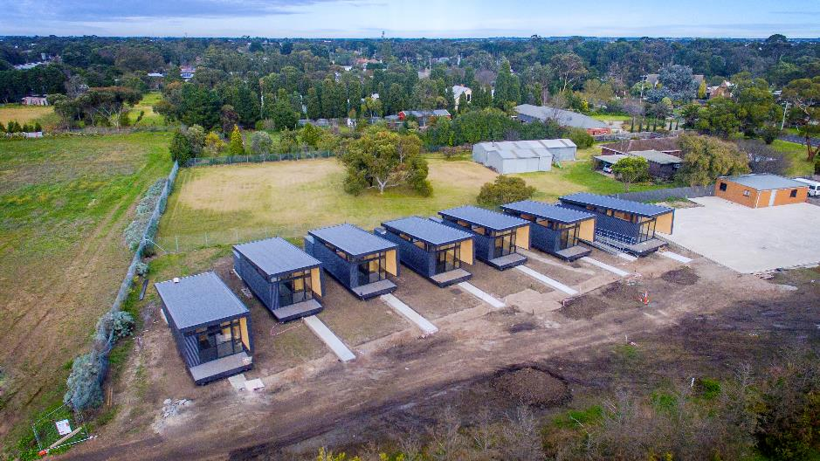

Samaritan House crisis accommodation in Geelong [Credit Deakin University and FormFlow]

### Design considerations

Successful implementation of OSC requires clearly defined design parameters that consider the interfaces between elements within the construction site as well as the potential manufacture of those elements.

This section describes OSC considerations across the Brief, Concept and Definition stages.

#### Brief

Preliminary consideration will be best supported by knowledge of OSC used in similar projects and the ability to select OSC components from a well‑maintained design repository, such as the BIM objects database.

Various considerations are necessary at this early stage and the organisation should develop standard and project‑specific checklists to assist the project team. Fit‑for‑purpose design and engineering requirements should be described, particularly the role of DfMA.

The project basis of design should consider:

* location and logistics (noting site constraints)
* value, urgency and cost of labour
* building type, standardisation
* structure type, repetitiveness
* project or program size (economy of scale) and interfaces with other projects
* area (m2) and number of levels
* site access and constructability
* complexity (number of components, sophistication, trades required)
* special requirements regarding standards or quality, such as advanced materials or specialisation such as earthquake resistance or medical, security or defence applications.

As OSC provides the opportunity to add value beyond the ability of traditional construction, the basis of design should also highlight aspects of particular importance to the project owner. This information may include certainty of quality, budget and schedule, the safety of personnel, fewer trades on site, the whole‑of‑life costs and schedule compression.

#### Concept

The ability to influence the application and scope of OSC is most significant in the concept design stage. Early designer and supplier involvement is most beneficial at this stage.

An early engagement team (if appropriate, this engagement may include contractors, subcontractors and manufacturers with OSC design and construction experience) can assist with developing a risk profile, assisting in risk identification and advising on market factors and supply chain capability.

At the concept stage, it is essential to consider the feasibility and extent of OSC, potential for standardisation and requirement for customisation.

Supplier capacity and capability and the use of modern digital tools should be considered, as well as how and in which formats information must be prepared to be of greatest value across the complete asset lifecycle.

#### Definition

Creating preliminary designs for OSC in the definition stage requires upfront effort and possibly increased design costs. This upfront investment is repaid with reduced design effort and rework and requests for information in the main design phase.

The design will benefit from commitment to design principles such as DfMA, simplification and standardisation:

* connections, allowing fewer tools and greater efficiency
* building systems, selecting structural and non‑structural elements allow sequenced installation
* materials, minimise hazardous materials and maximise efficient (lightweight, durable, low conductivity) and sustainable materials.

OSC uptake can be encouraged through the direction of project specific metrics. Using OSC heavily influences success in:

* sustainability and waste management
* project certainty (risk, cost, schedule, quality)
* health and safety (working at heights or in confined spaces, underground, less use of ladders)
* fewer disruptions (waste, traffic, noise, neighbours)
* standardisation and constructability
* design optimisation
* technical practice (lifting, precast, modular)
* project and process management (integrated, concurrent)
* stakeholder management (complexity)
* policies, regulations and standards

The team should not neglect information appropriate to a traditional build, such as site surveys, ground conditions and the availability of utilities.

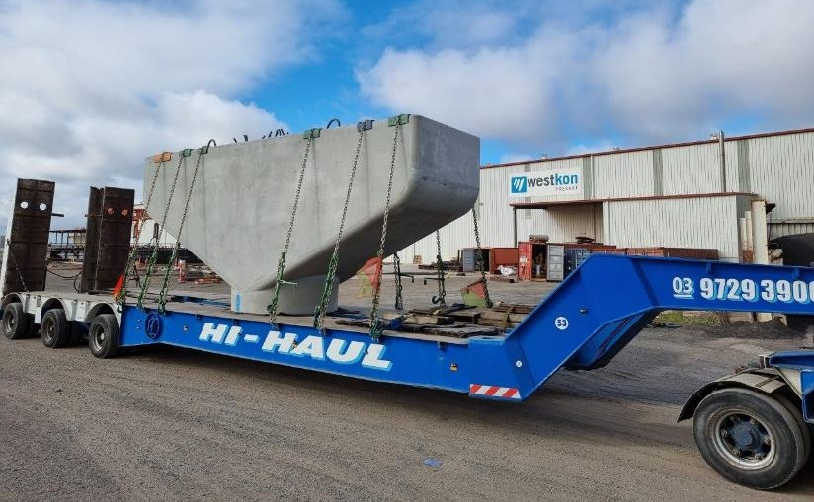

**Complete precast bridge crosshead delivery to site** [Credit Westkon Precast]

A summary of the four most important design considerations is presented below to assess the appropriateness of OSC on your project. These considerations are worked through in the OSC Evaluation Tool to support a recommended practice.

Design considerations

|  |  |  |  |
| --- | --- | --- | --- |
| Criteria | Description | Improves | Consideration |
| **Size of elements** | The maximum size of the element will be determined by transportation limitations or load requirements. | * design decision‑making * manufacture costs * transport costs | * transport route and options * handling and storage constraints |
| **Design complexity** | Elements are complex when interfaces across disciplines (architectural, structural, mechanical, electrical and plumbing) are required to a high degree.  In many instances of OSC, it may be required to lock‑in one trade (interface) requirement that impacts on another. | * design simplicity * on-site coordination * assembly costs * rework | * hierarchy of importance of design elements * commercial arrangements for conflict resolution * change management processes |
| **Design certainty** | Design certainty refers to the confidence that design requirements (to deliver a service need) will remain consistent throughout the project.  If there is a need for flexibility and the chance of significant design changes, the project is less suited to offsite manufacture. | * project delays * design coordination | * early design freeze * change management * collaborative design processes * highly detailed project requirements |
| **Design repeatability** | The more repeatable the design is, the more it lends itself to standardisation and OSC. | * manufacture and assembly durations * manufacture costs | * architectural requirements * offsite vs onsite works |

### Construction considerations

Site and construction‑specific constraints strongly impact the successful application of OSC. The criteria below can help navigate these constraints and should be assessed in the design phase prior to locking in any OSC elements.

Construction considerations

|  |  |  |  |  |
| --- | --- | --- | --- | --- |
| Criteria | Description | Improves | | Consideration |
| Storage, access or layout | May inhibit traditional build. OSC can improve inventory management (just‑in‑time), decrease stage space requirements and avoid double handling by allowing direct installation from the delivery vehicle. | * time * interfaces | * logistics (transport, storage, inventory) | |
| Contained/ constrained space | Underground activities and small sites in dense urban environments usually have a contained, constrained space, which limits offsite construction. | * time * health and safety | * logistics (transport, storage, inventory) | |
| Health and safety | Health and safety risks, such as falling from heights and working alongside live operations, can be drastically reduced by manufacturing offsite in a controlled environment where work can be automated and optimised. | * health and safety | – | |
| Labour resources | Labour resources may be constrained for roles that require high skills and experience. OSC allows people who are presently underrepresented in traditional construction to enter the workforce. | * diverse workforce | * planning and scheduling * include designers, manufacturers and assemblers to ensure realistic timelines | |
| Precision | Requirements for elevated levels of quality control or minimal defects, or specialised functionality such as earthquake, fire or blast‑resistant buildings, lend the development more towards OSC. | * quality * improved tolerances * longevity * maintainability * performance/ ready to use | * quality * meeting client requirements/user satisfaction * prototypes and models | |
| Sustainability | OSC typically increases energy efficiency and reduces waste by up to 40 per cent. | * environmental impact * waste reduction * carbon intensity * sustainability * energy and acoustics rating | * interfaces * employ VDAS, BIM and DfMA * consult and consider designers, manufacturers, and assemblers as an integrated team. | |
| Community impact | Disruption to the neighbouring community can include noise, dust or traffic from construction sites, blocking access and limiting access.  Fewer deliveries to the site of materials and components and an accelerated timeline with OSC mean less noise, disturbance and pollution in the surrounding area. | * disturbance or disruption * noise * traffic * dust * sites durations. | – | |

### Evaluation tool

Included with this guide is the OSC Evaluation Tool, which has been developed for use at the conceptual stages to evaluate a recommended scope for OSC inclusion in a project.

The OSC Evaluation tool asks a set of questions related to the topics detailed above in:

* Organisational readiness
* Project Considerations
* Design Considerations
* Construction Considerations

Based on your answers, the tool assesses whether your project and the elements you detail are more suited to:

|  |  |  |  |
| --- | --- | --- | --- |
|  |  |  |  |
| **Traditional construction** | **Non‑volumetric** **prefabrication** | **Volumetric**  **prefabrication** | **Modular** |

You can find the [OSC Evaluation Tool on the OPV website](http://www.opv.vic.gov.au/files/sharedassets/public-opv/publications/offsite-construction-evaluation-tool.xlsx).

Government construction procurement principles and procedures

The [Ministerial Directions and Instructions for Public Construction Procurement in Victoria](https://www.dtf.vic.gov.au/public-construction-policy-and-resources/ministerial-directions-and-instructions-public-construction-procurement) prescribe principles and procedures for all departments and agencies undertaking public construction procurement. The following principles must guide decision‑making regarding the use of OSC:

* Value for money by considering the total benefits, any risks and costs over the life of the goods, services or works procured as well as environmental, social, and economic factors.
* Proper planning and management of public construction procurement to deliver procurement objectives.
* Encouraging innovation and responsiveness in the supplier market.
* Fostering continuous improvement and building appropriate skills and capability in the conduct of public construction procurement.

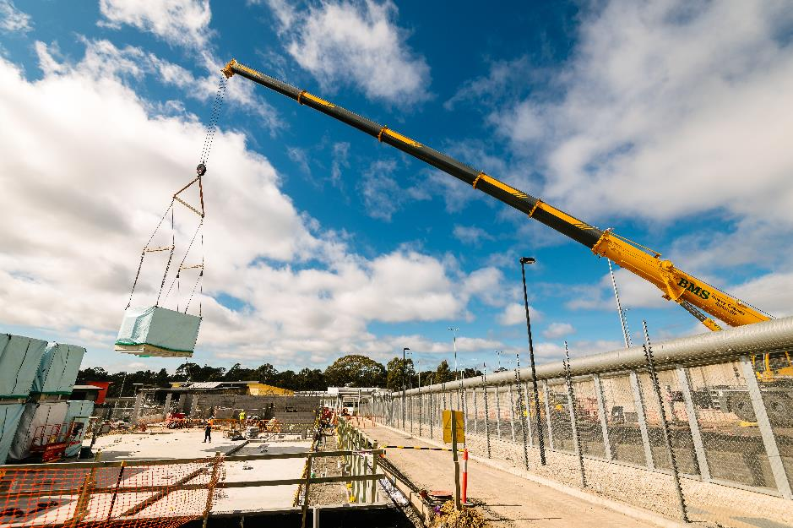

Volumetric module delivery to site [Credit to Community Safety Building Authority]

Project management and delivery

## About this section

This section explores the detailed OSC considerations for project management and the design, manufacturing, and construction (or assembly) stages of the delivery phase.

This section dives deeper to help explain important themes of function, quality, commercial, program, resources and sustainability to help navigate and mitigate the common pitfalls in offsite construction and get the best outcome for your project.

## Who this section is for?

This section is for those delivering major assets and projects, including project and portfolio managers, construction managers, asset owners and their project teams.

Project management and delivery contents

Part 1

Project management

Design for manufacturing and assembly (DfMA)

Scheduling

Resources

Sustainability

Part 2

Design management

Structure and function

Transportation

Lifting and handling

Standardisation

Materials

Design integration

Structural stability

Mass customisation

Design guidelines and standards

Quality

Tolerances and precision

Digital prototyping and testing

Commercial

Intellectual Property and design ownership

Novation/licensing of design

Part 3

Manufacture management

Structure and function

Quality

Commercial

Part 4

Construction management

Structure and function

Quality

Commercial

Health and Safety

Project management

**This section discusses the key OSC project management considerations to effectively control the three interfacing discipline teams: design, manufacturing and construction.**

OSC brings different objectives, drivers and management processes to integrate with typical construction project management techniques.

Where a traditional construction project manager will be comfortable adapting project schedules and designs to change, a manufacturing manager within an OSC supplier has a clear focus on predictable schedules, repeatable products and maximum productivity of resources.

OSC is highly dependent on collaboration and interface management – the designer, constructor and manufacturer have multiple touchpoints.

A OSC project manager requires an understanding of all three of these roles and the ability to optimise decisions that will impact all three.

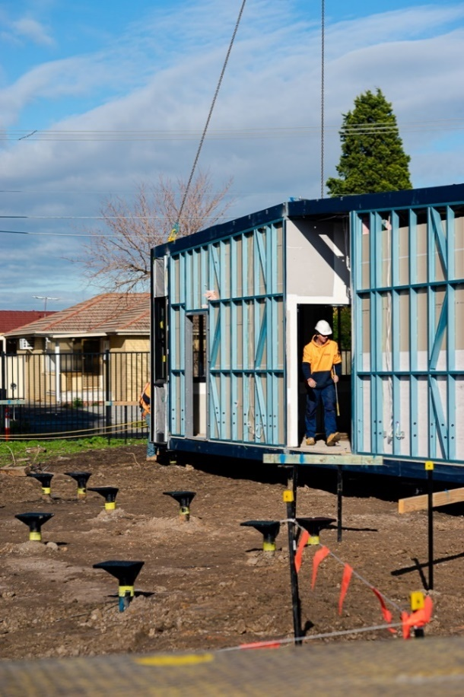

Volumetric building installation   
[Credit Sensum]

### Design for manufacturing and assembly (DfMA)

Represented in the figure below, DfMA is a process that considers and optimises the design, manufacture and onsite assembly and installation of OSC components.

It ensures that construction gets the most benefit from engaging with manufacturers and their cost-efficient production processes by considering their needs alongside construction.

DfMA seeks to ease the boundaries between design, manufacturing, transport and assembly of products and systems. The below diagram helps to detail some of the key considerations that are unique to each discipline alongside those shared with others.

The shared responsibilities inside the thick black line become the decision-making fields of the project manager weighing up considerations between disciplines. Tasks outside the thick black line are those delegated to construction, design and manufacturing managers as experts in their field.



DfMA - relating design, manufacturing and construction management of OSC

DfMA methodologies

DfMA enables the mass‑production of products and components using advanced manufacturing and easy assembly onsite without further steps.

Through standardisation and consistency, DfMA can deliver digitally designed components and systems for use across multiple types of construction projects. It minimises the need for repetitive work, and with slight changes, the standardised design can be used across a range of different projects to construct a school, a hospital, a train station or a bridge.

DfMA considers factors including location, supply chain, logistics and production at the design phase and influences the design definition with higher construction predictability.

DfMA also includes concepts such as kit of parts, a design approach that standardises design and reduces manufacturing and material requirements.

A kit of parts involves some standardisation and offsite construction. It aims to provide a pre‑engineered and designed collection of distinct components that can be assembled in various ways to create a complete construction.

The guidance provided in the [DfMA Overlay to the RIBA Plan of Work](https://www.architecture.com/knowledge-and-resources/resources-landing-page/dfma-overlay-to-the-riba-plan-of-work)(Royal Institute of British Architects) introduces DfMA as a future mainstream approach to construction.

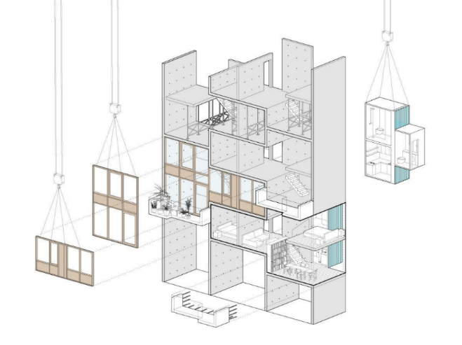**Assembling a structure from a kit of parts**

#### Collaboration

Collaboration is central to unlocking the opportunities afforded by OSC. It requires effective strategies and mechanisms to create trust between stakeholders. Success factors to collaboration include:

* providing leadership to champion and actively drive collaboration, such as by scheduling regular meetings
* using digital solutions to ensure alignment, including a single source of truth and common data formats
* collaborative contractual delivery approaches, such as project team integration, alliances and partnering, ECI and integrated delivery
* the willingness of stakeholders to invest in building medium to long‑term relationships, and a high level of commitment to behavioural changes across the supply chain.

#### Project development and due diligence

OSC benefits significantly from early‑stage planning and associated due diligence. All guidance material referenced in the preceding section is applicable, particularly the [PDDD Guidelines](https://www.dtf.vic.gov.au/sites/default/files/document/Project%20Development%20and%20Due%20Diligence%20Guidelines.DOCX). The project team should conduct due diligence concerning OSC components as early as possible and certainly before finalising project briefing documentation, technical specifications or developing tender documents. Due diligence should:

* incorporate relevant issues into the project risk profile and develop mitigating or management strategies
* confirm project scope definition, risk allocation and benefits realisation.

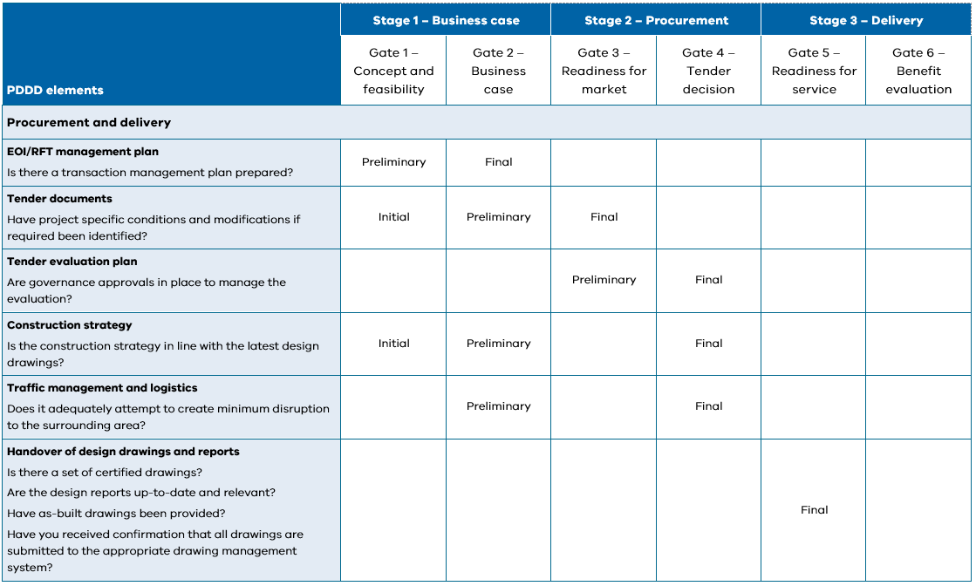

Extract from PDDD Guideline. DTF, 2019

### Scheduling

Schedule compression is one of the key benefits of OSC, with most time savings realised during construction. However, the use of kit of parts and repeatable components also enable time savings during the design stage.

Schedule compression in the design stage requires appropriate interfaces and iterations between designers responsible for manufactured and site constructed components. OSC enables designers to reduce effort on repetitive features. Design decisions must be ‘frozen’ at early stages to enable OSC component manufacture. Only minimal changes are accepted during manufacturing, meeting strict change management requirements.

For example, for a volumetric school classroom, while it may not be necessary to fix *all* the building design details, such as internal finishes, external cladding and light locations, early, it may be useful for the schedule **to lock-in those items that interface and would delay other design work e.g. footing location, tie-down bolt arrangement, door and window position and plumbing and electrical connection points.**

In a traditional build, progress is sequential with strong dependencies, such as building one level after another.

In manufacturing, the goal is to mass‑produce a standard product fully with minimum interruptions to design flow, as changing designs limits the ability to standardise or mass produce.

When working with OSC, project managers must understand the differences between manufacturing and construction schedules and how they can be aligned.

In projects with a high degree of OSC, such as those with a high percentage of modular or volumetric items, the manufacturing schedule will drive (or determine) the project schedule. Allowing entire or partial components to be manufactured in parallel, or even before, onsite work and delivery for installation is required.

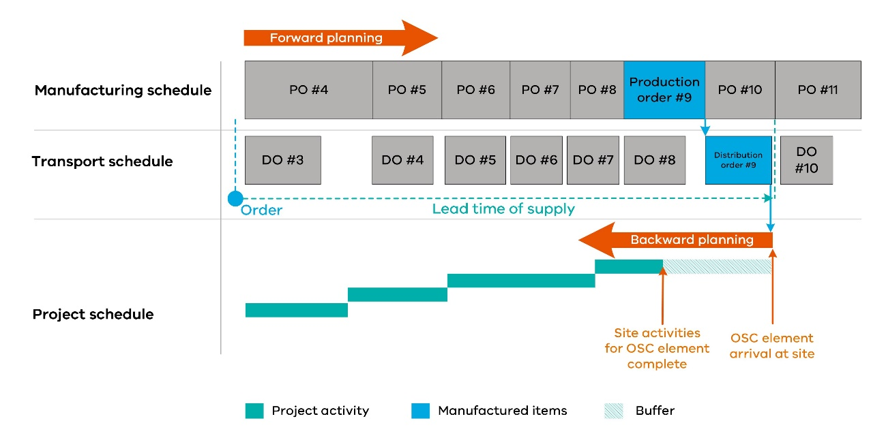

Project schedule subordinated to manufacturing - high degree of OSC

If there is a low degree of OSC, the project schedule should take precedence over the manufacturing schedule and the items should be delivered as required. The project manager needs to know the production freeze and lead time window to inform manufacturing of accelerated timelines or delays.

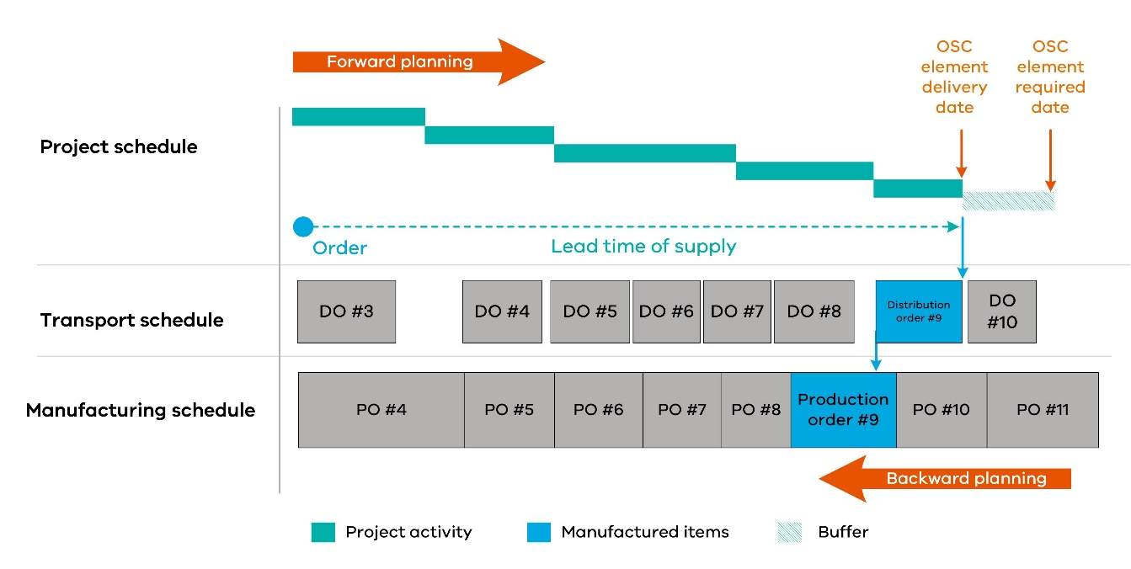

Manufacturing subordinated to project schedule - low degree of OSC

Unless there are clear parallels and an objective and independent assessment indicates the possibility to do so, the project team should resist the temptation to add OSC at a late stage, particularly to help a project already in distress. Late addition of OSC would cause additional strains on the program, such as:

* additional design time
* additional procurement
* modifications to site.

The [RTCC Guide](https://www.dtf.vic.gov.au/investment-lifecycle-and-high-value-high-risk-guidelines/stage-1-business-case) provides improved measures to schedule work, assess risk and track progress, such as earned value management, that are suitable for projects with onsite and offsite elements.

Development of the manufacturing schedule should also consider:

* the need for lead items such as the production of templates, moulds and jigs.
* the availability of skilled resources at the manufacturer and for offsite assembly.
* availability of appropriate lifting equipment and suitable transport.

As OSC component complexity increases, so may requirements for a particular sequence in OSC manufacture linked to onsite construction e.g. bottom configuration modular units must be manufactured and installed onsite before top.

The knock‑on effect of out of sequence production or defects in initial components may have significant ramifications on the program. To treat this risk, the supply schedule may include not only OSC component timing, but also links between components. There may also be penalties in place to disincentivise delays from the supplier.

### Resources

#### Participant selection

Make an early assessment of participant capability and base pre‑qualification on participants’:

* organisational maturity (processes, technology and human resources)
* risk profile, including financial stability and health and safety record (DTF can assist through the Construction Supply Register)
* experience, capacity and workload/pipeline
* accreditation and quality assurance
* record of digital capability and innovation

Victoria is home to several experienced and capable suppliers of OSC components, as illustrated in [Prefabricated Construction in Victoria ‑ Supply Chain Directory](https://business.vic.gov.au/__data/assets/pdf_file/0003/1880571/Prefabricated_Construction_Victorian_Business_Supply_Chain_Directory.pdf) (DJPR 2020).

#### Project team capability

Roles include the client/project owner or their representative, lead designers, project managers, contractors and advisors. The ultimate team structure will depend on factors such as the nature, size, scope and commercial model.

The project team's capability depends on them being provisioned with competent staff, time, tools and resources, supported by pertinent information, policies and procedures.

The [Digital Asset Policy](http://www.opv.vic.gov.au/Digital-Build/Digital-Asset-Policy) requires clear allocation of information management accountabilities and responsibilities and fit‑for‑purpose resourcing and support. This policy includes internal maturity, training needs and project supply chain capability.

Complexity increases with project size and the number of participants. Ensure fit‑for‑purpose team capability and informational and procedural consistency.

The capabilities of the project team must consider the following:

* the owner must specify applicable standards, methods, and procedures
* the design or construction lead can create an execution plan, including creating designs and models (architectural and OSC components)
* the project manager can develop and manage the project plan and associated risks across onsite and offsite activities. This role typically also ensures communication and integration between the stakeholders.

Appoint an information manager - this role works closely with the project manager to create the information models and should set and control the methods and procedures for collecting, verifying, integrating, and storing information, shared access to the data environment and change management.

#### Skills and training

Realising the full potential of OSC requires a 'rewiring' of traditional construction thinking that emphasises pre‑planning for smooth flow and control, including OSC training and skills, rather than troubleshooting after problems arise.

When considering OSC or significantly increasing OSC project participation, it is essential to conduct a gap assessment to determine skills and training requirements.

The understanding of OSC skills requirements is growing. Industry is increasingly calling for new roles such as OSC project coordinator and digital engineer.

In support of these roles, OSC education and training is offered via vocational training, polytechnics, universities and TAFEs. Skills and training in OSC can also come from:

* mentoring and training by experienced project members
* lessons learned on projects, updated with best practice
* online training for various levels of specialisation.

### Sustainability

OSC also has a positive impact across all sustainability categories:

|  |  |
| --- | --- |
| **Social** | * equity * health and safety * working conditions |
| **Environmental** | * reductions in road traffic * energy use * waste reduction |
| **Developmental / economic** | * compressed timelines * fewer defects |

Sustainability in OSC starts at the design stage, where via DfMA, waste can be minimised, and designs and models can be optimised for energy efficiency.

During the design phase, the team can:

* re‑consult the [Sustainable Investment Guidelines](https://www.dtf.vic.gov.au/sites/default/files/document/Sustainable%20Investment%20Guidelines.docx) (SIG)
* consider the sustainability of the design, including embodied energy, energy efficiency, materials use and recyclability
* employ methods such as 3D design and DfMA to optimise for sustainability.

The OSC facility must comply with relevant state legislation and the Environment Protection and Biodiversity Conservation Act 1999. The following standards are of particular benefit in assuring a focus on sustainability:

* The AS/NZS ISO 14000 Environmental Management series of standards.
* HB 207.2 2003 Rec:2016 Integrating environmental aspects into product design and development.

Case study 1 – Modular apartments

Constructed in Melbourne in 2012, the eight‑level Little Hero project used OSC modules to deliver 58 single and five double‑level apartments. The project highlighted how OSC provides synergistic improvements to sustainability in the following areas:

* **Environmental impact**  
  The modular pods, as they are constructed of steel, are more likely to be recycled than if traditional construction materials were used. The pods also allow for improved heating and cooling and lower overall energy use. Waste in production and onsite was demonstrably lower.
* **Schedule**  
  Following the development of the core, assembly with finishes took eight days, reduced down from an expected 5 months.
* **Quality**   
  Module construction occurred in a quality‑controlled facility to improved tolerances versus onsite projects.
* **Social**  
  Health and safety improvements included minimum working at heights and risk of falling objects as OSC modules included glazing, balconies and associated work. The building site had a very narrow access road, and the modules were planned, developed and delivered accordingly.

Design management

### Structure and function

#### Transportation

OSC components should be designed to accommodate transport constraints. Meeting these constraints requires planning transport logistics between the manufacturing site and the construction or third site, especially where OSC elements are heavy or oversized. Transport strategies, plans and schedules should further aim to minimise onsite storage, handling or relocation of OSC components.

The maximum size of OSC elements depends on transport regulations. Project teams can work with VicRoads to plan transportation routes, understand rules and meet permit requirements. VicRoads permits vehicles transporting a prefabricated building with a [maximum dimension](https://www.vicroads.vic.gov.au/-/media/files/documents/business-and-industry/heavy-vehicle-road-safety/transportinghousesandprefabricatedbuildingsjune2018rev1.ashx?la=en&hash=738419AE6D4997B64CF5DC8F380979BC) (summarised in the following table).

These dimensions must consider external fittings such as guttering, limits, rear overhang and the steer axle concession.

Standard vehicle dimension limits (VicRoads, 2018)

|  |  |
| --- | --- |
| Dimension | Maximum limits |
| **Width** | 5.0m | |
| **Height** | 5.0m | |
| **Length** | 30.0m | |
| **Trailer Deck Height** | 1.2m | |
| **Weight** | 43.0 tonnes | |

When planning OSC component transport, consider road conditions and infrastructure such as roundabouts and low clearances from bridges.

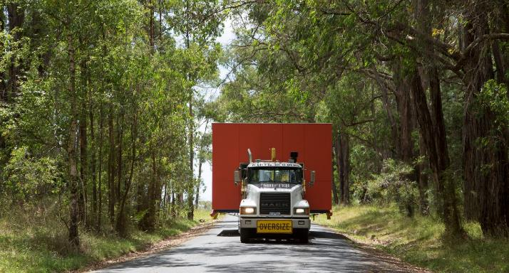

Transporting modules to site [Credit ARKit].

#### Lifting and handling

OSC frequently requires lifting or handling to install an element into its installed position and forms a large part of the construction. Lifting and handling constraints must be considered in the design stages to ensure constructability.

Designers must engage with manufacturers and constructions to provide consideration of:

* designated lifting points and lifting arrangements
* calculation of centre of gravity
* safe access to lifting points for riggers and diggers
* module storage support locations
* temporary stability and structural capacity while stored, transported and lifted
* transportation tie‑down arrangement and locations
* protection of module from rigging during lifting
* clearances to obstructions such as overhead power, trees and underground utilities
* any requirements for rotational loads during manufacture.

Designers need to consider spacing of lifting points to avoid instability, load shifting, tipping or twisting during loading, unloading and hoisting to install onsite. Standard practice includes lifting attachments such as frame or beam arrangements to stabilise the lift or avoid damage to the OSC component.

Guiding questions may help consider lifting in design, such as how many components are to be raised and what are their relative weights and sizes? How many lifting points are included on the component and where are they located geometrically?

Take care to secure pre‑installed components, such as doors and windows, with a degree of freedom to withstand dynamic and wind forces during handling and transportation.

Consult OSC component‑specific risk management guidance such as the [Guide to managing risk in construction: Prefabricated Concrete](https://www.safeworkaustralia.gov.au/system/files/documents/1909/managing_risk_in_construction_-_prefabricated_concrete.pdf) published by Safe Work Australia.

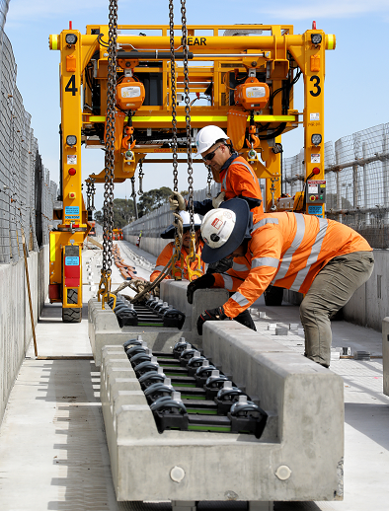

Specialist designed lifting system for handling prefabricated   
rail precast components [Credit LXRP]

#### Standardisation

Standardisation of OSC components seeks to enable large‑scale and widespread adoption and application, through repeatability, robust and regular processes, and evidence of successful implementation. Standardisation can improve traditional construction productivity but using standard OSC designs can create a multiplier effect.

OSC benefits accrue from economies of scale. Manufacturers can best drive production efficiencies from regular and significant orders.

For example, the production environment often employs templates, moulds and jigs to improve accuracy and geometric tolerances. This environment requires an investment of time and resources that is not suited to one‑off orders.

OSC also requires standard platforms, alignment of digital interfaces and an acceptance that there are fewer design options and providers with appropriate capabilities.

A further critical aspect is how the standardised elements and components come together – the way they are placed and arranged to respond to site brief and site needs.

Case study 2 – Standardisation, repeatability and scale

Internationally the health sector has been an early adopter of OSC, which is also the case in Victoria.

A VHBA project identified that 2000 out of 3500 hospital rooms for construction shared a standard design. The project required consistent high‑quality across the rooms.

OSC allowed the highly specified components to be delivered repeatedly and with increased efficiency. Additional reported benefits included minimising disturbances to ongoing hospital operations and time savings, particularly as VHBA estimates that traditional onsite construction allows almost one third of program time for inclement weather.

#### Materials

OSC manufacturers can often justify the use of advanced materials in their products, driven primarily by standardisation, mass production, improved supply chains, bulk buying and waste minimisation.

Project managers should consider the suitability of construction materials, including structural performance and performance across the asset lifecycle. Project managers should also keep in mind that approval processes must be followed for new materials. In particular, the use of novel materials in High-Value High-Risk (HVHR) projects requires pre‑approval supported by testing data.

#### Design integration

OSC should adhere to the [*Digital Asset Policy*](http://www.opv.vic.gov.au/Digital-Build/Digital-Asset-Policy) for requirements around information exchange through structured means.

Setting exchange information requirements will assist stakeholders in communicating their requirements across asset lifecycle stages. [VDAS](http://www.opv.vic.gov.au/Digital-Build/Victorian-Digital-Asset-Strategy) provides several resources in support.

Digital transformation is intended to support but not replace traditional methods of integration and interface smoothing such as checklists at boundaries and handover, RACI matrices, dispute resolution processes and provision of float in the schedule at critical points.

The project manager should also seek alignment of software compatibility to minimise re‑documentation as projects move from the design team to the fabrication team.

#### Structural stability

Assembling OSC components into a structurally stable construction is a key outcome of DfMA.

Designers must make consideration to provide the assembly and installation team with quality components that align well and can be assembled quickly, requiring the minimum specialised tools or skills.

Simple methods, such as the use of locating pins, can assist assemblers in fitting components together on site.

Advanced planning and design effort may use systems that enable even faster assembly, such as integrated stabbing guides, guide plates, orbi-plates and fixed threaded bar.

The project team should draw on experience of consultants and contractors to ensure structural stability when designing and constructing.

Designers should also consider the requirements for temporary structures, access, lifting and installing OSC elements in relation to structural stability.

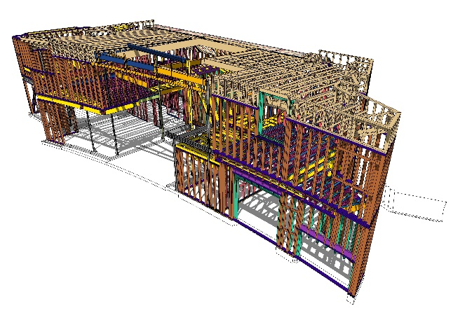

Design planning in digital environment [Credit ARKit]

#### Mass customisation

Mass customisation combines mass production processes with the flexibility of individual configuration.

For example, housing modules may utilise a similar footprint while providing numerous customisation options. The customer is given a choice of room layout and finishes while maintaining strict manufacturing process control.

By employing standard systems combined with various assembly options, the optimised design does not require significant changes to the production line to deliver custom features.

Designers should consider, in discussion with manufacturers, what elements are sensitive to customisation to avoid those and instead focus any changes on those elements that have little impact.

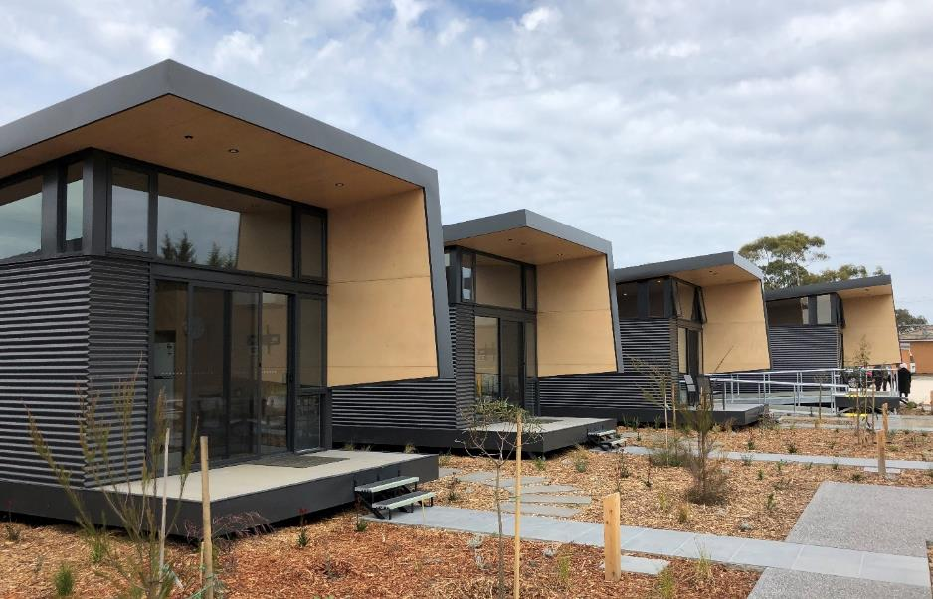

Housing modules have consistent external appearance with freedom for internal customisation [Credit to Samaritan House and FormFlow]

#### Design guidelines and standards

When planning for design, designers should use guidelines and standards that look to align with the objectives of OSC, including the following:

|  |  |  |  |
| --- | --- | --- | --- |
|  | Collaboration | Providing a collaborative work environment and shared context for onsite and offsite stakeholders. | |
|  | **Productivity** | Achieving greater productivity. |
|  | **Automation** | Assisting in the automation of supply chains. |
|  | **Competition** | Driving compatibility and competitiveness in the construction sector. |
|  | **Consistency** | Ensuring routine and consistent creation of designs and products, sharing data across the entire project and maintaining integrity over the asset life cycle. |
|  | **Better practice** | Helping identify risks and issues and determine better practice. |

The following OSC Guidelines should be consulted as applicable:

* [Handbook for the Design of Modular Structures](http://www.mccb.org.au/mccb) by the Modular Construction Codes Board, which aims to provide best practices for modular OSC with applicability across other OSC types
* Risk management guidance such as the [Guide to managing risk in construction: Prefabricated Concrete](https://www.safeworkaustralia.gov.au/doc/managing-risk-construction-prefabricated-concrete) by Safe Work Australia

Case study 3 – Changing standards

A 2019 amendment of the National Construction Code of Australia allowed timber construction systems for all building classes up to 25 metres, increasing from three to up to eight levels.

The change enabled the Oxford Apartment project outside Melbourne to use OSC lightweight timber frame systems. The system allowed developers to better construct on a site with poor soil conditions, common throughout Victoria's west. Furthermore, the lightweight structure allowed the construction to include above ground parking levels. Due to the lightweight construction, the entire project could be executed above ground without basement excavation, delivering estimated cost savings of $300/m2.

The multi‑level apartment complex also utilised OSC lightweight floor truss‑based cassettes, allowing installation cycles of 10 days, compared to 18 days for concrete pour. By employing OSC, optimised design and an experienced installation team, the project took only 12 months.

### Quality

#### Tolerances and precision

Possibly the most fundamental difference between OSC and traditional construction is the need for precision and repeatability at scale.

Where traditional construction has the on-site labour, supervision and control to manage change issues, the fundamental value proposition of OSC relies on elements connecting seamlessly

Variability in dimensional and geometric tolerances and associated defects is a common issue in construction and may lead to stakeholder disputes.

It is common manufacturing practice to include quality control points throughout the process to minimise accumulated errors and waste by quickly addressing quality issues as they arise.

This approach allows OSC components to be produced to more precise geometric tolerances than onsite components.

Standardisation and repeatability enable an OSC manufacturer to efficiently use moulds, jigs and fixtures to produce high‑precision products. However, the use of such tools makes rectifying significant deviations post‑production difficult.

It is the designer’s responsibility to discuss with manufacturers and contractors what are achievable tolerances in their offsite and on-site works and factor these into their design.

For example, for a prison cell hold down bolt, the precaster may be able to cast the penetration in the concrete to ±5mm and the constructor may be able to cast the footing hold-down bolt to ±10mm. In this case, the project is at risk of rework because the hold down bolts may clash with the penetration. The designer may either prescribe a specific, tighter tolerance to the on-site team or design the precast prison cells to have a larger void. **Using templates to position hold-down bolts and inspecting the positioning of them is also a good risk treatment.**

A designer must also pay attention to consequential tolerance issues and provide means for checking, adjusting and fixing.

For example, in building an eight-storey modular social housing tower, the manufacture can produce the modules with a squareness of one in 300. While each 3000mm tall module may be out of square by only 10mm at the top, when stacked on top of each other, the building may be leaning 80mm across in a single direction. In this case, the designer should provide for progressive measuring of the build and adjustment using shims to correct.

#### Digital prototyping and testing

Digital prototyping provides a common understanding of requirements between the contractor and the OSC manufacturer. Prototypes can be used to conduct checks, drive improvements and reduce risk, including to:

* prevent potential geometric misalignments
* estimate material requirements and minimise onsite waste
* check building code and standard compliance
* drive design optimisation by comparing arrangements and processes
* allow owner requirement evaluation
* assist sustainability evaluation, such as energy efficiency analyses.

Case study 4 – prototype modular bedrooms

The Victorian Health Building Authority (VHBA) mental health beds expansion program will enable 2 500 more Victorians to access vital mental health services annually. VHBA used a prototype OSC bedroom to confirm the design.

Design workshops evaluated the 2D architectural designs and accessed a physical prototype to test the suitability of the OSC modular bedroom, including for quality, look and feel. The workshop was inclusive, involving more than 300 people, including individuals with lived experience, clinical staff, research partners, capital representatives, consultants and designers.

### Commercial

#### Intellectual Property and design ownership

With OSC, various stakeholders must collaborate across disciplines and the project lifecycle using integrated frameworks and tools.

Open collaboration and knowledge sharing require overcoming legal and commercial barriers, including the allocation of risk, ownership of shared information and the management and distribution of payments.

Due to the collaborative nature of OSC, the ownership, right to use and liability for the use of IP such as a 3D design model must be considered.

Discussions with designers may flesh out protection measures that range from simple confidentiality and non‑disclosure clauses to multi‑party contracts with joint ownership.

The preferred arrangement is that all IP created by publicly funded projects is assigned to the State either exclusively or provides irrevocable right to use

This means that the default position should be that the State owns or agrees to share project developed IP for the public good relating to the design and construction methodology created within the project.

The manufacturer can typically retain the background and process IP that they have brought to the project related to how components are manufactured.

The contract should specify the ultimate ownership and use of the design or model. There are three approaches to this:

* The end-user or asset owner may own for ongoing maintenance and management.
* Each party retains ownership of their contribution. For project purposes, granting reciprocal licences to project team members must allow the use of the model. In this case, the Government must seek to own interface or ensure they are open source.
* Transfer of ownership or right to use to a third party such as a facility manager.

Over time, it is recommended that departments and agencies capture the value of their design IP by developing a 3D design library.

The [National Building Society (NBS) National BIM Library](https://www.nationalbimlibrary.com/en/) is a repository of open‑source designs and provides a collection of high‑quality generic and manufacturer BIM objects certified to NBS BIM Object Standard v2.0.

#### Novation/licensing of design

Delivery of OSC components may depend strongly on IP, including design rights and manufacturing methods vested in a single party.

Projects should seek to minimise OSC IP risks, including the following:

OSC IP risks

|  |  |
| --- | --- |
| **Insolvency** | Understand what rights the project team has in the case of default of an OSC supplier and whether a replacement supplier can produce OSC components that interface with those planned or existing. |
| **Access** | What rights do affected parties have to access OSC manufacturing facilities for testing and inspection? |
| **Liability** | Allocate risks for losses caused by improper design of interfaces, remediation of faulty components and breakage on delivery or assembly. |

The transfers of risks and IP in commercial arrangements and contracts should be carefully worded. Commercial contracts commonly used in construction may not address the transfer of rights and obligations in OSC.

In a novated contract model, the project owners employ design consultants to prepare a preliminary design based on a project brief. When the design reaches an agreed completion, the project owner can request tenders from contractors based on the design. The original contract with the designer is then novated to the winning contractor and the designer reports to the contractor until design completion.

Case study 5 – Licensing Victorian OSC Solutions internationally

Melbourne based construction company Hickory Group licensed its patented Hickory Building Systems (HBS) to a leading builder in the UK.

The application of HBS encompasses offsite components, including bathroom pods, utility cupboards and service modules. Compared to a traditional building approach, OSC:

* reduced design and construction schedules by 25 per cent, a compression of 18 weeks
* reduced onsite workforce by 20 per cent, site traffic by 40 per cent and waste by 70 per cent.

Manufacture management

**This section focuses on key manufacturing considerations when delivering projects with an OSC supplier.**

The focus is to minimise future conflicts by effectively planning the program, clearly stating expectations and requirements, agreeing on delivery dates, identifying payment provisions and tracking progress in the manufacturing stage of the project.

### Structure and function

#### Interface points

Suitable interfaces between designers and manufacturers can significantly increase manufacturing efficiency. For example, in the production facility, drawings and computer‑generated designs are converted into manufacturing drawings.

Providing the manufacturer with optimised 3D models and CAD drawings developed with a design for manufacture approach can help automatically generate technical drawings, minimise materials use and waste generation and even automatically create the fabrication schedule.

Project managers should facilitate early discussions between manufacturers and designers before starting digital design work. To improve ease of collaboration and quality of design, it is important to agree on software and export file formats.

Poor interfaces, including limited design review and feedback and incompatible data formats, will make it harder to move from design to production.

One example of an interface of Design for Manufacture (DfM) with OSC component production is adapting a CAD design for Computer Numerical Control (CNC) of machining tools. Machining is the process of removing material to produce a component, including shaping via milling, turning, and cutting via laser and waterjet. Design for manufacture is also important for interfaces with other automated and semi‑automated processes including welding, reinforcing bar configuration, concrete pouring for precast sections or 3D printing.

OSC components must also be assembled onsite, and efficiencies gained through Design for Manufacture can be lost by not considering or balancing manufacturing constraints with assembly constraints.

The interface between OSC manufacturers and the installer or onsite contractor must also be considered. The interface risk between supplier and installer or onsite contractor can be addressed by requiring the installer to review the designs for the OSC component and any other interfacing design (to minimise integration risk) and warrant they are suitable for transport and installation onsite.

### Quality

#### Quality assurance and quality control

Quality is a crucial function within manufacturing. Manufacturing quality processes seek to prevent mistakes and defects in products which would, if left uncorrected, lead to schedule delays and cost overruns. A key focus of OSC quality processes is ensuring that components require little to no rework during onsite assembly and fitting.

OSC components are typically inspected more thoroughly prior to delivery with pre‑close-up and other examinations in difficult to reach locations performed at safe heights by dedicated inspectors in a well‑lit manufacturing facility.

The reduction in defects produced from manufacturing quality control levels can:

* improve productivity
* reduce onsite rework
* reduce warranty and defect claims
* reduce maintenance workload
* reduce operational costs.

**Quality assurance (QA)** involves *managing the process* within control limits to meet quality standard required.

**Quality control (QC)** involves *checking quality standards* are met and is a key driver of continuous improvement.

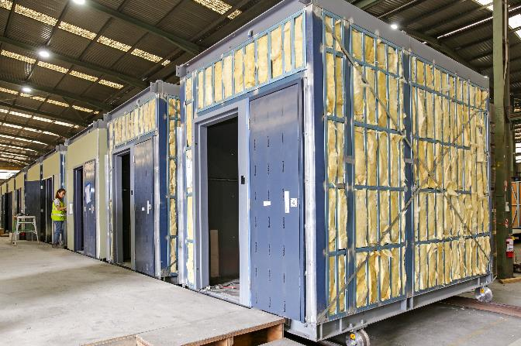

**Pre-close up Inspection** [Credit CSBA]

The expectation is that OSC suppliers will deliver products conforming to contract specifications in a consistent and competent manner.

QC should also consider handover interfaces and the control measures in place to treat delivery risks and adapt to project changes.

Project managers should stipulate standards, inspection requirements and secure capable resources to undertake QA and QC activities.

Some OSC manufacturers, particularly modular manufacturers, may have elected to undergo tests and inspections to show conformance to Australian standards. Compliance has become increasingly important due to considerations such as passive fire design and the National Construction Code.

Materials accepted to the manufacturing site should be held to strict quality standards. Samples of the manufactured component should be checked against approved templates, and products should be tested against performance standards to allow for verification prior to acceptance onsite.

The OSC manufacturer should be able to indicate:

* conformance to Australian Standards, including pre‑certification and validation of components and materials used
* that qualified and licensed trades were involved in procurement, manufacture and installation
* the number and type of checks carried out and certificates produced for components
* compliance with regulations such as the Building Code of Australia.

#### Pre‑close‑up inspection

Onsite supervision and inspection often require travel to and movement across large worksites on which numerous work crews are dispersed. In contrast, OSC provides a controlled environment for more efficient and effective supervision and inspection at a lower cost.

OSC can reduce the number of supervisors and inspectors who are highly skilled and certified. These essential but costly resources oversee outputs within the controlled workspaces, inspection stations and areas of the production facility.

The project owner may seek to engage a competent person to carry out a complete visual and close‑up inspection and identify areas of deviation from design and acceptable quality. Competent persons should ideally be certified to:

* AS/NZS ISO/IEC 17020‑2013 as an inspection agency
* AS/NZS ISO/IEC 17065‑2013 as a certification body.

#### Defects rectification

Like traditional construction, OSC manufacturers are subject to local legislation and standards. For example, the *Domestic Building Contracts Act* regulates design and construction contracts in Victoria and indicates that a supplier of OSC components must rectify defects in their products.

The choice of commercial model will determine the allocation of risk and responsibility of remediation. For example, under a subcontracting model, the contractor retains all defect risk, being responsible for performing the whole of the work. Under a supply model the supplier may support the contractor in accepting defect risk through a collateral warranty for the benefit of the contractor.

As with standard construction, contracts should be explicit regarding:

* the quality assurance and inspection processes
* the party responsible for rectifying interfaces and components
* how costs will be recovered.

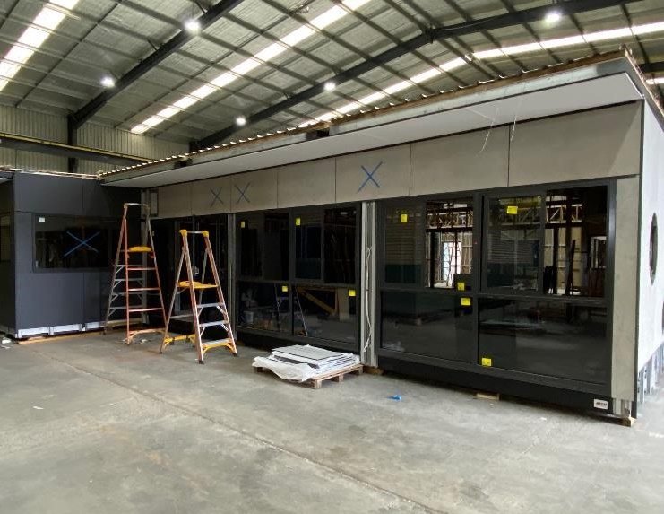

**Final inspection on completed module** [Credit ATCO]

### Commercial

#### Bonds

The project owner should carefully consider commercial risks and seek to implement treatments, such as progress payments or security to be released or paid in tranches on issue of the final completion certificate or on delivery of all OSC components.

The use of set preconditions to payment is preferred, and the project manager must seek to make provision for payment on achievement of certain milestones associated with OSC components.

Conditions may include project owner’s receipt of certificates of title, certificates of completion and personal property securities register checks, which provide greater certainty that the amount paid reflects the value registered.

In an insolvency scenario, ownership of OSC work in progress must revert to the project owner.

With OSC there is a risk that the supplier is incapable of providing traditional unfixed plant and materials security, such as bank guarantees or insurance bonds, to secure payments prior to affixing to sites, resulting in unsecured payments.

Due to the small balance sheets of OSC suppliers and contractors, it is a challenge to provide bonding (i.e. bank guarantees or insurance bonds) as security for the milestone payment for OSC work in the amounts required across multiple projects at a time.

#### Warranties

Accountabilities for the correction of defects in OSC components must be clear and supported by appropriate insurance and warranties. The various interfaces and stages i.e. transport, onsite assembly, and eventual operations, must be able to identify defects and determine component warranties.

Seek accredited OSC suppliers able to provide product warranties. Regardless of accreditation, obtain assurance of the integrity of the systems, processes and procedures used in manufacture of the OSC products.

Due to the numerous interfaces and areas of potential damage, witnesses from the affected party may be required at inspections and hand‑over activities. Ensure proper procedures are followed and that warranty conditions are met.

Warranties should be clear on provisions such as the scope of supply, value, maintenance conditions and the length of term or limitation date.

#### Progress payments

The payment terms must ensure delivery as scheduled of the correct quantity of OSC components, meeting agreed quality standards.

The payment regime can also assist early procurement of high-value materials, construction of moulds and jigs and the delivery of prototypes or samples as may be required.

Project managers should seek to avoid a situation where contractor or intermediates can potentially disrupt progress by delaying payment to OSC suppliers.

There is a risk of inaccurate comparison in estimating the value of OSC against that of traditional construction, so project managers should consider that OSC includes what would be indirect costs in a conventional build, such as some overheads, onsite facilities, quality assurance, rework or correction, and lifting systems.

#### The use of earned value management, discussed in the [RTCC Guide](https://www.dtf.vic.gov.au/sites/default/files/document/Risk%2C%20Time%2C%20Cost%20and%20Contingency%20Guidelines.docx), can be helpful to track progress and manage the project to agreed budget and schedule outcomes.

#### Staged payment vs progress payments

Traditional construction contracts often use staged payment, which requires projects to be completed to an agreed stage onsite before releasing an agreed amount in fees.

Traditionally, materials are purchased batch‑wise throughout the project and payments are made following delivery and onsite acceptance.

The OSC manufacturer may seek to complete related activities simultaneously to achieve maximum efficiency, such as manufacturing all the bathroom pods for the entire project in one production run, even though the onsite rooms are far from complete.

Staged vs. progress payments

|  |  |  |  |
| --- | --- | --- | --- |
|  | Payment terms | Considerations | Benefits |
| **Staged payments** | Payment released when delivery is made to site or installation on site is complete. | Mismatch of cashflow – payment received upon completion while upfront cost of manufacturing is significant, e.g. purchasing materials and wages. This may limit the subcontractor’s ability to run at full capacity and utilise bulk purchasing for cost savings. | Minimal upfront costs and lower exposure to production defaults. |
| **Progress payments** | Payment is based on percentage of work completed. It should reflect the subcontractor’s production schedule. | Costs may appear to be higher due to significant upfront expenses, such as all materials required for an entire order of modules and high value‑add possible with a short timeframe. | Ability to better track the subcontractor’s true progress. |

#### Security/ownership

Security for payment, such as through certificates of titles or completion, is important to ensure that the amount paid reflects the value of the OSC components completed.

The supplier must warrant that the OSC components are not subject to any security interest. Also agree at which stage of completion and payment the ownership of, and unencumbered title in, the OSC component will pass to the owner.

The contract should be clear on ownership of OSC components across all stages to address, for example, issues arising from supplier insolvency or damage requiring accessing insurance arrangements.

#### Insurance

Seek to understand the potential for use of insurance to treat risk as early as possible, including whether the project would best benefit from single insurance cover. The project team’s risk assessment should include insurance needs, allocation of risk and understanding of limitations of the proposed policy.

The Victorian Managed Insurance Agency (VMIA) should be engaged to assist in determining risk gaps i.e. insurable and uninsurable risks and areas where insurance can be used to manage risk.

VMIA’s property and combined liability (public and products liability) policies exclude construction activities over $500 000 in value. Construction projects should consider the cover provided by the VMIA construction risks – material damage and liability insurance.

Cover can extend to material damage, including physical loss, destruction or damage to insured property, such as work in progress, construction materials and specialised construction plant and equipment (when agreed), occurring during the construction period or defects liability period.

Manufacturing insurance considerations

|  |  |  |  |
| --- | --- | --- | --- |
|  | Insured property | Project team members | Other |
| **What can be covered?** | * Permanent or temporary structures, materials, and supplies. * Temporary buildings, camp buildings, project buildings and all contents. * Formwork, false‑work, scaffolding, access platforms, hoardings, and mouldings. * Consumables, drawings, documents, and electronic data. | * Project principal organisation. * Project and construction managers. * Contractors and subcontractors. * Any other parties involved in operations of works by agreement. | * Liability cover – damage and compensation for third party. * Legal defence cost and expenses. * Property damage and advertising injury sustained during the construction period. * Defect liability period. |

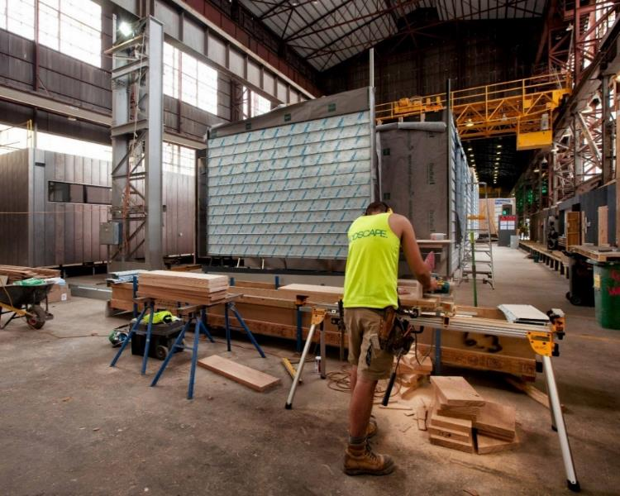

**Controlled factory manufacturing conditions** [Credit Modscape]

#### Storage and protection

OSC components must be allocated appropriate storage space, security from tampering and theft, protection from the elements and vermin and other damage such as accidental impact and controls offsite and onsite.

When designing storage, factors to consider should include:

* **physical properties**, including dimensions, geometry, construction materials and mass
* **logistics and placement**, including mode of transport and delivery, loading, and unloading cranage and hoisting
* **security and control**, including systems for access control, checking quality and quantity at delivery and stock management
* **shelter and protection**, as OSC components may come complete with paint, windows, and facades pre‑installed that are more susceptible to damage such as breakage and scratches. Construction materials may require protection from the elements, given that timber swells, metal components rust from moisture and plastics can warp from heat
* **efficiencies**, particularly the opportunity for improved stacking and handling of OSC components to save cost and time
* **scheduling**, to better understand when the components are to be delivered, whether the storage space is temporary and what risks exist if there are onsite and offsite delays.

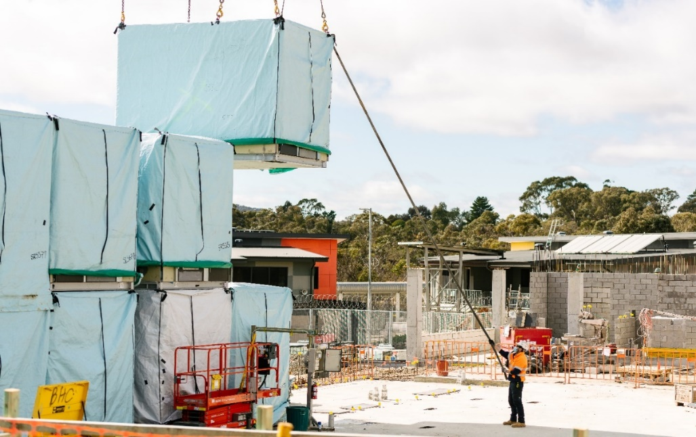

Preparation of modules for storage [Credit Community Safety Building Authority]

Construction management

**This section focuses on key construction considerations when delivering projects with OSC components.**

### Structure and function

#### Logistics

As with all industrialised supply chains, logistics is central to OSC. It is the largest single consideration for construction management. With proper planning, OSC logistics can be ‘just‑in-time’, significantly reducing storage requirements and time spent waiting for materials.

As with standard manufactured products, logistics requirements and considerations include inventory management, understanding of the schedule or time limitations and transport risks.

Logistics can be supported by mobile technologies such as handheld devices to scan and track components and software solutions to automate bills of materials and synchronise loading, transport and onsite receipt.

The responsibilities of a logistics manager can include:

* monitoring offsite production to ensure orders are set to be completed on time and in full
* planning loading sequences
* planning storage location and sequences
* developing contingency plans for wet weather, industrial action and delay
* ensuring OSC components meet quality requirements, are constructed of the correct materials, and are supplied in the right order, in proper amounts at the scheduled time
* checking vehicles and drivers, cranage and operations comply with legal requirements (loads, certifications, and licenses)
* helping assess the risks and health and safety requirements of the above.

#### Transport

Transport of OSC components can make up a more significant percentage of cost, particularly in the case of large OSC types such as fully fitted modules.

The most significant changes to transport from the use of OSC are:

* the reduced frequency of deliveries
* the increased size of components

For extensive long‑term projects, purpose built OSC facilities (near-site facilities) may be established close to the final location.

The standard benefits from shelter from the elements and manufacturing efficiencies and controls are achievable from these near‑site facilities.

Additional transport considerations include:

* optimising the mode and route, including evaluating day or night movement, traffic congestion and control and security requirements
* understanding road conditions including gradients or stones and jarring movements from poor surfaces
* understanding of individual manufacturer’s delivery requirements, which can include return of lifting frames
* balancing many small crane lifts or deliveries vs fewer larger crane lifts or oversize loads.

In the case of high‑performance freight vehicles, due to their weight and geometry, additional considerations need to be made as bridges may not been built to cater for loads heavier than 68.5 tonnes, or the road geometry may not be suitable for vehicles longer than 26 metres.

Some networks are already cleared for transport, eliminating the need for individual route assessments, such as Victoria’s high‑performance freight vehicle networks cleared for vehicles up to 36.5 metres and 85.5 tonnes.

VicRoads coordinates the planning and approval of any [Superloads](https://www.vicroads.vic.gov.au/business-and-industry/heavy-vehicle-industry/superloads).

A load is a Superload if it is:

* a vehicle and load with a gross vehicle mass of 250 tonnes or greater
* a vehicle with a platform axle load of 15 tonnes or more per axle with 6 or more axles
* any high-frequency movement of vehicles with a gross vehicle mass of 170 tonnes or greater that cannot be considered ‘business as usual’. These high-frequency and repetitive movements have a high impact on the road and bridge network which the Department of Transport is required to monitor, manage and keep safe.

Case study 6 – Transporting houses

The Harris Transportable Housing Project uses parcels of presently vacant VicRoads land in Melbourne's inner west to create up to 57 tiny homes for people with a chronic experience of homelessness.

Prefabricated offsite in regional Victoria, the 'tiny houses' are a pet‑friendly, affordable, long‑term housing solution where people can live privately and independently.

The houses measure 3.6m x 11m, explicitly sized to enable semi‑trailer transport. The homes are fully equipped with essentials and meet 6‑star energy ratings.

The project won the Planning Institute of Australia's Award for Planning Excellence in 2019. Victorian Government participants included VicRoads, the Department of Families, Fairness and Housing (DFFH) and the Victorian Property Fund.

#### Swept path area

OSC is impacted by spatial restrictions both onsite and offsite. Moving OSC components may be impacted by narrow roads and the obstacles encountered during travel, including signs, parked vehicles, trees, cables and bridges.

Swept path area refers to the envelope swept out by the sides of a vehicle body, or any other parts of the structure of a vehicle, including towed loads. Digital technology and models are available to conduct swept path analysis to optimise safety, load placement and vehicle size for OSC manufacturers and onsite routes.

Project managers should seek assurance from contractors, manufacturers and delivery contractors that they have undertaken a route assessment and considered swept paths. This can be included in commercial arrangements as the risk requires.

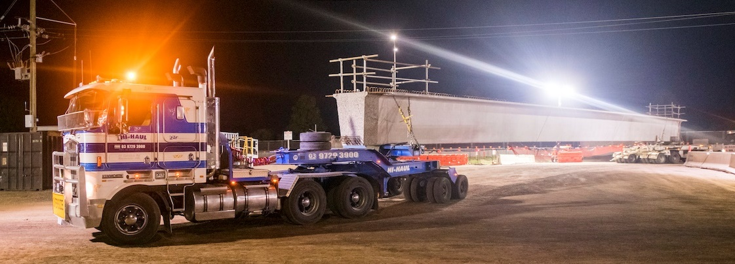

Large precast beam delivery with rear dolly requiring clear swept path [Credit Westkon]

Case study 7 – Melbourne traffic and trams

La Trobe Tower, Melbourne, is presently the tallest building in Australia constructed using OSC components. The 44‑level residential building took 16 months to complete, a nine to 10 month saving over traditional build.

This was achieved through the use of various OSC components, such as steel box frames and bathroom modules.

Tram traffic impacted site access during the day. However, as OSC construction is quieter than a traditional build, with fewer power tools and generators and less construction noise, the contractor was permitted to shift to night work without disturbing adjacent residents, avoiding trams and reducing site traffic during peak daytime traffic hours.

#### Lifting/cranage

Planning for lifting of OSC components must be incorporated in the design stage.

For example, 3D design models can be used to determine the optimal location of lifting positions on modules through consideration of an OSC component’s centre of gravity or shape. Increased requirement for lifting may place activities such as cranage on the critical path.

OSC components are typically suited to a particular lifting system. Larger components will suit cranes (mobile, tower and crawler), and smaller components can typically be managed by forklifts and lifting trucks.

OSC might introduce new risks to the construction site including slinging failure, oversized beams or modules contacting the crane or surrounding structures and breakage of pre‑installed items.

OSC lifting and cranage systems and timing should also consider risks from weather, including high winds.

As resource requirements are lower and installation times are shortened, particularly for modules, it is possible to plan cranage for quieter periods such as weekends.

Construction teams should, as a minimum, consider:

* ground conditions and geotechnical capacity
* access to install and remove lifting points (with consideration for changing adjacent modules)
* underground and overhead utilities
* temporary handrail progressive installation and removal
* permissible wind speeds and loads for crane lifting lightweight, high‑volume elements (and risk this may present to programs)
* timing for when loads are considered fixed and safe for persons to access
* timing for reinstatement of lifting points, especially in precast
* crane set up and pack up durations and space or secondary cranes needed.

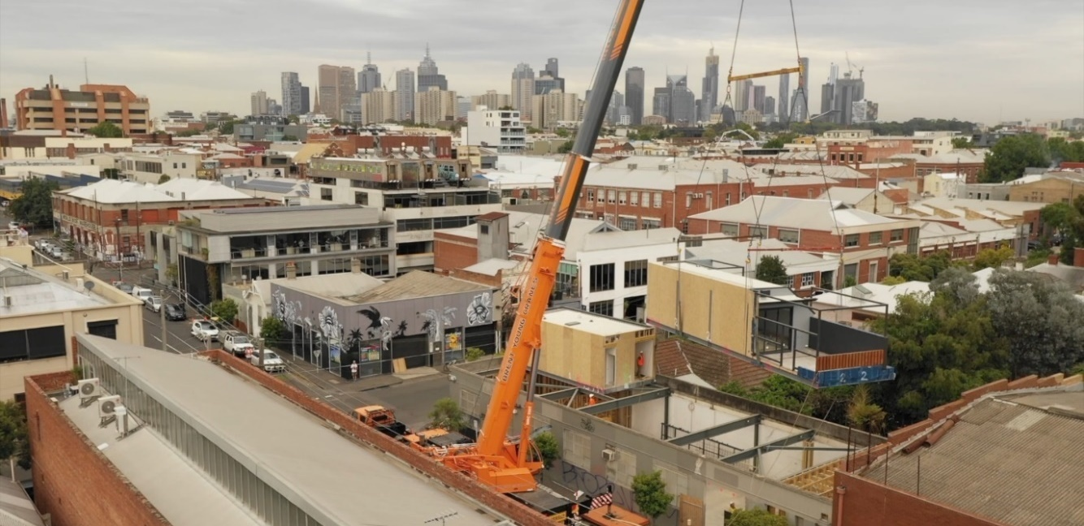

Module installation with specialised rigging in a tight environment [Credit XXX]

#### Site disruptions

Site disruption refers to productivity losses from interruption of onsite construction progress.

Various external factors can disrupt construction, and onsite mitigation efforts can do little to reduce the impact of industrial action, the COVID‑19 pandemic and inclement weather.

OSC offers shorter activity durations on site from faster mobilisation, commissioning, demobilisation and cleanup.

OSC allows continuation of work in controlled environments where workers can be distanced, workspaces cleaned and disinfected, and products protected from inclement weather.

OSC further minimises disruption from material losses and replacement, such as theft, incorrect delivery or degradation such as rusting of metal.

Scheduling the arrival of OSC components just as required for installation minimises disruptions from traffic and deliveries while reducing the need for double handling and storage and provides more space for onsite operations.

However, project teams should be aware this scheduling also increases the risk of disruption due to supply chain and/or transportation issues.

#### Readiness

Mobilisation of OSC components and assemblers should not occur until warranted by onsite progress.

The next stage of construction activities must be ready to start and productivity needs to be sustained.

Readiness checks should be conducted onsite and offsite to avoid delays and out‑of‑sequence work and to mitigate risks prior to transport and installation of OSC components.

Stakeholders must agree on objective measures and standards and the process to determine readiness.

Requirements for readiness checks and checklists can be included in the DfMA considerations and QA Plan.

Considerations can include the interfaces between OSC components and onsite structures and services, potentially allowing accelerated installation and early commissioning.

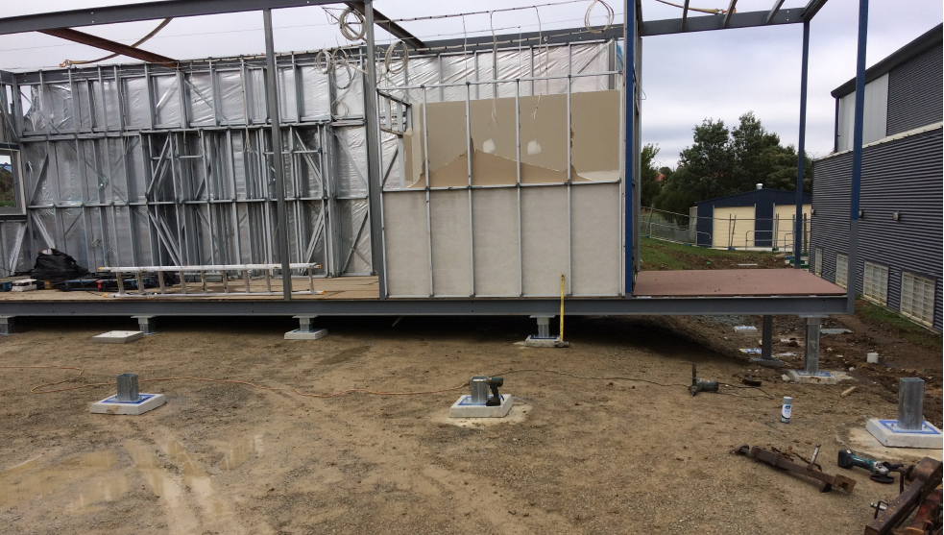

Site footings prepared, checked and ready to receive further modules [Credit KLMS]

### Quality

#### Quality control and assurance

OSC components are typically inspected more thoroughly prior to delivery with pre‑close-up and other examinations in difficult to reach locations performed at safe heights by dedicated inspectors in a well‑lit manufacturing facility.

Onsite quality inspection is manual, which can be inefficient and inaccurate.

That said, it is good practice for the construction team to do a final visual inspection of the component prior to and after installation to ensure no damage has occurred during storage, transport or lifting.

Inspections should look for:

* change in dimensions
* cracking, especially precast
* water damage, staining or rusting
* pests and vermin
* seizing of bolts or connectors
* damage to lifting points.

Procedures may include non‑destructive inspection technologies such as visual and laser scanning, which can help collect information on the geometric, dimensional, surface, and underlying defects.

The risk of damage during the supply, transport and installation of OSC components may lie with one party but the delays caused will extend to the entire project.

Careful consideration must be given to what constitutes the point of delivery, the interfaces and instructions at interfaces.

Proactively seek and address areas of potential dispute, such as what will happen if damage occurs when a contractor follows the handling instructions provided by the OSC supplier.

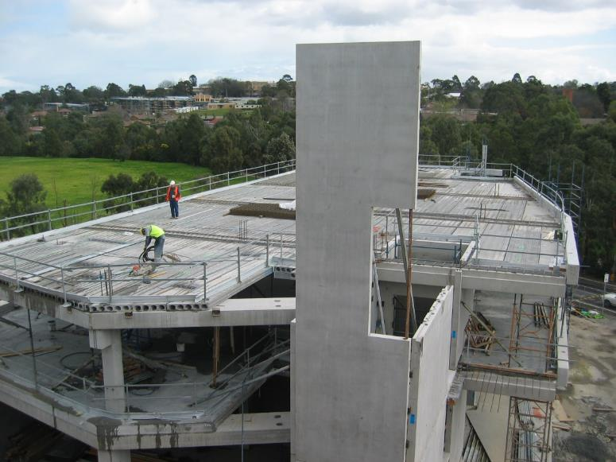

Precast concrete in assembly for university [Credit Westkon]

### Commercial

Commercial OSC construction considerations

|  |  |  |  |
| --- | --- | --- | --- |
| Risks | | | Treatment measures |
| **Security/ ownership** | Uncertainty around the terms and conditions of supply and transfer of ownership. |  | * Clearly specify responsibilities in the contractual arrangements. * Ensure mutual understanding of the commercial model’s terms and conditions. |
| **Insurance** | Lack of clarity around which party is responsible for damage at distinct stages in the supply chain. |  | * Ensure that all stakeholders provide details of indemnity insurance which meet procurement standards. * Ensure that all parties are aware/agree to their accountabilities. * Proactively seek and address areas of potential dispute. |

#### Security/ownership

The commercial model and contractual arrangements should be clear on the terms and conditions of supply and transfer of ownership.

Under the subcontracting model, the contractor is responsible for supplying and installing modules and completing all the other works. As such, the contractor takes the risk regarding integration of the modules with other parts of the works.

#### Insurance

Where applied, insurance terms and conditions must clearly stipulate which events are covered, and the extent of cover provided by the policy. Project participants should provide details of their individual professional indemnity insurance that meets procurement standards, in addition to agreeing to the policy and use of waivers as may be required. Insurance is a last line of defence.

### 

### Health and Safety

#### Site OHS and wellbeing

OSC practices change the risk environment, but overall benefit projects.

Project managers should be aware of the impact of their chosen OSC methodology to their project and include this into their decision-making and risk mitigation strategies. OSC can reduce safety risks through:

* fewer people and trades interfacing on site
* fewer small material deliveries, lifts and manual handling by labourers
* fewer pedestrian interfaces
* work moved from outdoor, weather‑affected site to controlled environment
* small, daily changes in site conditions are fewer
* removed works at height and noise and dust
* less rework

OSC can increase safety risk by:

* adding a new manufacturing workplace and risks to monitor
* more large loads to transport, lift and install
* large, critical community disruption activities
* increased work at heights
* panels and temporary structures subject to wind loads.

Case study 8 – Faster delivery with fewer workers at risk

Two major London underground stations, Tottenham Court Road (TCR) and Liverpool Street (LS), were delivered with a near‑identical scope. However, the 450‑metre platforms were constructed quite differently. TCR used in situ methods, and LS used OSC, with precast concrete components manufactured offsite in a controlled environment. OSC contributed to:

* an 11‑week saving in the construction period (TCR 41 weeks vs. LS 30 weeks)
* twenty‑three fewer trades on site. TCR required 57 skilled trades for in situ installation and LS delivered with seven tradespersons onsite and 27 offsite
* significantly reducing the number of people required to work underground, lowering occupational health and safety risks.

Onsite OHS must comply with all relevant legislation. Ideally, both onsite and OSC activities should use management systems compliant with standards such as:

* AS/NZS 4801:2001 – Occupational Health and Safety Management Systems
* BS OHSAS 18001:2007 – Occupational Health and Safety Management Systems.

#### Pedestrian safety

Construction sites are notoriously hazardous – construction is in the top three industries regarding the number of fatal onsite accidents. Onsite incidents can involve a worker or any other person in the immediate vicinity, including pedestrians and bystanders.

OSC can improve safety from public interactions with the site.

For example, OSC is more conducive to use of site simulation and virtual reality, as well as digital models that can help visualise public interactions and identify safety risks.

OSC can reduce:

* vertical work with falling object hazards e.g. installation of windows
* requirements for signage, covers, netting and harnesses
* onsite welding and cutting work and related hazards such as electric shock and fires
* slips, trips and falls e.g. from unfinished and uneven areas.

OSC may require transporting, lifting and positioning large and heavy prefabricated components such as complete modules, columns and floor slabs.

Some modules may also have facades, windows and similar fittings pre‑installed, which must be fastened and secured.

The focus is to minimise risk to workers and the public from traffic and falling objects.

#### Local business disruptions

Offsite disruptions are minimal, as OSC manufacturers are typically located in an industrial area where activities have negligible impact on the local community.

By conducting activities more efficiently and in parallel to onsite work, OSC offers reduced onsite activity and site extent, faster time to completion and minimum impact on and disruption of businesses and adjacent activities.

Any of these can be critical client requirements, particularly in the case of hospitals and schools where operations might need to continue without any interruption.

Acknowledgements

OPV would like to extend thanks to the following entities for providing photos and case studies in the development of the Offsite Construction Guide:

### Government Departments and agencies Industry

References

|  |  |
| --- | --- |
| Reference | Source |
| Department of Treasury and Finance (DTF) Victoria, Investment Lifecycle and High Value and High‑Risk Guidelines | **Source:** [https://www.dtf.vic.gov.au/infrastructure investment/investment lifecycle and high-value and high-risk guidelines](https://www.dtf.vic.gov.au/infrastructure-investment/investment-lifecycle-and-high-value-and-high-risk-guidelines) |
| Department of Treasury and Finance (DTF) Victoria, Technical Guidance: Procurement Strategy Guideline | **Source:** [https://www.dtf.vic.gov.au/sites/default/files/2018-03/Procurement strategy guideline.doc](https://www.dtf.vic.gov.au/sites/default/files/2018-03/Procurement%20strategy%20guideline.doc) |
| Department of Treasury and Finance (DTF) Victoria, Project Development and Due Diligence Guidelines | **Source:** [https://www.dtf.vic.gov.au/sites/default/files/document/Project Development and Due Diligence Guidelines.docx](https://www.dtf.vic.gov.au/sites/default/files/document/Project%20Development%20and%20Due%20Diligence%20Guidelines.DOCX) |
| Department of Treasury and Finance (DTF) Victoria, (2022). Victoria’s Women in Construction Strategy | **Source:** [https://www.vic.gov.au/victorias women construction strategy](https://www.vic.gov.au/victorias-women-construction-strategy) |
| Department of Jobs, Precincts and Regions, (2017). Advancing Victorian Manufacturing, a Blueprint for the Future | **Source:** [https://djpr.vic.gov.au/__data/assets/pdf_file/0009/1543761/10764‑DEJTR‑EIT‑Advanced‑Manufacturing‑Statement‑.pdf](https://djpr.vic.gov.au/__data/assets/pdf_file/0009/1543761/10764-DEJTR-EIT-Advanced-Manufacturing-Statement-.pdf) |
| DJPR *(*2020*)*. Prefabricated Construction in Victoria ‑ Supply Chain Directory, [Online] | **Source:** <https://business.vic.gov.au/__data/assets/pdf_file/0003/1880571/Prefabricated_Construction_Victorian_Business_Supply_Chain_Directory.pdf> |
| Long, K (1999). EC funds Eurohouse research, Building Design, February 12 |  |
| McKinsey & Company (2019), Modular construction: From projects to products | **Source:** [https://www.mckinsey.com/~/media/mckinsey/business functions/operations/our insights/modular construction from projects to products new/modular construction from projects to products full report new.pdf](https://www.mckinsey.com/~/media/mckinsey/business%20functions/operations/our%20insights/modular%20construction%20from%20projects%20to%20products%20new/modular-construction-from-projects-to-products-full-report-new.pdf) |
| Ministerial Directions and Instructions for Public Construction Procurement (2018) | **Source:** [https://www.dtf.vic.gov.au/public construction policy and resources/ministerial directions and instructions public construction procurement](https://www.dtf.vic.gov.au/public-construction-policy-and-resources/ministerial-directions-and-instructions-public-construction-procurement) |
| Modular Construction Codes Board (2017), Handbook for the Design of Modular Structures | **Source:** [www.mccb.org.au](http://www.mccb.org.au) |
| National Building Society National BIM Library | **Source:** [https://www.nationalbimlibrary.com/en‑au/](https://www.nationalbimlibrary.com/en-au/) |
| NATSPEC (2019), NATSPEC National BIM Portal | **Source:** <https://bim.natspec.org/> |
| Office of Projects Victoria (2019), Victorian Digital Asset Strategy | **Source:** <http://www.opv.vic.gov.au/Digital-Build/Digital-Asset-Policy> |
| Office of Projects Victoria (2021), Sustainable Investment Guidelines | **Source:** [https://www.dtf.vic.gov.au/sites/default/files/document/Sustainable Investment Guidelines.docx](https://www.dtf.vic.gov.au/sites/default/files/document/Sustainable%20Investment%20Guidelines.docx) |
| Office of Projects Victoria (2021), Risk, Time, Cost and Contingency Guidelines | **Source:** [https://www.dtf.vic.gov.au/sites/default/files/document/Risk Time Cost and Contingency Guidelines.docx](https://www.dtf.vic.gov.au/sites/default/files/document/Risk%2C%20Time%2C%20Cost%20and%20Contingency%20Guidelines.docx) |
| Office of Projects Victoria (2021), Digital Asset Policy | **Source:** [http://www.opv.vic.gov.au/Digital‑Build/Digital-Asset-Policy](http://www.opv.vic.gov.au/Digital-Build/Digital-Asset-Policy) |
| Safe Work Australia, Guide to managing risk in construction: Prefabricated Concrete | **Source:** https://www.safeworkaustralia.gov.au/resources-and-publications/guidance-materials/guide-managing-risk-construction-prefabricated-concrete |
| Royal Institute of British Architects (2021), DfMA Overlay to the RIBA Plan of Work2nd Edition | **Source:** [https://www.architecture.com/knowledge and resources/resources landing page/dfma overlay to the riba plan of work](https://www.architecture.com/knowledge-and-resources/resources-landing-page/dfma-overlay-to-the-riba-plan-of-work) |
| VicRoads (2018), Transporting Houses and Prefabricated Buildings | **Source:** [Transporting houses & prefabricated building information update - June 2018](https://www.vicroads.vic.gov.au/-/media/files/documents/business-and-industry/heavy-vehicle-road-safety/transportinghousesandprefabricatedbuildingsjune2018rev1.ashx?la=en&hash=738419AE6D4997B64CF5DC8F380979BC) |
| WRAP Report: Designing out Waste: A design team guide for buildings | **Source:** <https://www.modular.org/marketing/documents/DesigningoutWaste.pdf> |
| Worksafe Victoria Safety Alert: Temporary Structures | **Source:** [https://www.worksafe.vic.gov.au/safety-alerts/temporary site structures](https://www.worksafe.vic.gov.au/safety-alerts/temporary-site-structures) |
| Cross rail – Platforms completed at new Liverpool station | **Source:** https://www.crossrail.co.uk/news/articles/platforms-completed-at-new-liverpool-street-station |
| B&ES - An Offsite Guide for the Building and Engineering Services Sector | **Source:** https://www.buildoffsite.com/content/uploads/2016/01/OffsiteGuide.pdf |
|  |  |

Glossary

|  |  |
| --- | --- |
|  |  |
| **Asset** | Defined as an ‘item, thing or entity that has potential or actual value to an organisation’. Assets can be tangible or intangible through physical and non‑physical (digital) assets. Data and information are considered a digital asset.  *Source: ISO 55000.* |
| **Building information modelling (BIM)** | Use of a shared digital representation of a built or to be built asset to facilitate design, construction, and operation processes to form a reliable basis for decisions.  *Source: ISO 19650‑1: 2018* |
| **Delivery team** | Lead appointed party and their appointed parties.  A delivery team can be any size, from one person carrying out all the necessary functions through to complex, multi‑layered task teams. The size and structure of each delivery team are in response to the scale and complexity of the asset management or project delivery activities.  Multiple delivery teams can be appointed simultaneously and/or sequentially in connection with a single asset or project, in response to the scale and complexity of the asset management or project delivery activities. A delivery team can consist of multiple task teams from within the lead appointed party’s organisation and any appointed parties.  A delivery team can be assembled by the appointing party rather than the lead appointed party.  *Source: ISO 19650‑1: 2018* |
| **Design for Manufacture and Assembly (DfMA)** | Is the combination of two approaches: Design for Manufacture (DfM) and Design for Assembly (DfA) that allows for manufacture of building subassemblies or modules with onsite construction assembly. Considering the manufacturing operation and efficiency of assembly in the design process aims to create the most efficient product possible.  A further extension of this principle is Design for Manufacture, Assembly and Disassembly (DfMA+D). |
| **Digital engineering** | A contemporary and collaborative approach to working on assets allowing for a faster and more efficient approach to delivering projects and managing physical assets. It is a convergence of emerging technologies such as BIM, GIS, and other related systems for deriving better businesses, projects, and asset management outcomes. Digital engineering enables a collaborative way of working using digital processes to enable more productive methods of planning, designing, constructing, operating, and maintaining assets through their life cycle. The core elements of digital engineering include a standardised classification system, open data format, object‑based models, spatially located data, and common data environment across all asset phases.  *Source: Victorian Digital Asset Strategy* |
| **High Value High Risk (HVHR)** | Mandatory requirements exist for High Value High Risk (HVHR) projects. These requirements are detailed in the DTF HVHR Project Assurance Framework which comprises a series of project assurance checks and processes to increase the likelihood that such projects achieve their stated benefits and will be delivered successfully, on time and to budget.  To determine whether a project should be subject to the HVHR project assurance framework the DTF Project Profile Model (PPM) is used to assign a risk assessment grade based on the intrinsic characteristics and complexity of a proposed project. Projects that exceed the set risk and value thresholds are classified HVHR and are required to comply with more rigorous processes.  *Source: RTCC Guidelines May 2021* |
| **Offsite Construction (OSC)** | Refers to construction works that are carried out away from site, often in a manufacturing environment. |

Acronyms

|  |  |
| --- | --- |
| Abbreviation | Term |
| CAD | Computer aided design |
| CNC | Computer numerical control |
| DTF | Department of Treasury and Finance |
| ILG | Investment Lifecycle Guidelines |
| IP | Intellectual property |
| OPV | Office of Projects Victoria |
| OSC | Offsite Construction |
| PDDD | Project development and due diligence |
| PM | Project management |
| RTCC | Risk, time, cost, and contingency |
| SIG | Sustainable Investment Guidelines |
| VDAS | The Victorian Digital Asset Strategy |
| WBS | Work breakdown structure |