How to Access ISO 19650

Conditions of access
You are authorised to print and download excerpts of the document contained in the subscription, provided that:
- you do not amend it or its accompanying graphics in any form;
- you do not remove any proprietary markings or electronic watermarks, including any copyrights and trademarks;
- you explicitly agree not to reproduce, duplicate, copy, sell, resell or exploit any of the material for commercial purposes;
- you only copy a maximum of 25% of the content and paste it to another document for internal use. The copied content in the new document must contain a copyright notice. Such content is licensed for use only for the duration of the relevant subscription
- a single copy of these documents may be viewed and printed for reference purposes and only for internal purposes within the site on which the copies are made. Such copies are dated and destroyed after the reference usage, typically no more than 60 working days after use; and
- these documents may not be filed to form part of any hard copy reference collection.

Instructions for access
Setting up a VGLS account:
- Use the following link to access the Victorian Government Library Service (VGLS) Gateway: http://library.intranet.vic.gov.au
[Note: you will need to have access to the vic.gov.au intranet to access this page.]

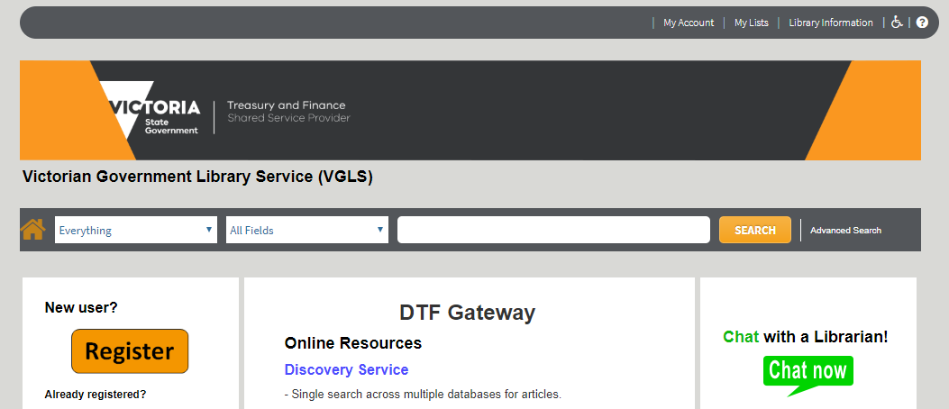
- For new users, click on the ‘Register’ button and fill in the form using your Victorian Public Service (VPS) details to create an account. Confirmation of your registration will appear on screen and in your email.

- If you have already registered in the past, click on ‘My Account’ (located on the top right-hand corner of the webpage) and sign-in with your VGLS username and password.
- Click on the home icon to return to the VGLS Gateway
If you are experiencing issues with setting up a VGLS account, email: vgls@dtf.vic.gov.au

Accessing the ISO 19650 Standards
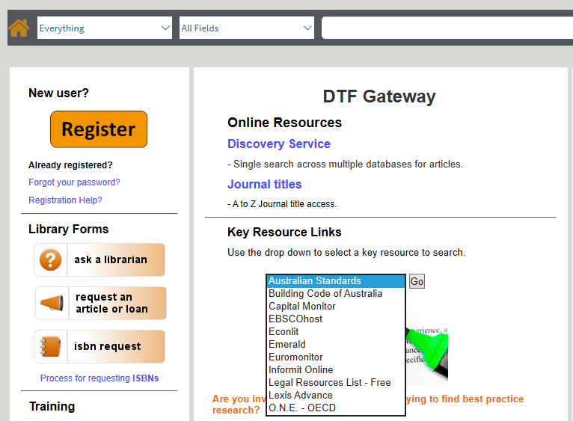
- Once you have signed in to VGLS, select ‘Australian Standards’ in the Key Resource Links drop down section and click ‘Go’

- After being redirected to SAI Global, click ‘New Registration’ and fill in the form using your government email address
[ Note: SAI Global will not grant access to standards for Victorian government employees that are part of an agencies that is not a member of Victorian government’s shared service provider.]
- To activate your account, follow the instructions from the confirmation email and log-in with your new credentials.

- Enter ‘ISO 19650’ in the document number search bar and click on your desired standard (ISO 19650-1 or ISO 19650-2).
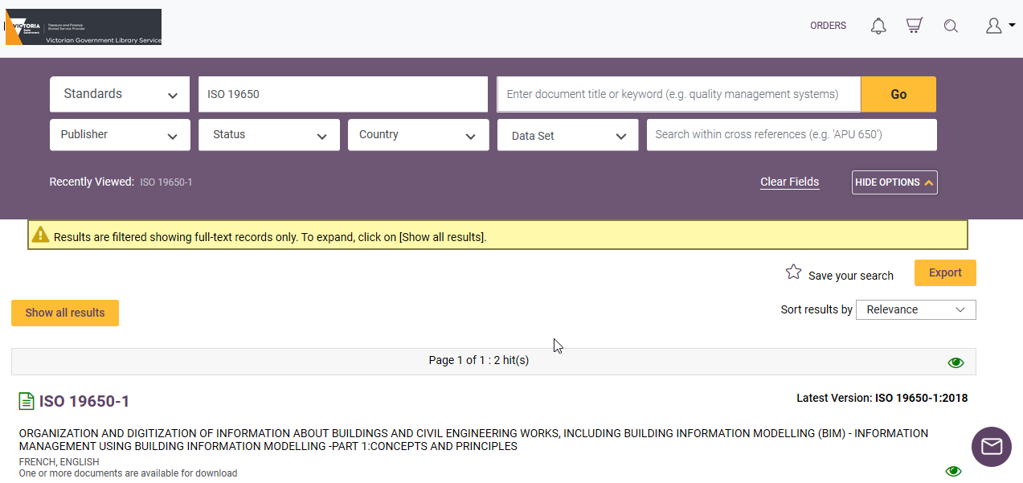

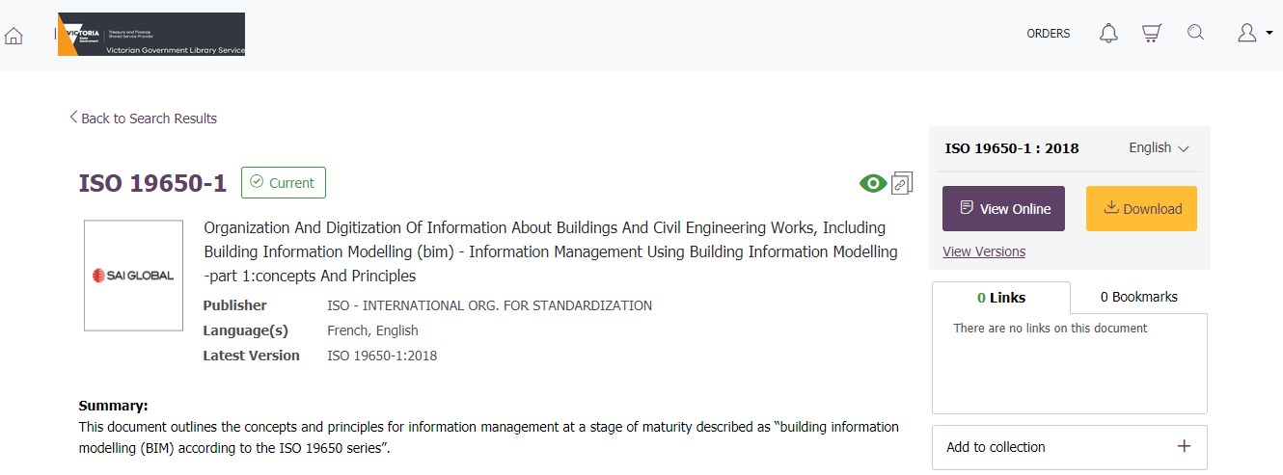
- Click on either ‘View Online’ or ‘Download’ to access the document.

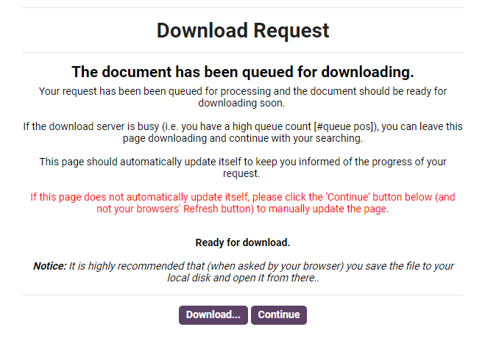
- If choosing the download option, wait until your request has been processed and click the ‘Download’ button.

- Save the file to your local disk for future use noting Conditions of Access, noted above.

